VistA Scheduling Enhancements (VSE)

VS GUI  
User Guide



June 2017

Department of Veterans Affairs

Office of Information and Technology (OI&T)

Version 1.7

Revision History

|  |  |  |  |
| --- | --- | --- | --- |
| Date | Revision | Description | Author |
| 06/23/2017 | 1.7 | Addressed Business User comments and updated for Build 1.3 Release 1; provided technical edits for format and consistency | M. Habic |
| 01/27/2017 | 1.6 | Addressed VA comments; added Section 5.1.8 Viewing/Editing Patient-Centered Scheduling Request; added alternate text to all figures and tables; added sections for acronyms and hot keys | M. Woehrle  C. Kron  E. Phelps |
| 01/18/2017 | 1.5 | Performed internal peer review; removed *Welcome to VA* references; updated Section 2; added VSE Additional Enhancements description | M. Woehrle  L. Masucci  E. Phelps |
| 01/08/2017 | 1.4 | Incorporated user acceptance testing updates: pages 7, 9, 11, 15, 22, 23, 25, 27, 35-37, 46-48, 50, 52, 55, 57-58,60,63,69,71, 74,76,79,81,84,86,89-91,93,96-109,117-118,120-121, 123, 125, 127-130,132-147,166,181-195; provided technical edits for format and consistency | C. Kron  E. Stuck  C. Zavala E. Phelps |
| 12/21/2016 | 1.3 | Updated table of contents and footers for pages 161-211; provided technical edits – fixed figure captions, added table list, added queries for author | C. Kron E. Phelps |
| 12/7/2016 | 1.2 | Updates to Clinic Grid (pages 31,37-38,72,91) | C. Kron |
| 11/21/2016 | 1.1 | Updates from CIT/ST: pages 6-13,16-21,23-24,27-95,97,99-104,123-124,127,129-131,133,135-137,139-145,157-161,168-171,173-174,176,184 | C. Kron |
| 05/02/2016 | 1.0 | Initial baseline | D. Reed |

Table of Contents

1 Introduction 1

1.1 Purpose 1

1.2 Overview 1

1.3 Project References 1

1.3.1 Information 1

1.3.2 Coordination 1

1.3.3 Help Desk 1

1.3.4 Organization of the User Guide 2

2 System Summary 3

2.1 User Access Levels 7

3 Getting Started 8

3.1 Logging On 8

3.2 Logging Off 9

3.3 VS GUI Tabs 10

3.3.1 Tasks Tab 10

3.3.2 System Tab Action Areas 11

3.3.3 Reports Tab Action Areas 12

3.4 Searching 12

3.4.1 Search for Patient 12

3.5 Filtering 14

3.5.1 Filtering Lists 14

3.5.2 Paging Through Records 15

3.5.3 Filtering by Facility or Clinic 16

3.5.4 Filtering by Time Period 16

3.6 Sorting 17

3.6.1 Sorting by Column 17

3.7 Printing and Exporting a Request Management Grid 18

3.7.1 Printing a Request Management Grid 18

3.7.2 Exporting a Grid 19

3.8 Viewing 19

3.8.1 View Only Mode 19

3.8.2 Viewing Requests by Request Type 20

3.8.3 Viewing Requests by Patient 21

3.8.4 Changing the Schedule View 22

4 Ribbon Bar 23

4.1 Patients Demographics 23

4.1.1 Finding a Patient 23

4.1.2 Viewing Patient Demographics in the Ribbon Bar 24

4.1.3 Patient Eligibility Information 25

4.1.4 Updating Patient Demographics 26

4.1.5 Editing Permanent Address 28

4.1.6 Adding a Temporary Address 29

4.1.7 Marking for Bad Address 30

4.2 Actions 33

4.2.1 New Request 33

4.3 Arrangement 33

4.3.1 View Mode 33

4.4 Pending Appointment Window 33

4.5 Special Needs/Preferences 36

4.5.1 Adding/Removing Special Needs/Preferences from Requests 36

4.6 Patient Flags 38

4.7 Tools 39

4.7.1 Print 39

4.7.2 Export 39

4.7.3 Refresh 40

4.7.4 Query 40

4.8 Settings – User Preferences 42

5 Request Management 44

5.1 Request Management Procedures 44

5.1.1 Viewing a Patient’s Existing Requests 44

5.1.2 Adding Appointment Request 48

5.1.3 Viewing/Editing Appointment Request 52

5.1.4 Disposition or Removing an Appointment Request 54

5.1.5 Transfer to EWL Request for a Patient 55

5.1.6 Disposition or Removing a Patient from the EWL 57

5.1.7 Adding Patient-Centered Scheduling Request 57

5.1.8 Viewing/Editing Patient-Centered Scheduling Request 59

5.1.9 Disposition or Remove Patient-Centered Scheduling Request 64

5.2 Contacting a Patient 66

5.2.1 New Contact Attempt 66

6 Appointment Management 71

6.1 Adding Appointments 71

6.1.1 Add Appointment for Appointment Request 71

6.1.2 Add Appointment for EWL Request 77

6.1.3 Add Appointment for Patient-Centered Scheduling Request 82

6.1.4 Add Appointment for Consult Request 87

6.2 Disposition Appointments 92

6.2.1 Edit Appointment Information 92

6.2.2 View Appointment Information 93

6.2.3 Cancelling an Appointment 95

6.2.4 Mark as No Show Appointment 98

6.2.5 Undo No-Show Appointment 101

6.2.6 Checking In a Patient 102

6.2.7 Undo a Patient Check In 104

6.2.8 Check Out a Patient 106

6.2.9 Undo a Patient Check Out 109

6.2.10 Rescheduling an Appointment 110

6.3 Multiple Appointment Requests and Appointments 112

6.3.1 Multiple Appointment Request 112

6.3.1.1 Note Regarding Parent and Child Appointment Requests 113

6.3.2 Adding Multiple Appointments from Find Appointment Dialog 114

6.4 Overbooking Appointments 118

6.4.1 Overbooking Appointments with SDMOB Security Key 119

6.4.2 Overbooking Appointments with SDOB Security Key 123

6.5 VL APPT 127

6.5.1 Identifying a VL Clinic 127

6.5.2 Add a VL APPT 129

6.6 Compensation and Pension (C&P) APPTs 132

6.6.1 Add a C&P APPT Request 132

6.6.2 Add a C&P APPT for Pending 2507 Request NOT Previously Linked to Appointment 133

6.6.3 Add a C&P APPT for Pending 2507 Request Already Linked to APPT NOT Due to Cancellation 134

6.6.4 Add a C&P APPT for Pending 2507 Request due to Clinic Cancellation 136

6.6.5 Add C&P APPT for Pending 2507 Request due to Veteran Cancellation/No Show 139

6.6.6 Disposition APPT Linked to Pending 2507 Request 142

6.7 VAR Scheduling 143

7 Clinics 144

7.1 Tasks Tab 144

7.1.1 Viewing Clinic Schedule Availability 144

7.1.2 Viewing Clinic’s Availability Cancellation 147

7.1.3 Viewing Clinic’s Length of APPT and Max OB 148

7.1.4 Viewing Clinic’s VL Indicator 148

7.1.5 Viewing Clinic’s Special Instructions 149

7.1.6 Viewing Clinic’s Available Slots 150

7.1.7 Time Slot Viewer 150

7.1.8 Viewing Provider Availability 154

7.1.9 Viewing Clinic Group Availability 157

7.2 System Tab 159

7.2.1 Viewing Clinic Availability Information 159

7.2.2 Adding and Removing Privileged Users 160

7.2.2.1 Add Privileged User 160

7.2.2.2 Remove Privileged User 161

7.2.3 Creating Clinic Groups 162

7.2.4 Removing Resource(s) from a Clinic Group 165

8 Reports 166

8.1 Audit Activity Report 166

8.1.1 Generating an Audit Activity Report for Individual Scheduler 166

8.1.2 Generating Audit Activity Report for All Schedulers 167

8.1.3 Working with Audit Activity Report Data 168

8.1.3.1 Sorting by Column Header 168

8.1.3.2 Filtering by Column Data 170

8.1.4 Export Audit Activity Report for Individual or All Schedulers 170

8.2 Clinics Report 171

8.2.1 Clinic Activity Report – Individual Clinic 171

8.2.2 Working with the Clinic Activity Report 171

8.2.2.1 Sorting by Column Headers 171

8.2.2.2 Filtering by Column Data 173

8.2.3 Exporting a Clinic Report 174

9 Trash Queue Cleanup 175

9.1 Compile List of Re-Opened REQUEST Records that Can Be Closed 176

9.2 Commit Records to Be Closed from Compiled List 177

9.3 View Unresolved APPT Requests Reopened by the SDCANCEL Option 179

10 VistA Scheduling 508 Compliance 181

10.1 Tasks Tab 181

10.1.1 Ribbon Bar 181

10.1.2 Request Type Dialog 182

10.1.3 Appointment Request Dialog 182

10.1.4 Query Dialog 183

10.2 Systems Tab 185

10.2.1 Systems Tab Ribbon Bar 185

10.2.2 Scheduling Management Dialog 186

10.2.2.1 Clinics and Users Tab 186

10.2.2.2 Clinic Groups Tab 186

10.2.3 Availability Selection Dialog 187

10.3 Reports Tab 188

10.3.1 Reports Tab Ribbon Bar 188

10.3.2 Audit Activity Dialog 188

10.3.3 Clinic Activity Dialog 189

11 Troubleshooting 189

11.1 Changing User ID and Password 189

11.2 Special Instructions for Error Correction 190

12 Acronyms and Abbreviations 191

13 Hot Keys Quick List 193

List of Figures

Figure 1: User Login 8

Figure 2: Main Screen with Test Environment Displayed 9

Figure 3: User Logoff 9

Figure 4: VS GUI Tabs 10

Figure 5: Mobile Requests Unavailable Displayed in Ribbon Bar 10

Figure 6: Tasks Tab Display 11

Figure 7: System Tab 12

Figure 8: Reports Tab 12

Figure 9: Patient Search 13

Figure 10: Filtering Lists 14

Figure 11: Paging Through Records 15

Figure 12: Filtering by Facility/Clinic 16

Figure 13: Filtering by Time Period 16

Figure 14: Sorting by Column 17

Figure 15: Selecting the Print Option 18

Figure 16: Selecting a Printer 18

Figure 17: Exporting a Grid 19

Figure 18: Request Type Column 20

Figure 19: Select Patient 21

Figure 20: Request Type 21

Figure 21: Patient Pending Requests and Booked Appointments 21

Figure 22: View Mode 22

Figure 23: Changing View of a Specific Schedule 23

Figure 24: Search Patient 23

Figure 25: Patient Demographics in the Ribbon Bar 24

Figure 26: Patient Inquiry Detail 25

Figure 27: Patient's Eligibility Information 26

Figure 28: Request Type–APPT 26

Figure 29: Patient Information Dialog 27

Figure 30: Patient is Being Edited Warning Pop-up 28

Figure 31: Patient Info Dialog–Permanent Address 29

Figure 32: Patient Info Dialog – Temporary Address 30

Figure 33: Select Patient 31

Figure 34: Request Type 31

Figure 35: Appointment Request Dialog—Bad Address Selection 32

Figure 36: Actions Pane 33

Figure 37: Request Type – APPT 33

Figure 38: Pending Appointment Window – Past Appointment Date 34

Figure 39: Pending Appointment Window – Current less than Three Days in Future 35

Figure 40: Pending Appointment Window – Future Appointment Dates 35

Figure 41: Request Type – APPT 36

Figure 42: Patient Info Dialog – Special Needs/Preferences Section 37

Figure 43: Ribbon Bar – Special Needs/Preferences 37

Figure 44: Patient Record Flags Dialog 38

Figure 45: Patient Record Flags 39

Figure 46: Refresh Button in Tools Pane 40

Figure 47: Request Query 41

Figure 48: Query Rule Validation 41

Figure 49: Request Query Rule Confirmation 41

Figure 50: Settings – User Preferences 42

Figure 51: Settings – Save as Default View 43

Figure 52: Request Type 44

Figure 53: Request Grid and Pending Appointments 44

Figure 54: Request Grid Displaying Expand Entry Block 45

Figure 55: Appointment Demographics 46

Figure 56: Appointment Event Log 46

Figure 57: Appointment Wait Time 47

Figure 58: Patient Information 47

Figure 59: Encounter Information 48

Figure 60: Request Type - APPT 48

Figure 61: Actions Pane—New Req. Selection 49

Figure 62: Appointment Request Dialog – Request Information Section 49

Figure 63: Special Needs/Preferences Section from Patient Info Dialog 50

Figure 64: Appointment Request Dialog 51

Figure 65: View Request (Read Only) 53

Figure 66: Edit Request (Request Information Only) 54

Figure 67: APPT/Veteran Disposition Options 55

Figure 68: EWL Request Dialog 56

Figure 69: Request Type–PATIENT-CENTERED SCHEDULING 58

Figure 70: Patient-Centered Scheduling APPT Request Dialog 59

Figure 71: Patient-Centered Scheduling Disposition Dialog 60

Figure 72: Patient-Centered Scheduling Appointment View Request Dialog 61

Figure 73: Patient-Centered Scheduling Disposition Dialog 62

Figure 74: Patient-Centered Scheduling Appointment Edit Request Dialog 63

Figure 75: Patient-Centered Scheduling Disposition Options 64

Figure 76: PtCSch Comment Comment Dialog Box 65

Figure 77: Warning Pop-Up If Business Rules Were Not Met 65

Figure 78: Request Type/Dispositions/Contact Message Reference 66

Figure 79: Contact Attemps 67

Figure 80: Patient Contact Dialog 67

Figure 81: New Contact Attempt Submitted and Displayed 68

Figure 82: Displaying Name of Person Entering Contacts 69

Figure 83: Appointment Canceled 69

Figure 84: New Contact Attempt After Cancellation 70

Figure 85: Request Type 71

Figure 86: Select APPT Request – Clinic Schedule Grid Display 72

Figure 87: Select Time Slot 72

Figure 88: Right Click Options – Add Appointment 73

Figure 89: New Appointment Dialog 74

Figure 90: Print Letter? Dialog 74

Figure 91: Closing Request Dialog 75

Figure 92: Clinic Schedule Grid – Past Appointment Display 75

Figure 93: Clinic Schedule Grid – Current Appointment Display 76

Figure 94: Clinic Schedule Grid – Future Appointment Display 76

Figure 95: Request Type 77

Figure 96: Select EWL Request 78

Figure 97: Select Time Slot 78

Figure 98: Right Click Options – Add Appointment 79

Figure 99: New Appointment Dialog 79

Figure 100: Print Letter? Dialog 80

Figure 101: Closing Request Dialog 80

Figure 102: EWL Appointment Past Date Display 81

Figure 103: EWL Appointment Current Date 81

Figure 104: EWL Appointment Future Date Display 82

Figure 105: Request Type 82

Figure 106: Select Patient-Centered Scheduling Request 83

Figure 107: Select Time Slot 83

Figure 108: Right Click Options – Add Appointment 83

Figure 109: New Appointment Dialog 84

Figure 110: Print Letter? Dialog 84

Figure 111: Closing Request Dialog 85

Figure 112: Clinic Schedule Display – Past Date Appointment 85

Figure 113: Clinic Schedule Display – Current Date Appointment 86

Figure 114: Clinic Schedule Display – Future Date Appointment 86

Figure 115: Request Type 87

Figure 116: Select Consult Request 87

Figure 117: Clinic Schedules 88

Figure 118: Select Time Slot 88

Figure 119: Right Click Options – Add Appointment 88

Figure 120: New Appointment Dialog 89

Figure 121: Print Letter? Dialog 89

Figure 122: Clinic Schedule Display – Consult Past Appointment Date 90

Figure 123: Clinic Schedule Display – Consult with Current Date 90

Figure 124: Clinic Schedule Display – Consult Future Appointment Date 91

Figure 125: Appointment Right Click Options – Edit Appointment 92

Figure 126: Edit Appointment Dialog 93

Figure 127: Hover Box Displaying Appointment Details 94

Figure 128: Appointment Right Click Options – View Appointment 94

Figure 129: View Appointment Dialog 95

Figure 130: Appointment Right Click Options – Cancel Appointment 96

Figure 131: Cancel Appointment Dialog 97

Figure 132: Pending Appointment Window – Appointment Status Cancelled by Clinic 97

Figure 133: Pending Appointment Window – Appointment Status Cancelled by Patient 98

Figure 134: APPT Request – Time Slot Count Increase 98

Figure 135: Appointment Right Click Options – Mark as No Show 99

Figure 136: Mark as No Show Dialog 99

Figure 137: Clinic Schedule Display – No-Show Red 100

Figure 138: Pending Appointment Window – Appointment Status No-Show 100

Figure 139: No-Show Warning Message 100

Figure 140: Appointment Right Click Options – Undo NoShow 101

Figure 141: Appointment Clinic Schedule Display – Undo NoShow as Purple 102

Figure 142: Undo NoShow – Appointment Status No Action Taken 102

Figure 143: Appointment Right Click Options – Check In Patient 103

Figure 144: Appointment Check In Dialog 103

Figure 145: Clinic Schedule Display – Check In Yellow 104

Figure 146: Pending Appointment Window – Status ACT REQ/CHECKED IN 104

Figure 147: Appointment Right Click Options – Undo Check In Patient 105

Figure 148: Clinic Schedule Display – Undo Check In Patient Purple 105

Figure 149: Pending Appointment Window – Appointment Status No Action Taken 106

Figure 150: Appointment Right Click Option – Check Out Patient 107

Figure 151: Appointment Check Out Dialog 108

Figure 152: Clinic Schedule Display – Check Out Patient Orange 108

Figure 153: Pending Appointment Window – Status ACT REQ/CHECKED OUT 108

Figure 154: Appointment Right Click Options – Undo Check Out Patient 109

Figure 155: Clinic Schedule Display – Undo Check Out Patient Yellow 109

Figure 156: Pending Appointment Window – Status ACT REQ/CHECKED IN 110

Figure 157: Move Appointment? Dialog 110

Figure 158: Cancel Appointment Dialog 111

Figure 159: Pending Appointment Window – Appointment Status Cancelled and Future 111

Figure 160: MRTC Interval/Appt. # Dialog 113

Figure 161: MRTC Requests displayed in Request Management Grid 114

Figure 162: Find Appointment Dialog 115

Figure 163: Find Appointment Dialog and MRTC Booking Status Dialog 116

Figure 164: Future Clinic Inactivation Date 118

Figure 165: Request Type 119

Figure 166: Clinic Schedule Display – APPT Request Future CID/Preferred Date 120

Figure 167: Max Overbook Limit 120

Figure 168: Appointment Right Click Options – Add Appointment 121

Figure 169: New Appointment Dialog – Appointments 121

Figure 170: Print Letter? Dialog 122

Figure 171: Closing Request Dialog 122

Figure 172: Clinic Schedule Display – Overbook Appointment 123

Figure 173: Request Type 123

Figure 174: Clinic Schedule Display – APPT Request Future CID/Preferred Date 124

Figure 175: Overbook After Hours Time Slot 124

Figure 176: Appointment Right Click Options – Add Appointment 125

Figure 177: Overbook Confirmation Dialog 125

Figure 178: New Appointment Dialog 126

Figure 179: Print Letter? Dialog 126

Figure 180: Closing Request Dialog 126

Figure 181: Clinic Schedule Display – Overbook Appointment After Hours 127

Figure 182: Clinic Schedules – Clinic Search 128

Figure 183: Clinic Schedule Grid 128

Figure 184: VL Indicator 128

Figure 185: New Appointment Dialog 129

Figure 186: Clinic Schedule Display – Multiple Time Slot Selected 130

Figure 187: New Appointment Dialog – VL APPT Duration 131

Figure 188: Clinic Schedule Display – Appointment Length Extended 132

Figure 189: TRACKING Record Updated 133

Figure 190: C&P Appointment for Patient with No Pending 2507 Request 133

Figure 191: C&P Requests Dialog 135

Figure 192: C&P Request Due to Cancellation Dialog 135

Figure 193: AMIE C&P EXAM TRACKING Record Updated 135

Figure 194: C&P Requests Dialog 137

Figure 195: C&P Request Due to Cancellation Dialog 137

Figure 196: C&P Request APPT Links Dialog 138

Figure 197: C&P APPT Links Due to Veteran Cancellation or No Show 138

Figure 198: C&P APPT Links Due to Cancellation Dialog 138

Figure 199: C&P APPT Links Adjustment Dialog 139

Figure 200: C&P Requests Dialog 140

Figure 201: C&P Request Due to Cancellation Dialog 140

Figure 202: C&P Request APPT Links Dialog 141

Figure 203: C&P Canceled APPT Links Dialog Warning 141

Figure 204: C&P APPT Links Due to Veteran Cancellation or No Show 141

Figure 205: AMIE C&P EXAM TRACKING Record Updated 142

Figure 206: C&P Cancel APPT Associated 2507 Request Updated 143

Figure 207: C&P Cancel APPT NOT Linked to Pending 2507 Request 143

Figure 208: Clinic Schedules Search 145

Figure 209: Clinic Schedules Display – Available and Unavailable 145

Figure 210: Clinic Schedules Display – Hours of Operation 146

Figure 211: Clinic Schedules Display – Holiday Bookable 146

Figure 212: Clinic Schedules Display – Holiday Unbookable 147

Figure 213: Clinic Schedule Display – No Availability Defined 147

Figure 214: Clinic Schedule Display – Cancel Availability 148

Figure 215: APPT Length and Max OB Allowed 148

Figure 216: VL Indicator 149

Figure 217: Special Instructions Indicator 149

Figure 218: Time Slot Count 150

Figure 219: Overbook Time Slot Count 150

Figure 220: Minimized Time Slot Viewer 151

Figure 221: Expanded Time Slot Viewer 151

Figure 222: Time Slot Viewer Displays Slot Details 151

Figure 223: Time Slot Viewer Right Click Options – Add APPT 152

Figure 224: Time Slot Viewer Right Click–Edit, View, Cancel 152

Figure 225: Time Slot Viewer – Check In Patient 153

Figure 226: Time Slot Viewer – Check Out Patient 153

Figure 227: Time Slot Viewer – Mark as No Show 154

Figure 228: Provider Schedules 154

Figure 229: Provider Schedules Selection List 155

Figure 230: Provider Schedule Display 155

Figure 231: Provider Schedules Booked APPTs 155

Figure 232: Fixed View Size 156

Figure 233: Clinic Groups 157

Figure 234: Clinic Groups Search Result List 157

Figure 235: Clinic Groups Schedule Display 158

Figure 236: Provider Schedules – Fixed View Size 158

Figure 237: Clinic Availability Search 159

Figure 238: Clinic Availability 160

Figure 239: Clinics and Users 161

Figure 240: Add Privileged User 161

Figure 241: Remove Privileged User 162

Figure 242: Create New Clinic Group 163

Figure 243: Find Resource 164

Figure 244: Add Resource to Clinic Group 165

Figure 245: Remove Resource from Clinic Group 166

Figure 246: Reports Tab Selections 166

Figure 247: Audit Activity Report – Individual Scheduler 167

Figure 248: Audit Activity Report – All Schedulers 168

Figure 249: Audit Activity Sort – Ascending 169

Figure 250: Audit Activity Sort – Descending 169

Figure 251: Audit Activity Report – Filtered 170

Figure 252: Audit Activity Report – Multiple Filters 170

Figure 253: Clinic Activity Report Sort – Ascending Order 172

Figure 254: Clinic Activity Report Sort – Descending Order 173

Figure 255: Clinic Activity Report – Filtered 173

Figure 256: Clinic Activity Report – Multiple Filters 174

Figure 257: Clinic Activity 174

Figure 258: Save As 175

List of Tables

Table 1: Clinic Schedule Availability 144

Table 2: Hot Keys for Ribbon Bar Components 181

Table 3: Hot Keys for Request Type Dialog 182

Table 4: Hot Keys for Appointment Request Dialog 183

Table 5: Hot Keys for Systems Tab Ribbon Bar 185

Table 6: Hot Keys for Scheduling Management Dialog 186

Table 7: Hot Keys for Clinic Groups Tab 187

Table 8: Hot Keys for Availability Selection Dialog 187

Table 9: Hot Keys for Reports Tab Ribbon Bar 188

Table 10: Hot Keys for Audit Activity Dialog 189

Table 11: Hot Keys for Clinic Activity Dialog 189

Table 12: Warning Messages 190

# Introduction

Department of Veterans Affairs (VA) Veterans Health Information Systems and Technology Architecture (VistA) Scheduling (VS) Graphical User Interface (GUI) module is the Windows GUI version of the Patient Information Management System (PIMS) Scheduling module. It provides appointment management functions included in PIMS Scheduling, but with the added convenience and usability of a GUI.

## Purpose

The Veterans Health Administration (VHA) Office of Veterans Access to Care (OVAC) requested an enterprise enhancement for the VS package. The enhancement reduces operating costs for VHA and improves operational efficiencies, resulting in patient-centered access to care, coordinated care, increased customer satisfaction, and the reduction of excessive cycle/wait time for scheduling patients.

## Overview

VS GUI is a software module that allows schedulers to make appointments quickly by viewing multiple appointment request types and multiple clinics in one screen. A scheduler can easily view patient requests for service, find the next available open appointment, view the provider’s availability in multiple clinics, and track a patient’s appointment process. Refer to Section 2 for a more detailed description of VS GUI functionality.

## Project References

### Information

The VS GUI points of contact (POCs) include:

* OVAC VSE Project Manager – Ms. Debbie Malkovich, [Debbie.Malkovich@va.gov](mailto:Debbie.Malkovich@va.gov)
* OI&T VSE Project Manager – Mr. Shannon Ayers, [Shannon.Ayers@va.gov](mailto:Shannon.Ayers@va.gov)

**Note:** The VSE project SharePoint site can be accessed via the following link: <http://vaww.oed.portal.va.gov/pm/iehr/vista_evolution/enhancements/SitePages/Home.aspx>

### Coordination

Coordination between the project and its specific support functions (e.g., installation coordination, security, etc.) for VS GUI are the same as those for VistA.

### Help Desk

Refer to Section 11 for additional information.

### Organization of the User Guide

This user guide is comprised of 11 sections, as follows:

1. **Introduction:** Addresses general project information
2. **System Summary:** Contains system configuration, data flows, and user access level information
3. **Getting Started:** Contains procedures for logging on and off of the system, instructions on how to print and export schedules, and information on VS GUI tab displays, basic functions for searching, sorting, filtering, and viewing
4. **Ribbon Bar:** Contains procedures for using the Schedule Manager Ribbon Bar and details on features, such as patient demographics, new request actions, view mode, and patient preferences
5. **Request Management:** Outlines features and procedures for using the Request Management Grid (where patient’s pending requests are displayed 25 at a time) and the Pending Appointments window (where booked appointments are displayed in the in the Ribbon Bar of the Tasks tab)
6. **Appointment Management:** Provides details describing how to manage an appointment – after selecting a patient, the option appears to schedule a new appointment (APPT) or Patient-Centered Scheduling (PtCSch); a list of recent and upcoming appointments is displayed in the Ribbon Bar
7. **Clinics:** Provides an overview of clinic and administrator views and actions
8. **Reports:** Provides an overview of viewing and printing reports, and procedures for generating audit and clinic reports; a list of warnings is also included
9. **Trash Queue Cleanup:** Defines this task and provides instructions for use
10. **VistA Scheduling 508 Compliance**: Outlines processes for executing VistA Scheduling application functionality from the keyboard
11. **Troubleshooting:** Contact the Help Desk for any problems with the VS GUI module

# System Summary

The VSE project delivers a series of enhancements to legacy VistA Scheduling version 5.3 via the VS GUI application. The initial release, which consists of features listed in following paragraphs as: Enhancement 1, Enhancement 2, New Service Request (NSR) #002, Veteran Appointment Request (VAR) Interface, Optional Task #3 (OT3), Optional Task #4 (OT4), and Enhancement 3. These enhancements are included in VS GUI 2.0.0.5 and VistA patches SD*5.3*627, SD*5.3*628, SD*5.3*642, SD*5.3*643, SD*5.3*645 and GMRC*3*83, approved for National Release on 4/29/2016, and released 5/3/2016 for test environments only.

The VS GUI 2.0.0.8 and VistA M patches GMRC*3*86, SD*5.3*651, and SD*5.3*658 provide the existing functionality listed above, in addition to the features listed in the “VSE Additional Enhancements” paragraph below**.**

**Enhancement 1:** VHA requires an aggregated (combined) view of clinic profile scheduling grids to allow the user to view the resource’s availability collectively, and decrease the time it takes to match an available resource with the patient’s request, and improve the appointment scheduling process. Enhancement 1 provides an aggregated view of clinic profile scheduling grids for VistA Scheduling and:

1. Includes a standard tool for viewing and scheduling aggregated resources in order to improve performance for appointment scheduling
2. Improves visibility into resources across clinic profiles
3. Exposes previously underutilized resources
4. Improves business processes and efficiency

**Enhancement 2** consolidates information from multiple appointment request sources, allowing all patient requests to be available collectively for query, filtering, and sorting, thereby improving the appointment scheduling process. A single request list queue provides immediate, incremental relief to the field, and:

1. Promotes a standard tool for consolidating, viewing, sorting and prioritizing appointment requests to improve appointment scheduling performance
2. Improves the business’ ability to accurately prioritize patient appointment needs, regardless of request method and work list
3. Improves business processes and efficiency by streamlining and removing duplication
4. Eliminates waste in a scheduler’s appointment request workload processes

**NSR #002** addresses the following functionalities:

1. The aggregated request list functionality built into the VS GUI must be separated from the wait list file structure in VistA
2. Assigning of schedulers to clinics must be done on an exclusionary instead of the current inclusionary basis
3. The current capability to link multiple appointments to a single appointment request must be replaced by a one-to-one linkage (one appointment request per appointment)
4. The aggregated request list functionality built into the VS GUI only displays wait lists associated with clinics whose clinic profiles allow such display
5. In multiple return to clinic scenarios (multi-book appointments), VS GUI calculation of subsequent desired dates based on initial appointment booking date, rather than initial desired date

**VAR** **Interface** provides an interface between the VS GUI and the VAR appointment request database, including the ability to:

1. Link an appointment requested in VAR and processed in VistA, such that the state of the appointment in VistA (e.g. cancelled, checked out) can be displayed in the VS GUI application
2. View appointment requests within VS GUI
3. Communicate or message the Veteran from within VS GUI up to a limit of four times
4. Close out requests from VS GUI

**OT3** captures three enhancements to the VS GUI, identified by VHA to support scheduling workflow and policy:

1. Appointments generated from Consults in Computerized Patient Record System (CPRS) shall use the consult **Earliest Appropriate Date** to populate the **DESIRED/PATIENT-CENTERED SCHEDULING Clinically Indicated Date (CID)/Preferred Date** and **ENTERED/RR NO DATE** fields in the VS GUI when a value is present other than **Today’s** date (as set as default by CPRS) and is not equal to the “Appointment Entered Date”
2. Functionality in Legacy VistA Scheduling and VS GUI that provided the ability to hide appointment requests associated with wait lists associated with clinics is removed
3. Veteran disabilities shall display in the VS GUI to aid in determining eligibility for specific clinics

**OT4 Functionality** consists of additional enhancements identified by VHA to support the scheduling workflow and policy, such that the VSE GUI shall:

1. Follow the same rules as in VistA for Overbooking and Master Overbooking Security keys
2. Display the number of available appointment slots (in the calendar view for a clinic) within each appointment time slot to allow booking of several appointments
3. Have a consistent visual indication (color) for the following:

* Hours of operation
* Non-workable hours during that specific day (after hours bookable using a key)
* Unavailable for any type of scheduling
* Clinic inactive
* Holiday but bookable
* Holiday but NOT bookable
* No availability created for the clinic

1. Allow ability to enter variable length (VL) appointments, only for clinics with variable appointment lengths defined in the VistA Clinic Setup Parameters
2. Display a visual indicator for clinics that allow variable appointment lengths
3. Display special clinic instructions on the screen (example: “only make new appointments on Tuesday and Thursday”)
4. *NOT* display Occasion of Service (OOS) clinics (field 50.01 = yes is the OOS indicator), including drop down lists
5. Display message "No availability was created for the clinic" when a grid does not exist for the clinic (example: Veterans Crisis Line (VCL) and admin clinics), similar to current VistA Scheduling processing
6. Allow ability to enter CID/Preferred Date and/or appointment date within the appointment requests using past dates
7. Include multi-book enhancement GUI features:

* For inpatients, the VSE GUI shall display ward location in patient demographic area for each patient
* **Comp & Pension Appointments** need to be linked to the **2507 Request**, as it currently does in VistA
* Multi-Appointment Booking Wait Time
* Scheduling “Desired Date” Change
* Patient-Centered Scheduling Reminder Parameters
* Patient-Centered Scheduling Reminder Print Failures
* Modification to VistA Patient-Centered Scheduling Reminders

**Enhancement 3** provides a consolidated view of resource management metrics related to scheduling supply and demand for appropriate organizational components (e.g., clinic, facility levels). The tool is referred to as Resource Management Reporting. The enhancement provides aggregate views of Legacy VistA Scheduling data and does not directly contain Personally Identifiable Information (PII) data.

**VSE Additional Enhancements** include the following modifications to VS GUI:

1. VS GUI Schedulers have the ability to schedule appointments at times and with the variations needed to support clinic operation, as well as identify the exact appointment times for unscheduled patients/walk-ins.
   * Display clinic hours of operation based on the clinic profile definition, which only defines “Clinic Start Time”
   * Display availability start and end time accurately in VS GUI based on the appointment length, dislay of increments er hour and availability set up in the clinic profile
   * Display the current available appointments per slot
   * Overbooking indication and warning
   * Allow VS GUI Scheduler to enter exact time when booking an unscheduled appointment
     + Identify appointment type as “Unscheduled”
2. VS GUI Schedulers have the ability to manage requests more efficiently and effectively by editing requests, saving and viewing all comments, and reopening requests as needed, while preserving the original preferred date.
   * Editing, displaying, and auditing certain non-editable fields in appointment (APPT), electronic wait list (EWL), and patient-centered scheduling requests
   * View a previously closed, correlating request when an appointment is “No Showed,” so that the information is available for future appointments
   * Resource Management Grid no longer displays the appointment request when performing an “Undo No Show,” so that an appointment can no longer be booked against it
3. Patient demographic updates made in VS GUI are automatically updated in VistA.
   * VS GUI displays patient demographics
   * VS GUI displays the Veteran’s next-of-kin address information in the demographics and special needs view
   * VS GUI no longer displays the contact information tab
   * VS GUI displays patient and national record flag notices to the VS GUI Scheduler
4. Synchronizes patient information across functional areas (CPRS and VistA) within VS GUI to the patient in focus, and provides more information about a patient’s identification in the calendar view of appointments.
5. VS GUI displays the last four digits of the patient’s social security number (SSN) along with the patient (last name, first name).
6. Enables improved printing of letters and Veteran appointments.
7. Provides the ability to identify and purge unresolved appointment requests for administrators via VistA.
8. Allows a VS GUI user to set their default view preferences and adds a “View Only” option for those users that are not VS GUI Schedulers.
   * Provides a means for the user to save column order and filtering criteria for the Resource Management Grid as the default for part of their user preferences
   * Provides a means for the user to be aware that their user preferences are in use
   * Provides a means for the VS GUI user to be aware that they are in “View Only” mode
   * Removes the “Patient” label on the “Request Type” window
9. The VAR queue displays the telephone number that was entered into the VAR screen by the Veteran.
10. The VS GUI sends a “Not Booked” message to the VAR system when the scheduler does not book an appointment, so that the Veteran is accurately informed of the request to book an appointment.
11. Provides efficient and effective response time (displaying real-time pick lists/drop down lists, query results, and reports) by way of the following features:
    * A message displays to indicate the system is retrieving data while the system is processing a search by patient, provider, clinic, or service/specialty
    * A message displays to indicate the system is retrieving data whenever a query is processing in Query Tool
    * A message displays to indicate the system is retrieving data while the system is processing clinics reports and audit activity reports
    * A message displays to indicate the system is retrieving data while the system is processing for any feature in use on the “Tasks” tab
    * Resource Management Reports are disabled and no longer available to the VS GUI user

## User Access Levels

The VS GUI module uses three access levels:

1. **Provider and Non-Scheduler (View Only)** can view patient appointments, clinics, and provider’s availability in VS GUI via:
   * **VS GUI** to view patient appointments, clinics, and provider’s availability
   * **Find Appointments** to specify the dates to view only available appointments in a clinic or list of clinics
   * **Resource Schedules** to display clinic schedules
   * **Appointment Schedule** to display appointment schedules for a clinic and be able to view a provider’s schedule for the day, week, or month in 10, 15, 20, 30, or 60 minute time slots
   * **Request Management Queue** to display a list of patients waiting for an appointment
2. **Scheduler** can make appointments quickly by viewing multiple clinics in one screen. The user can easily find the next available open appointment, view the provider’s availability in multiple clinics, and track a patient’s appointment process in VS GUI via:

* **Find Appointments** to specify the dates to view only available appointments in a clinic or list of clinics
* **Resource Schedules** to display clinic schedules
* **Appointment Schedule** to display appointment schedules for a clinic and be able to view a provider’s schedule for the day, week, or month in 10, 15, 20, 30, or 60 minute time slots
* **Request Management Queue** to display a list of patients waiting for an appointment
* **Ribbon Bar** for a view that organizes the VS GUI into a series of tabs at the top of the module: Tasks, System, Reports
* **Mobile Requests** to show the number of pending mobile requests and provide access to the Mobile Request List for scheduling

1. **Administrator** can performall VS GUI Scheduler functions, with the addition of the following:

* **System** to add/delete privileged users from a prohibited clinic and setup clinic groups
* **Reports** to view and export reports

# Getting Started

This section provides a general walkthrough of the system from initiation through exit. The logical arrangement of the information shall enable the user to understand the sequence and flow of the system.

## Logging On

VistA User Access and Verify codes are required in order to log on to the VS GUI.

**Note:** If User Access and Verify codes are needed, contact your supervisor or site administrator.

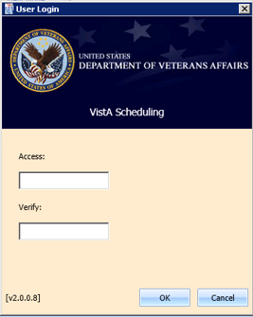

Figure 1: User Login

**Note:** The main screen of the application informs user whether they are logged into the test or production environment. The environment to which the user is logged in will be displayed in the top right corner of the main screen page.

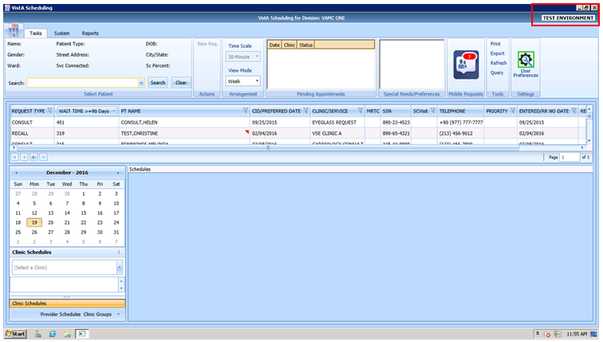

Figure 2: Main Screen with Test Environment Displayed

## Logging Off

To log off when you are finished scheduling appointments, click the close button (**X**) in the upper right corner of the VS GUI.

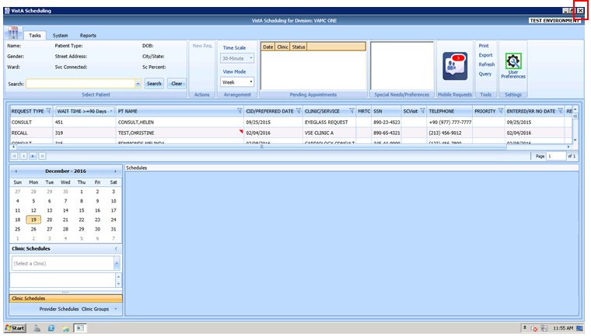

Figure 3: User Logoff

## VS GUI Tabs

The VS GUI provides the following tabs:

* **Tasks:** Allows Scheduler to search for patient requests, view clinic resources, and make appointments.
* **System:** Allows an administrator (with the SDECZMGR security key) to add/delete privileged users from a prohibited clinic and set up clinic groups.
* **Reports:** Allows for various reports to be generated by users holding the SDECZMGR security key.

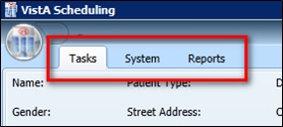

Figure 4: VS GUI Tabs

### Tasks Tab

The **Tasks** tab display includes the following sections:

1. **Select Patient:** Search for and view information about a selected patient
2. **Actions:** Allows Scheduler to initiate new APPT or Patient-Centered Scheduling requests
3. **Arrangement:** Time Scale and View Mode (Day, Week, or Month) for the clinic schedule grids of the screen
4. **Pending Appointments**: Date, clinic, and status of any pending appointments, past appointments (365 days back), and future appointments (365 days forward) for the selected patient
5. **Special Needs/Preferences:** Identified special needs and/or preferences for the selected patient missing the Patient Record Flags (PRFs)
6. **Mobile Requests:** Shows number of pending mobile requests and provides access to the Mobile Request List for scheduling. If the mobile request service is not available, **UNAV** is displayed in place of the request number.

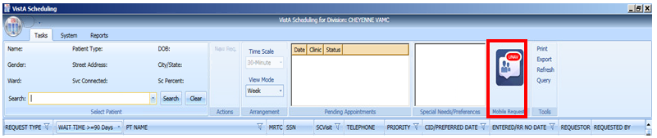

Figure 5: Mobile Requests Unavailable Displayed in Ribbon Bar

1. **Tools:** Options include print, export, refresh, and queries.
2. **Settings:** Access to User Preferences.
3. **Resources:** Calendar to choose a desired appointment date and to search for and access **Clinic Schedules**, **Provider Schedules**, and **Clinic Groups**
4. **Schedules:** View single or multiple clinic schedules in one screen

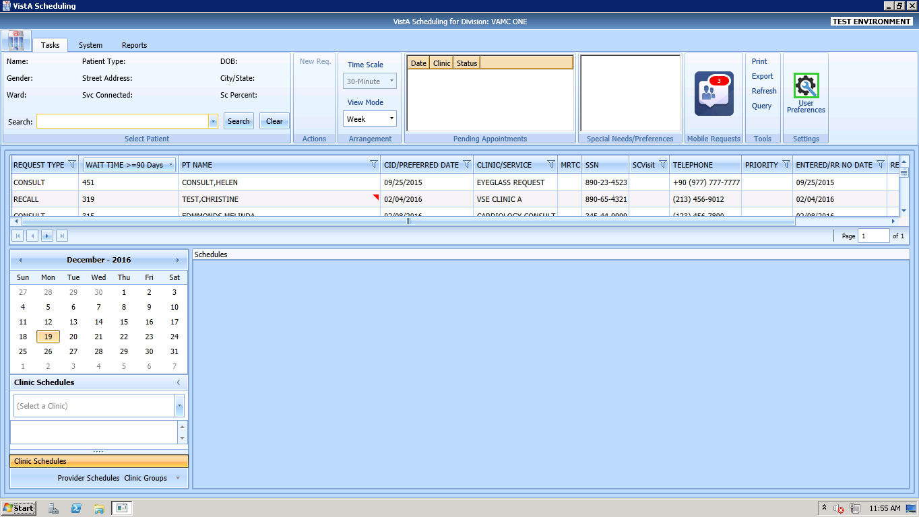

Figure 6: Tasks Tab Display

### System Tab Action Areas

The System tab display includes the following sections:

1. **Resource Management:** **Scheduling Management** allows for management of privileged users within Prohibited and Clinic Groups as well as the creation and management of clinic groups.
2. **Resource Schedules** **Availability** allows for search of resource by name.
3. **Selected Clinic** provides a quick view of the selected clinic’s Primary Provider, Overbook Limit, Inactive Date, and ReactiveDate.

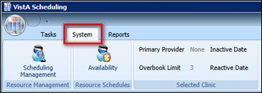

Figure 7: System Tab

### Reports Tab Action Areas

The **Reports** tab display allows for viewing and exporting of **Audit Activity** and **Clinics** setup information.

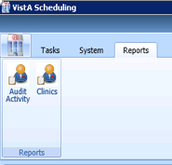

Figure 8: Reports Tab

## Searching

The search feature enables a Scheduler to:

1. View and search clinic profiles to view appointments resources by clinic or by clinic groups
2. View and search patient requests by request type
3. Sort the request queue by any column in ascending or descending order
4. Sort results and save the search into various outputs, such as Microsoft Excel or Adobe PDF
5. Generate an audit report of search and sort results
6. Print various screens and open lists

### Search for Patient

1. Log into VS GUI.
2. In the **Tasks** tab display, in the **Search** text box, type the search criteria for the patient, click the **Search** button, and select the requested patient name. Click **Search/Choose patient from the resulting list**.
3. In the Search field, the following options are available for searching for a patient:

* Last name, First name
* Full SSN
* First initial last name + last four SSN (ex. T0170)
* Last four of SSN (0170)
* Last name only (three character minimum)

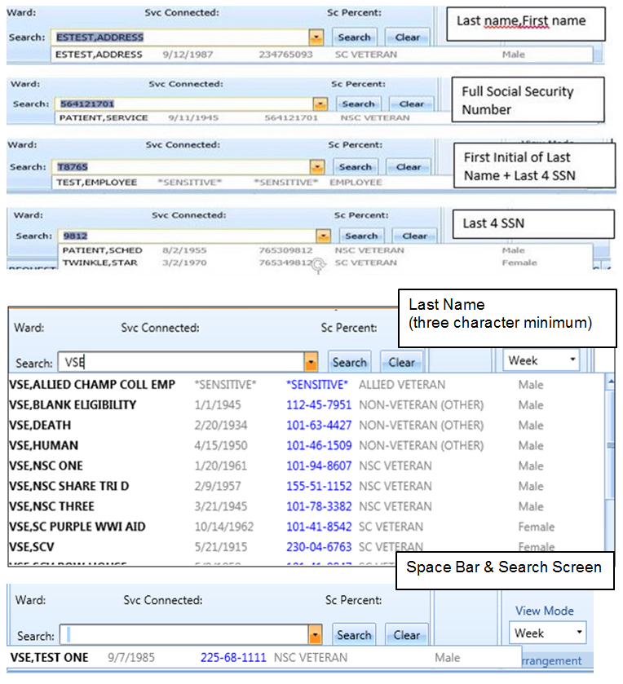

Figure 9: Patient Search

## Filtering

Filtering can be accomplished in a number of areas of the VS GUI. Items that can be filtered are:

1. Lists
2. Time Period
3. Facility

The following sections describe basic filtering.

### Filtering Lists

You can filter any column on the request grid to narrow the type of information that you want to view. In the request grid, click any column that shows a filter icon, and then select a filter option.

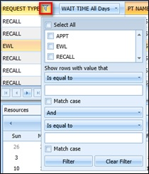

Figure 10: Filtering Lists

### Paging Through Records

Filtered results are retrieved from the database and displayed in 25 row increments. To view additional records, use the arrow key located below the list to page through the records.

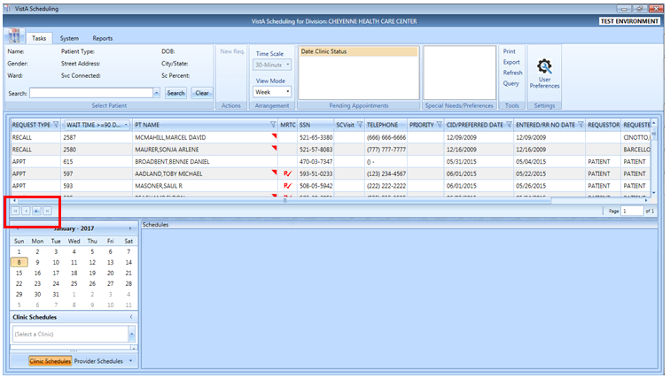

Figure 11: Paging Through Records

### Filtering by Facility or Clinic

To filter by facility or clinic, in the Clinic Schedules pane, type in the name of the desired clinic (six character minimum when searching by clinic name; four character minimum when searching by clinic abbreviation) and then choose the desired clinic to view by clicking the clinic name from the drop down menu.

VS GUI Filtering by Facility or Clinic window

Figure 12: Filtering by Facility/Clinic

### Filtering by Time Period

To filter by time period, in the Resources pane, search for and select a desired clinic and then use the calendar to select a month and day for viewing appointments. Clicking the back and forward arrows moves to the previous or next month respectively.

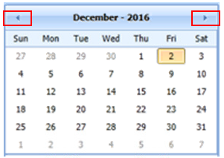

Figure 13: Filtering by Time Period

## Sorting

You can sort the consolidated list of requests in the request grid in different ways to isolate the information that you need to see.

### Sorting by Column

You can sort the consolidated list of requests in ascending or descending order. The default sort is by Priority Group, Service Connected priority, Preferred Appointment date, and Date entered (Request date).

**Note:** A user can override the default sort by setting and saving their preferred sort order (refer to Section 4.9).

Perform the following procedure to sort by column.

1. Log on to VS GUI.
2. Click any of the column headers to change the sort order.

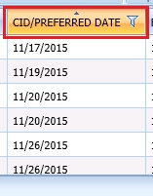

Figure 14: Sorting by Column

1. Click on the column header again to return to the default sort order.

## Printing and Exporting a Request Management Grid

### Printing a Request Management Grid

The VS GUI also allows for printing of a Request Management Grid. Use the following procedure to print a request grid.

**Note:** Only requests downloaded on Request Management Grid will print.

1. On the Ribbon Bar, in the Tools section, select the **Print** option.

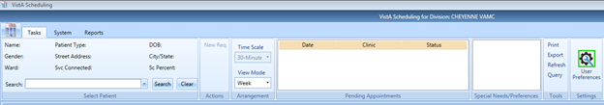

Figure 15: Selecting the Print Option

1. Select the desired printer and click **Print**.

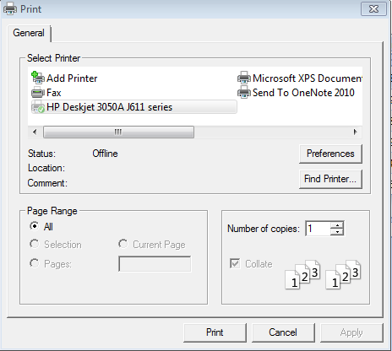

Figure 16: Selecting a Printer

### Exporting a Grid

The VS GUI also allows for exporting of a Request Management Grid in Microsoft Excel format. Use the following procedure to export a schedule.

1. On the Ribbon Bar, in the Tools section, select the **Export** option.

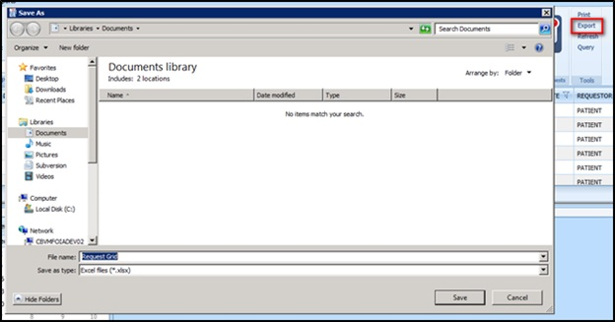

Figure 17: Exporting a Grid

1. In the **Save As** dialog box, type a file name, select a file type, browse to the location where you want to save the information, and then click **Save**.
2. Open the file and review the contents. All data displayed in the Request Management Grid is saved.

**Note:** Only data that was loaded on screen at the time of export will be exported to the file. Users may need to load more screens to see all of the data.

## Viewing

### View Only Mode

A View Only mode is available for non-scheduling personnel. To provide this mode to a user, need the option SDECRPC and the SDECVIEW security key must be assigned to the user. This mode allows users to view data in VS GUI but no changes or edits will be allowed. This key overrides other VS GUI keys and assigns the user to View Only of the Task Tab.

Information available for viewing include:

* All Pending Requests
* Previously scheduled appointments
* Clinic with appointment scheduled for day and week
* Provider with appointments scheduled for day
* Clinic Group with appointments scheduled for day
* Patient demographics and special needs/preferences

### Viewing Requests by Request Type

A Scheduler can view requests for Veteran Appointments (APPT) requests—Consults, Procedure, Veteran, Patient-Centered Scheduling reminders, or EWL reminders. The default view is for requests that are 90 days or older. A user can change the view for a particular session or change the default view by changing their user preferences (refer to Section 4.9).

Use the following procedure to view requests by request type. Requests display 25 records at a time. Additional requests can be viewed by paging to the next page.

1. Log on to VS GUI.
2. View the request grid. Consult, APPT, EWL, Procedure, Veteran, and Patient-Centered Scheduling requests that have a wait time of 90 days or more will appear in the grid. The preferred date for the patient request type is shown in the **CID/Preferred Date** column.

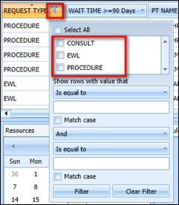

Figure 18: Request Type Column

1. Click the **Request Type** column to filter specific requests. Only request types that are in the current request grid display in the filter tool.
2. Select **EWL** to view the Electronic Wait List requests.
3. Select **APPT** to view appointment requests.
4. Select **Patient-Centered Scheduling** to view Patient-Centered Scheduling requests.
5. Select **Procedure** to view procedure requests.
6. Select **Consult** to view consultation requests.
7. Or any combination of the above.

### Viewing Requests by Patient

Use the following procedure to view requests by patient.

1. Log on to VS GUI.
2. In the **Tasks** tab display, in the **Search** text box, type the patient’s last name or patient’s first initial of last name, last four of SSN (e.g. S1234), etc., click the **Search** button, and select the requested patient name. Click **Search**.

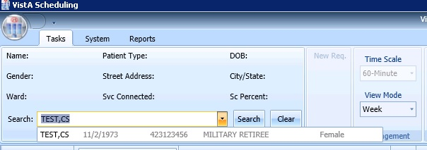

Figure 19: Select Patient

1. In the **Request Type** dialog box select either **APPT** or **PATIENT-CENTERED SCHEDULING** and click **OK** or click **Cancel**.

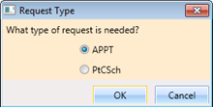

Figure 20: Request Type

The patient’s pending requests are displayed in the Request Management Grid 25 records at a time. Booked appointments are displayed in the Pending Appointments window in the Ribbon Bar of the **Tasks** tab.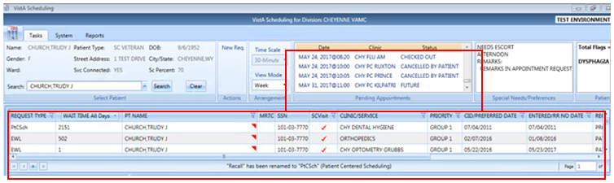

Figure 21: Patient Pending Requests and Booked Appointments

### Changing the Schedule View

The default schedule view for displaying clinic schedule grids is by week, but the view can be changed to day or month view for ease of scheduling. Use the following steps to change the schedule view.

1. Log on to VS GUI.
2. Search and select a Clinic to open.
3. In the Arrangement section, click on the **View Mode** pull-down menu and select:

* Day
* Week
* Month

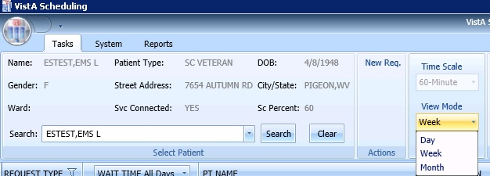

Figure 22: View Mode

1. A view for a specific schedule can be changed at the top of the Schedules section by clicking on the button that reflects the desired view. The available views from the schedule include:

* Day
* Week
* Month
* Timeline

See the timeline view display below.

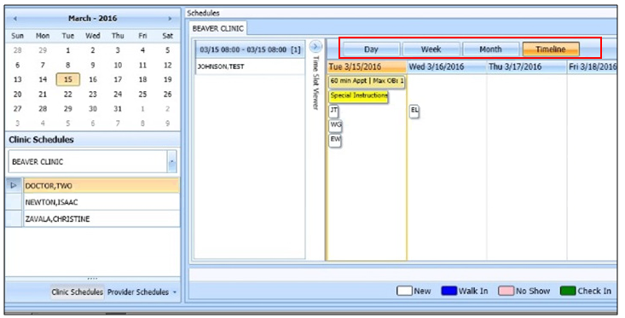

Figure 23: Changing View of a Specific Schedule

# Ribbon Bar

The following section outlines the features available in the Ribbon Bar of Schedule Manager. Note the Ribbon Bar is located in the uppermost window of the screen and launches when a patient is searched for and selected.

## Patients Demographics

### Finding a Patient

1. Log on to VS GUI.
2. In the **Tasks** tab display, in the **Search** text box, type the patient’s last name or patient’s first initial of last name and last four of SSN (e.g. S1234), click the **Search** button, and select the requested patient name. Click **Search**.
3. Select the requested patient name from drop down list.

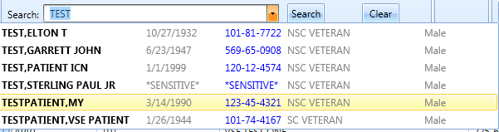

Figure 24: Search Patient

### Viewing Patient Demographics in the Ribbon Bar

You can view basic patient demographic information in the Ribbon Bar; it provides a limited amount of patient information, but you can choose to display more patient details. Use the following steps to view patient demographics in the Ribbon Bar.

1. Log on to VS GUI.
2. In the **Tasks** tab display, in the **Search** text box, type the patient’s last name or patient’s first initial of last name and last four of SSN (e.g. S1234), click the **Search** button, and select the requested patient name. Click **Search**.
3. In **Request Type** dialog, click **Cancel**.
4. View the patient demographics in the Ribbon Bar. The following patient demographics are available:
   * **Name:** Last name,First name
   * **Patient Type:** VA patient type
   * **DOB:** Date of birth in mm/dd/yyyy format
   * **Gender:** Male (M) or female (F)
   * **Street Address:** Patient’s street address
   * **City/State:** Patient’s address city and state
   * **Ward:** For inpatients, current ward location display
   * **Svc Connected:** Is the patient service connected (YES or NO)
   * **Sc Percent:** Percent of service connected disability

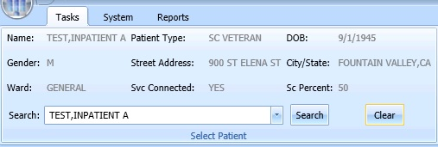

Figure 25: Patient Demographics in the Ribbon Bar

1. Click anywhere in the Select Patient section of the screen to view the Patient Inquiry Detail screen. This allows for viewing of additional patient information.

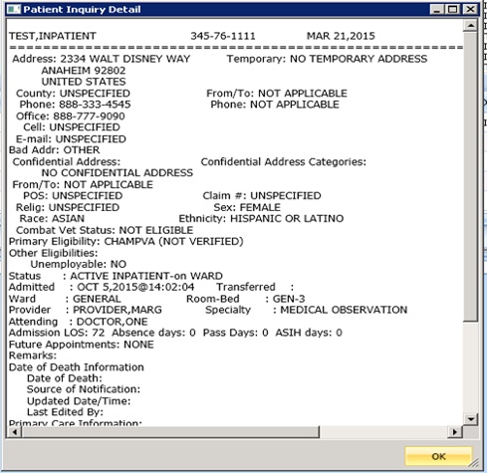

Figure 26: Patient Inquiry Detail

### Patient Eligibility Information

When adding a new Patient-Centered Scheduling or APPT request, a **Patient’s Eligibility Information** window displays along with the **New Appointment** dialog. The user can move the **Patient’s Eligibility Information** window around the screen, for convenience.

The window includes:

1. SC Percent
2. Current Disabilities
3. Primary and Secondary Eligibility Codes

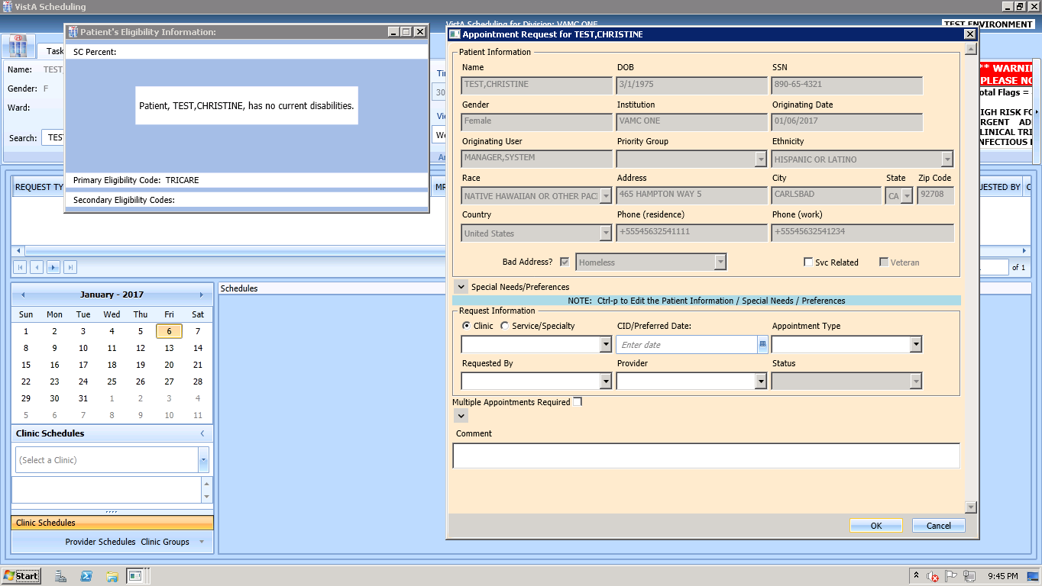

Figure 27: Patient's Eligibility Information

When the **New Appointment** dialog is closed, the **Patient Eligibility Information** window closes automatically.

### Updating Patient Demographics

Patient demographic information, such as ethnicity, race, address, state, ZIP code, country, or phone numbers that were not defined during registration, can be updated at any time during the process. Perform the following procedure to update patient demographic data.

1. Log on to VS GUI as a Scheduler.
2. In the **Tasks** tab display, in the **Search** text box, type the patient’s last name or patient’s first initial of last name and last four of SSN (e.g. S1234), click the **Search** button, and select the requested patient name. Click **Search**.
3. In the **Request Type** dialog box, click **Cancel**.



Figure 28: Request Type–APPT

1. Patient demographic information can now be displayed and edited at any point in the process by entering **Ctrl + P** to bring up the Patient Info screen. Undefined patient demographic information displays in empty drop down boxes and text field, in the Patient Information section. Information that is not editable displays dimmed.

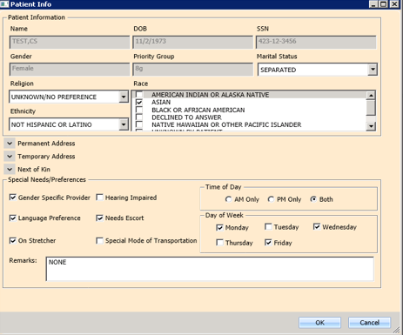

Figure 29: Patient Information Dialog

1. Click **OK** to update patient demographics. At this point the updated information displays in Ribbon Bar.
2. Click **Cancel** to go back to the all patients view.

**Note:** If the patient is being edited in VistA Register a Patient or Load/Edit Patient Data and the user attempts to save edits made to the Patient Info data, a “Patient is being edited” warning pop-up will appear and the user must click OK and Cancel to get out of the Patient Info screen until the VistA Register a Patient or Load/Edit Patient Data option is exited.

Patient is Being Edited Warning Pop-up

Figure 30: Patient is Being Edited Warning Pop-up

### Editing Permanent Address

Permanent address for a patient may be edited via the **Patient Info Dialog** screen and is available at any point via the RM Grid. View the patient information by entering **Ctrl + P**.

A user can update the patient’s address Line 1 and 2, Zip Code, and Phone Numbers.

* Zip Code – five or nine digits (when entered, the system provides choices for Cities that match that zip code and based on that, automatically completes the State and County fields).
* For Phone numbers, VS GUI automatically formats the Patient Work Phone to (xxx) xxx-xxxx if 10 digits are entered. If more than 10 digits are entered, it auto formats to x-xxx-xxx-xxxx x….  
  Only characters (,), +, -, and X (Except Cell and Pager) are allowed in the Phone Numbers.

Click **OK** when complete to save the information.

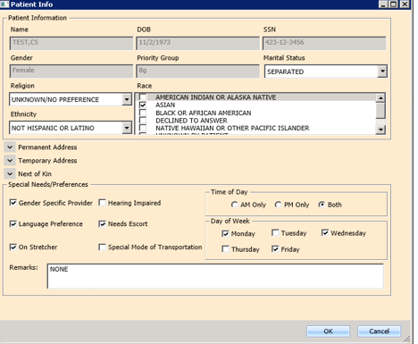

Figure 31: Patient Info Dialog–Permanent Address

**Note:** Areas shadowed in grey cannot be edited.

### Adding a Temporary Address

Temporary address for a patient may be entered via the **Patient Info Dialog** screen available at any point in the RM Grid by entering **Ctrl + P**.

The Address Active? Box should be checked with a Start Date and End Date (if known).

A user can update the patient’s address Lines 1 – 2 and Zip Code.

Zip Code – five or nine digits (when entered, the system provides choices for Cities that match that zip code and based on that, automatically completes the State and County fields).

Click **OK** when complete to save the information.

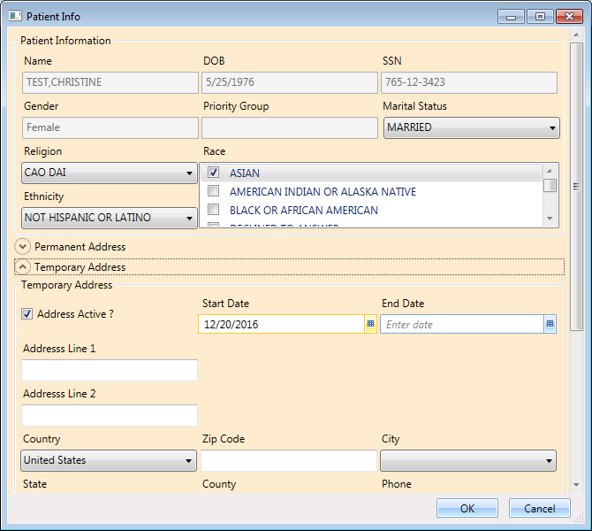

Figure 32: Patient Info Dialog – Temporary Address

**Note:** Areas shadowed in grey cannot be edited.

### Marking for Bad Address

A patient’s address may be incorrect (e.g., mail has been returned as undeliverable, or if the patient is homeless). If you learn that a patient’s address is incorrect, you must indicate that information on the patient record so notices are no longer sent. The bad address can be indicated while updating the patient’s address information in the Patient Info dialog.

1. Log on to VS GUI as a Scheduler.
2. In the **Tasks** tab display, in the **Search** text box, type the patient’s last name or patient’s first initial of last name and last four of SSN (e.g. S1234), click the **Search** button, and select the requested patient name. Click **Search**.



Figure 33: Select Patient

1. In the **Request Type** dialog box, click **Cancel**.



Figure 34: Request Type

1. Enter **Ctrl + P** to pull up the Patient Information dialog box. Confirm that the patient’s address information is incorrect or missing, and then check the Bad Address check box.

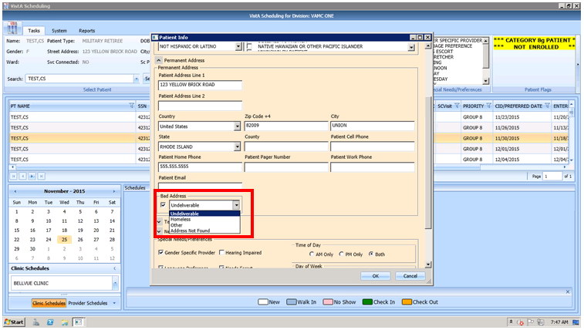

Figure 35: Appointment Request Dialog—Bad Address Selection

1. Choose the reason for the bad address:
   1. Undeliverable
   2. Homeless
   3. Other
   4. Address Not Found
2. Click **OK**.

## Actions

### New Request

After searching for and accessing a specified patient’s demographics and associated pending appointments, the Action pane allows you to create a new request for the patient. For example, creating a Patient-Centered Scheduling request as a follow-up to an appointment request or creating a new appointment request after looking at only patient information.

To start a new request for an already selected patient, use the following steps:

1. Patient demographics and pending appointments appear in the Ribbon Bar. In the Actions pane, select **New Request**.

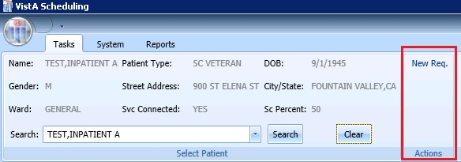

Figure 36: Actions Pane

1. The Request Type dialog box appears, allowing you to create a new request.



Figure 37: Request Type – APPT

## Arrangement

### View Mode

Refer to Section 3.8.4for changing the arrangement of the default calendar view.

## Pending Appointment Window

The Pending Appointment Window displays a patient’s already booked appointments. The appointment view defaults to the current date. The Scheduler can utilize the scroll bar to the right to scroll up to view appointments 365 days in the past. Or, the Scheduler can utilize the scroll bar to scroll down to view appointments 365 days in the future.

Selecting an appointment from the Pending Appointment window in the Ribbon Bar opens the Clinic Schedule Grid. When you select a past appointment, the clinic schedule defaults to the appointment.

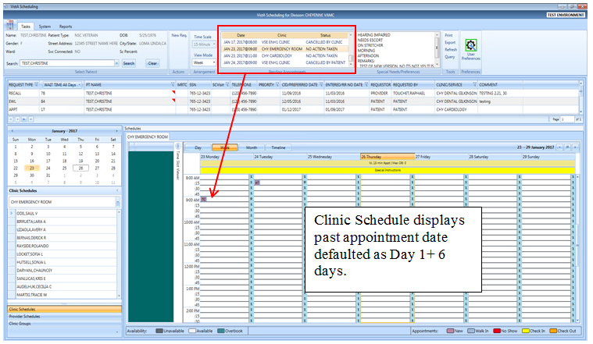

Figure 38: Pending Appointment Window – Past Appointment Date

The clinic schedule defaults to current (today’s date) when you select an appointment dated “today” or less than three days in the future.

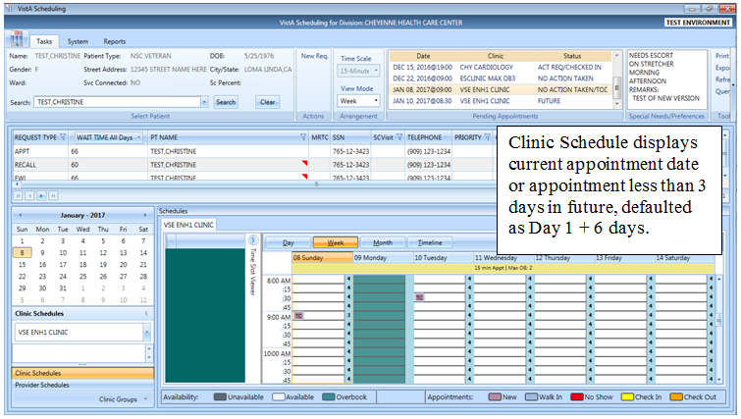

Figure 39: Pending Appointment Window – Current less than Three Days in Future

The clinic schedule defaults to -/+ three days of the appointment date for future dates.

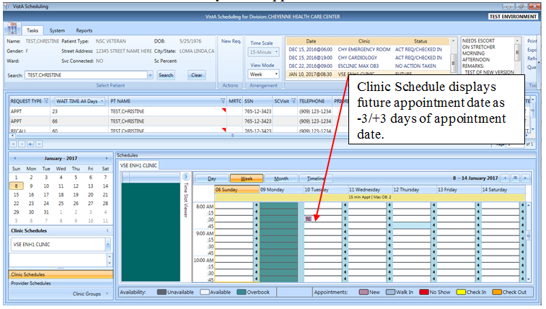

Figure 40: Pending Appointment Window – Future Appointment Dates

## Special Needs/Preferences

### Adding/Removing Special Needs/Preferences from Requests

Patients visiting the VA may require additional assistance when they arrive for their visit. Some of these special needs/preferences may include issues with hearing, how they are arriving at the VA, Day of the Week or Time of the Day etc.

To add Special Needs/Preferences to an appointment request, perform the following:

1. Log on to VS GUI
2. In the **Tasks** tab display, in the **Search** text box, type the patient’s last name or patient’s first initial of last name and last four of SSN (e.g. S1234), click the **Search** button, and select the requested patient name. Click **Search**.
3. In the Request Type dialog box, click **Cancel**.



Figure 41: Request Type – APPT

1. Enter **Ctrl + P** to select the Patient Info dialog.
2. Select the patient’s special needs from the Special Needs/Preferences section of the Patient Info dialog box.
3. Add additional information regarding patient’s Special Needs/Preferences selections in the Remarks field.

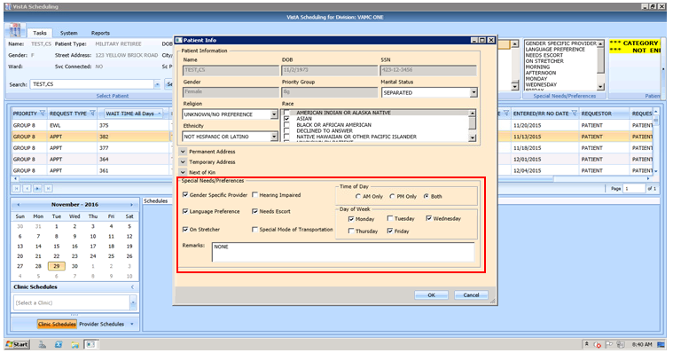

Figure 42: Patient Info Dialog – Special Needs/Preferences Section

1. Click **OK**. Special Needs/Preferences entered display in the Ribbon Bar.

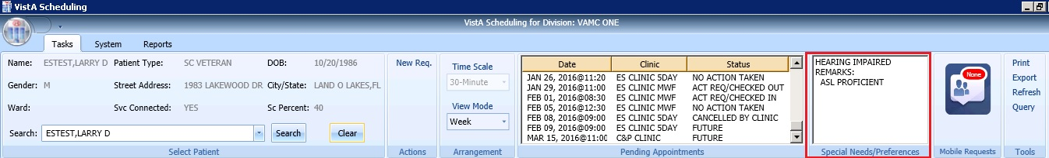

Figure 43: Ribbon Bar – Special Needs/Preferences

## Patient Flags

PRFs are used to alert VHA medical staff and employees of patients whose behavior and characteristics may pose a threat either to their safety, the safety of other patients, themselves, or compromise the delivery of quality health care. PRF assignments are displayed during the patient look-up process.

Each PRF includes a narrative that describes the reason for the flag and may include some suggested actions for users to take when they encounter the patient.

When a patient’s record is flagged, a box appears with appropriate action recommended.

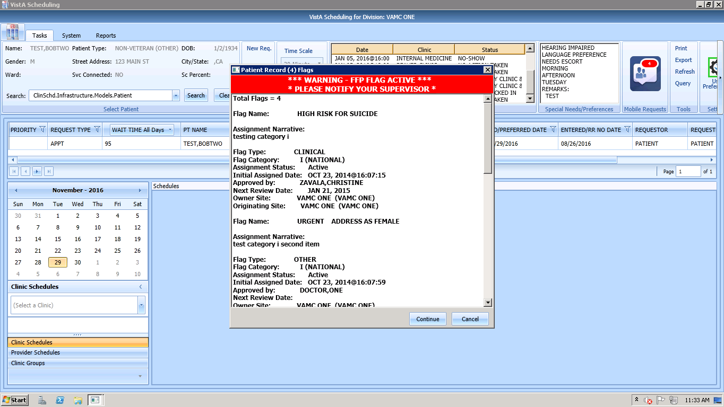

Figure 44: Patient Record Flags Dialog

After appropriate action has been taken and appointment processing is to continue, click **Continue**; otherwise, click **Cancel**.

Once processing has continued, the PRF continues to show on the Ribbon Bar.

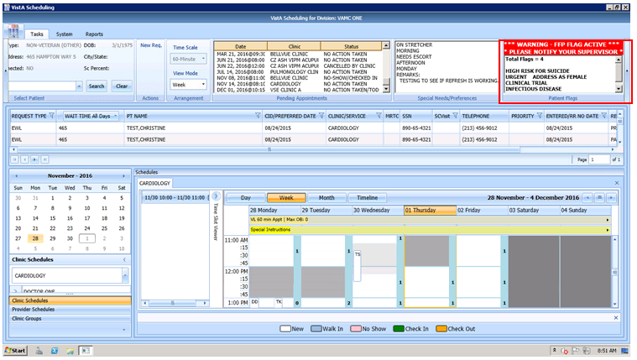

Figure 45: Patient Record Flags

## Tools

### Print

Refer to Section 3.7.1for details on using the Print functionality of the Tools Pane.

### Export

Refer to Section 3.7.2for details on exporting the request grid.

### Refresh

After checking a patients pending appointments or checking availability for a clinic, you may want to reset the GUI back to the default view from when you first logon to the GUI, clearing all text entered in any fields.

To refresh the GUI, in the Tools pane, click **Refresh**. The GUI resets to its default logon view.

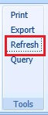

Figure 46: Refresh Button in Tools Pane

### Query

In order to sift through patient data and only view data of a specific type, the Query tool can be utilized to show only data matching specific criteria. Once the query has been performed, only records matching the query criteria appear in the request grid.

* Patients are in **Group A** and can be used independently or in conjunction with other search criteria.
* Request Type + Clinic/Services are in **Group B**. This group can be used independently or in conjunction with other search criteria.
* Priority, Wait Time, SCVisit, Service Connected, Origination Date, CID/Preferred Date and Urgency are in **Group C**. This group must be combined with other search criteria from either Group A, Group B, or Group A and B to satisfy the Query Tool business rules.

To perform a query, use the following footsteps:

1. Log on to VS GUI.
2. Select **Query** from the **Tools** pane. The **Request Query** window displays.

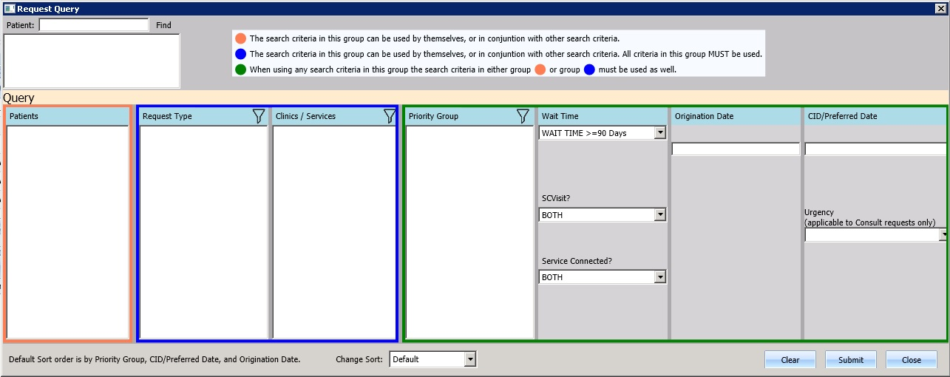

**Group A**

**Group C**

**Group B**

Figure 47: Request Query

Click **Submit**. If the search criteria rules are not satisfied, a **Query Rule Validation** dialog box displays.

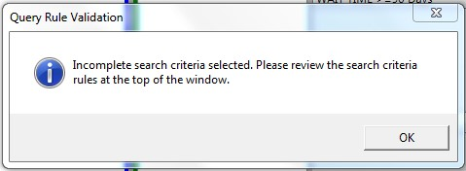

Figure 48: Query Rule Validation

Once all search criteria has been selected and the results have been returned, a **Request Query Confirmation** dialog displays indicating how many records were found that satisfied the search criteria.

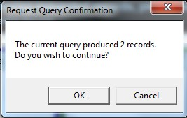

Figure 49: Request Query Rule Confirmation

1. Click **OK** to display the Query results in the Request Management Grid.
2. Click **Cancel** to remove search criteria and start a new search.

## Settings – User Preferences

A user may now set their own column preferences within a session or as their default view.

From the far right of the Ribbon Bar, select the User Preferences setting icon.

Current Column order is:

Request Type;

Wait Time;

Patient (PT) Name;

Multiple Return To Clinic (MRTC);

SSN;

SC Visit;

Telephone;

Priority;

CID/PreferredDate;

Entered/RR No Date;

Requestor;

Requested By;

Clinic/Service; and

Comment.

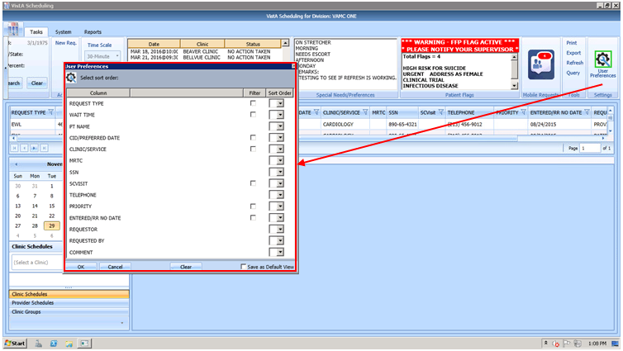

Figure 50: Settings – User Preferences

Filters on the following fields are also available:

* Request Time
* Wait Time
* CID/Preferred Date
* Clinic/Service
* SC Visit
* Priority
* Entered/RR No Date

To save your user preferences:

* Select the sort order or filters to display.
* If you would like to save the selections as your default view, select “Save as Default View” on the bottom right. If you do not select “Save as Default View,” your selections will only be applicable to your current session.
* Select OK to save.

**NOTE:** If you filter the requests to view only Consult requests you will not see the PtCSch requests unless you unfilter the preferences.

The User Preferences Settings icon displays with green highlight indicating user preferences have been stored.

To remove any existing user preferences for the user’s default view:

* Click on the User Preferences icon.
* In the User Preferences window, click **Clear** then click **OK** to save.

The User Preferences Settings icon will now display without green highlight when no user preferences have been stored.

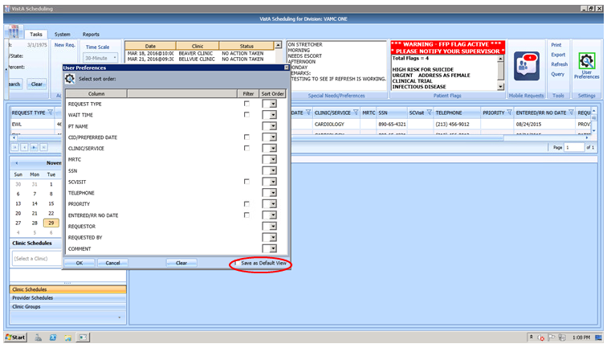

Figure 51: Settings – Save as Default View

# Request Management

## Request Management Procedures

### Viewing a Patient’s Existing Requests

1. Log on to VS GUI.
2. In the **Tasks** tab display, in the **Search** text box, type the patient’s last name or patient’s first initial of last name and last four of SSN (e.g. S1234), click the **Search** button, and select the requested patient name.
3. Click **Search**.
4. Select the requested patient name from drop down list.
5. In the **Request Type** dialog box, click **Cancel**.



Figure 52: Request Type

1. In the Request Management grid, view the existing requests for the selected patient. Patient’s booked appointments display in Pending Appointment Window in the Ribbon Bar defaulted to current date. Schedulers can scroll up or down to view appointments dated -/+365 days of current date.

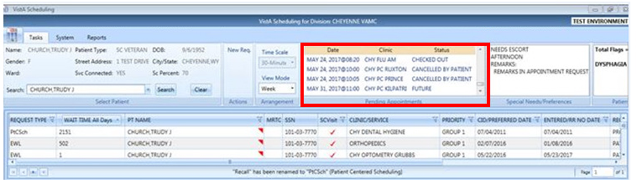

Figure 53: Request Grid and Pending Appointments

1. Right Click on an appointment in the Pending Appointments block and the EXPAND ENTRY block opens.

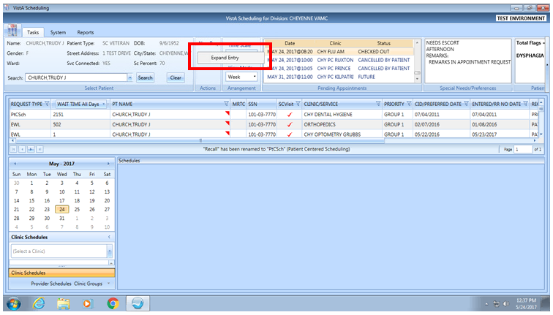

Figure 54: Request Grid Displaying Expand Entry Block

Left click on the Expand Entry block to see expanded appointment information.

* Appointment Demographics
* Appointment Event Log
* Appointment Wait Time
* Patient Information
* Encounter Information (this information will only display if the encounter information has been entered for this patient)

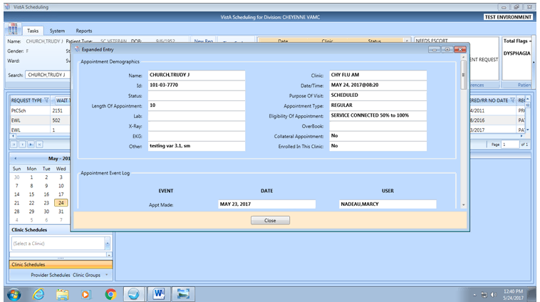

Figure 55: Appointment Demographics

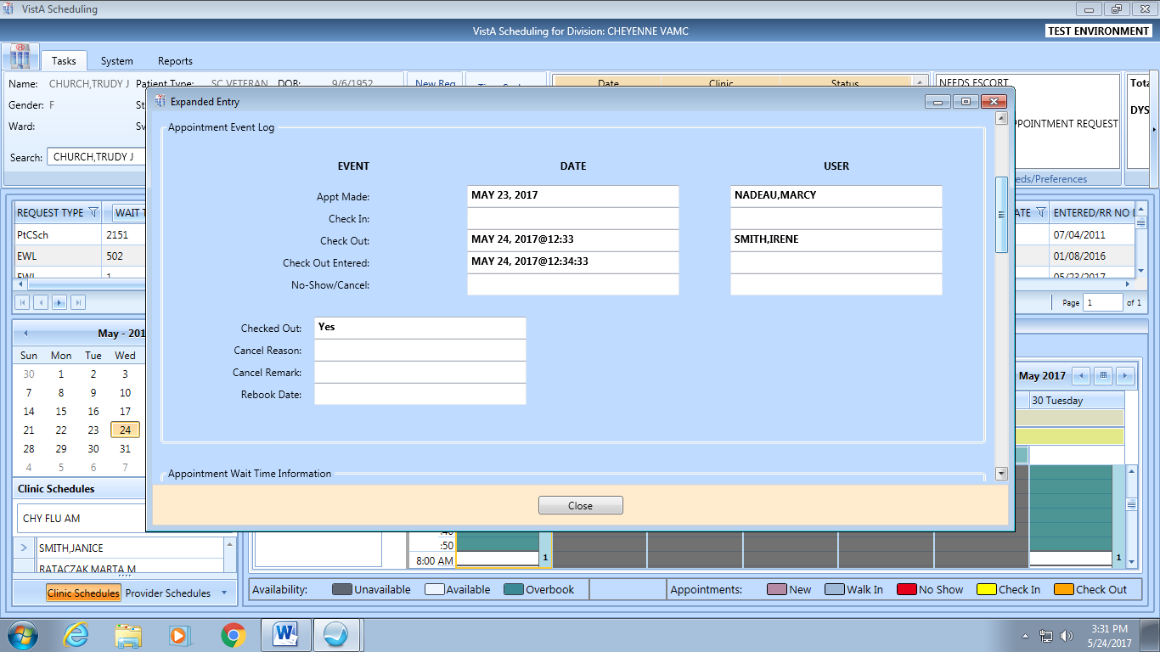

Figure 56: Appointment Event Log

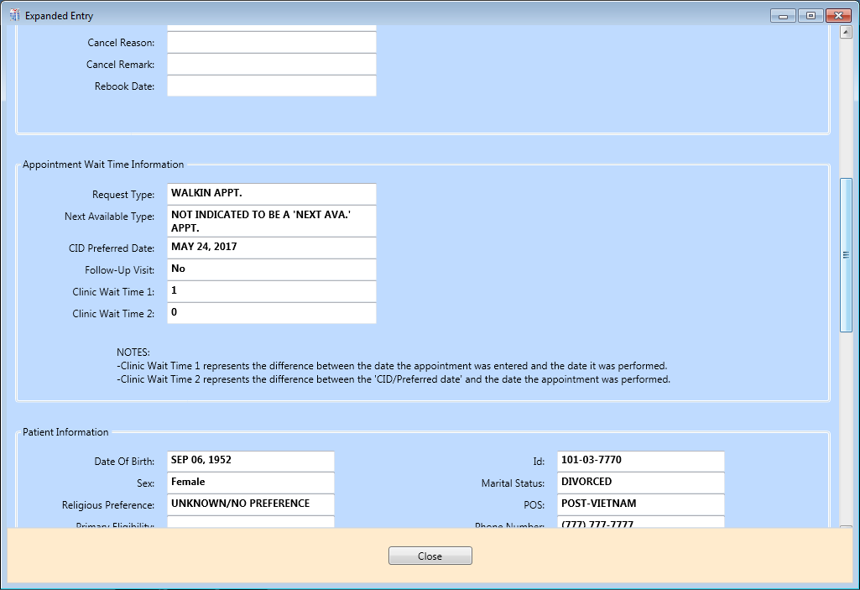

Figure 57: Appointment Wait Time

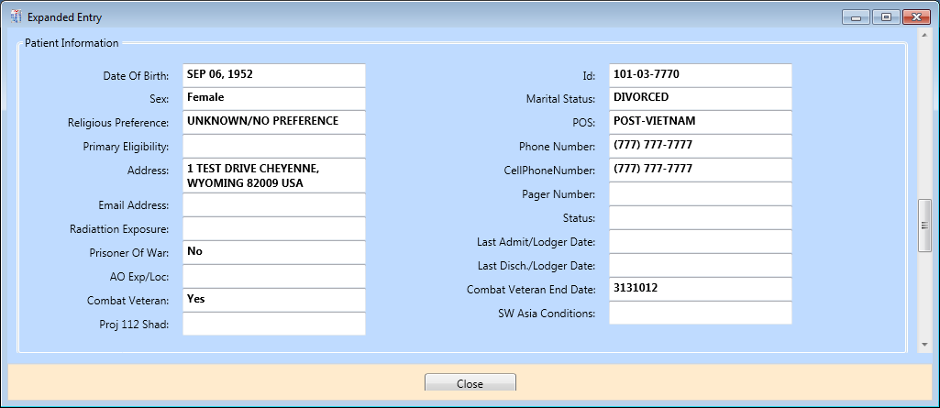

Figure 58: Patient Information

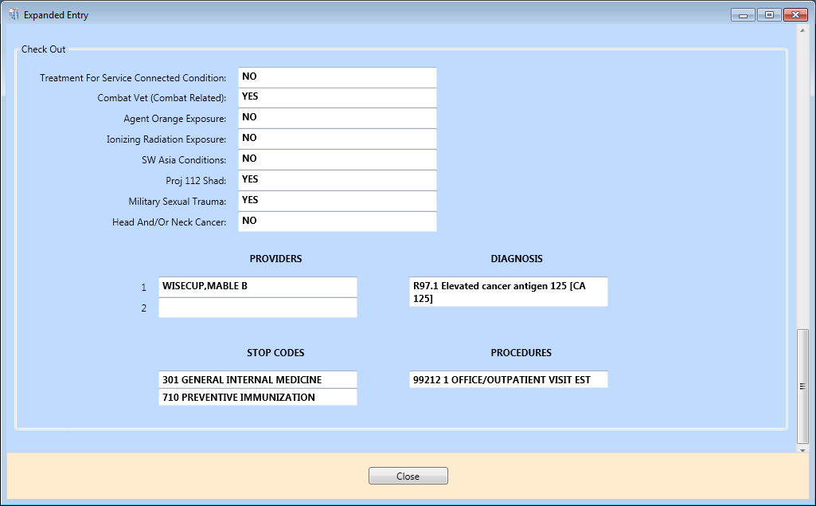

Figure 59: Encounter Information

**Note:** This information will only display if the encounter information has been entered for this patient.

### Adding Appointment Request

1. To submit an appointment request, from **Tasks** tab search for the patient using the Search field.
2. Select **APPT** in the **Request Type** dialog.



Figure 60: Request Type - APPT

**Note:** If the patient has already been selected, the **Request Type** dialog can be accessed by clicking **New Req.** in the Actions Pane of the Ribbon Bar.

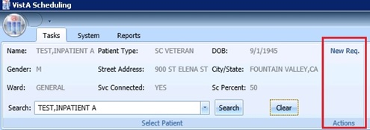

Figure 61: Actions Pane—New Req. Selection

1. In the **Appointment Request** dialog box, confirm Patient Information details.
2. In the **Appointment Request** dialog box, complete the **Request Information** section.
3. Select **Clinic** or **Service/Specialty** radio button. For Clinic, enter clinic name (minimum of six characters) or Clinic abbreviation. For Service/Specialty enter service or specialty (minimum of six characters required).

* Enter **CID/Preferred Date** for the preferred appointment/Patient-Centered Scheduling date. Enter date directly or select date from Calendar control option. CID/Preferred Date can be past, current, or future.
* Select **Appointment Type** if not defaulted by patient eligibility and clinic selection then choose from drop down list.
* In **Request By**, select either Provider or Patient.
* If **Provider** selected, then enter provider name (three character minimum for drop down to populate) and select from list.   
  **Note:** If Patient was selected in Request By field, then Provider field is dimmed and not editable.
* **Status** is automatically populated.

1. Established – The patient has been seen at that clinic in the past 24 months.
2. New – The patient has not been seen at that clinic in the past 24 months.

* Refer to Section 6.3.2  for additional instructions regarding Multiple Appointment Requiredcheck box options.

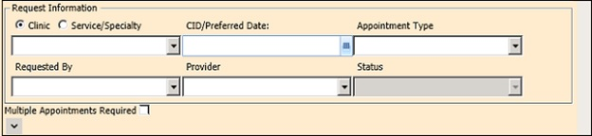

Figure 62: Appointment Request Dialog – Request Information Section

1. If needed, in the **Patient Info (Ctrl + P)** dialog box, complete the **Special Needs/ Preference** section. **Remark**s field is available to add clarifying information regarding selections made. **Selected Special Needs/Preferences** and **Remarks** display in the Ribbon Bar.
2. Text can be added in the **Remarks** field up to 80 characters to add information regarding Appointment Request. Text displays in Request Management Grid under Comment column.
3. Click **OK**. Updated demographics display in ribbon bar. The APPT Request appears on Request Management grid. Clinic Schedule Grid opens for clinic specified in request.

**Note:** APPT Requests with Comments are flagged with a red arrow in the Request Management Grid.

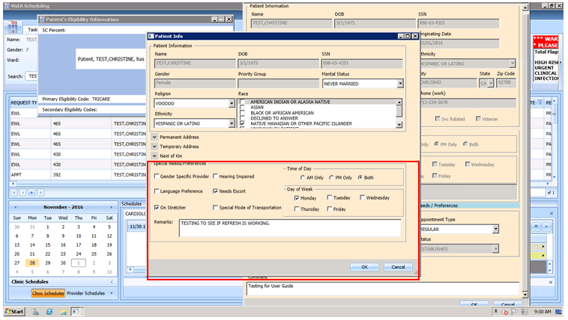

Figure 63: Special Needs/Preferences Section from Patient Info Dialog

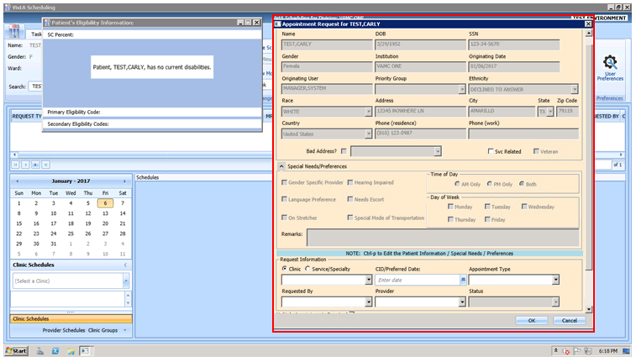

Figure 64: Appointment Request Dialog

### Viewing/Editing Appointment Request

If a request (APPT, EWL, Veteran) needs to be reviewed or modified before being booked, you can View/Edit the request in the Request Grid using the following steps:

1. Log on to VS GUI as a Scheduler.
2. In the **Tasks** tab display, in the **Search** text box, type the patient’s last name or patient’s first initial of last name and last four of SSN (e.g. S1234), click the **Search** button, and select the requested patient name. Click **Search**.
3. Select the requested patient name from dropdown list.  
   **Note:** When **Spacebar + Search** is used, the Ribbon Bar and RM Grid adjust to that selected patient.
4. In **Request Type** dialog, select **Cancel**.
5. In the **Request Management** grid, right click on the applicable **APPT** request.
6. Select APPT/VETERAN Disposition option.
7. The following options appear for selection:

* View Request
* Edit Request
* Transfer to EWL – refer to Section 5.1.5 for instructions
* Death
* Removed/Non-VA Care
* Removed/Scheduled-Assigned
* Removed/VA Contract Care
* Removed/No longer Necessary
* Entered in Error

1. Select **View Request**. The **Appointment Request** dialog box appears with everything greyed out as the dialog box is Read-Only.

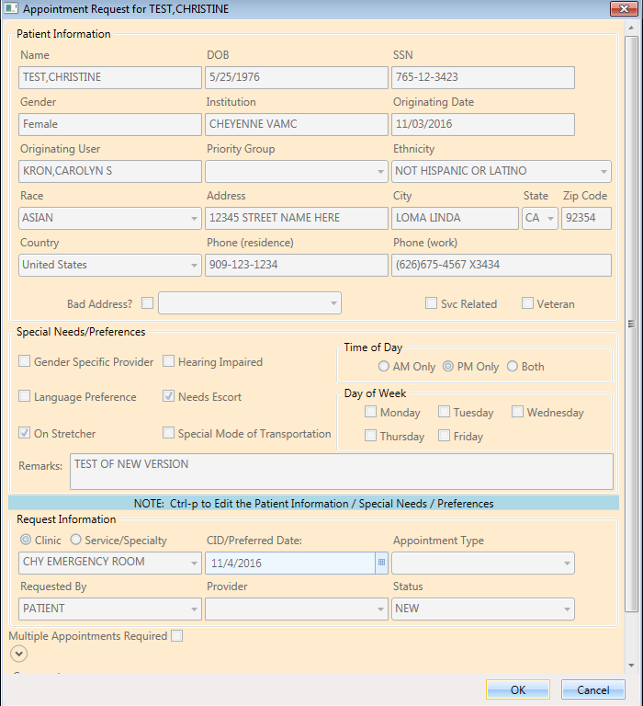

Figure 65: View Request (Read Only)

1. Click **OK**. You return to the RM Grid.
2. Right click on the applicable **APPT** request.
3. Select APPT/VETERAN Disposition option.
4. The following options appear for selection:

* View Request
* Edit Request
* Transfer to EWL – refer to Section 5.1.5 for instructions
* Death
* Removed/Non-VA Care
* Removed/Scheduled-Assigned
* Removed/VA Contract Care
* Removed/No longer Necessary
* Entered in Error

1. Select **Edit Request.** The Appointment Request and Patient’s Eligibility Information dialog displays.

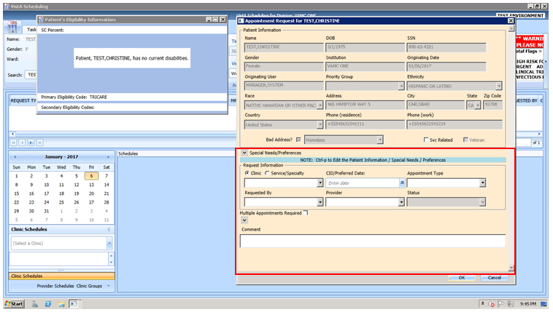

Figure 66: Edit Request (Request Information Only)

The editable fields are Clinic/Service Specialty; Appointment Type; Requested By; Provider, and Comments. CID/Preferred Date is NOT editable.

1. Click **OK**. The request returns to the RM Grid with the altered information listed.

**Note:** If you change the request for a Clinic to a Service/Specialty request, the **Appointment Type** field becomes editable. Also, changes to the **APPT Request** are tracked by the system in the SDEC APPT REQUEST file.

### Disposition or Removing an Appointment Request

If an APPT request is found to no longer be needed, Scheduler can remove from Request Grid following the steps below.

1. Log on to VS GUI as a Scheduler.
2. In the **Tasks** tab display, in the **Search** text box, type the patient’s last name or patient’s first initial of last name and last four of SSN (e.g. S1234), click the **Search** button, and select the requested patient name.
3. Click **Search**.
4. Select the requested patient name from drop down list.
5. In **Request Type** dialog, click **Cancel**.
6. In the **Request Management** grid, right click on the applicable **APPT** request.
7. Select APPT/VETERAN Disposition option.
8. The following options appear for selection:

* Transfer to EWL – refer to Section 5.1.5 for instructions
* Death
* Removed/Non-VA Care
* Removed/Scheduled-Assigned
* Removed/VA Contract Care
* Removed/No longer Necessary
* Entered in Error

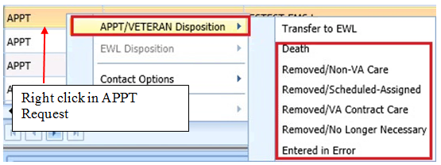

Figure 67: APPT/Veteran Disposition Options

1. Select the applicable APPT Disposition option. APPT Request is removed from Request Management Grid.

### Transfer to EWL Request for a Patient

If an appointment cannot be scheduled because of limitations, the patient is put on an EWL for future scheduling. Use the following procedures to transfer an APPT Request to an EWL Request.

1. Log on to VS GUI as a Scheduler.
2. In the **Tasks** tab display, in the **Search** text box, type the patient’s last name or patient’s first initial of last name and last four of SSN (e.g. S1234), click the **Search** button, and select the requested patient name. Click **Search**.
3. Click **Search**.
4. Select the requested patient name from drop down list.
5. In the **Request Type** dialog box, click **Cancel**.
6. In the **Request Management** grid, view the open APPT Requests for the patient.
7. Select the **APPT** request that needs transferred to **EWL**.
8. Right click the APPT request and select **APPT/VETERAN Disposition**.
9. In the APPT/VETERAN Disposition options, select **TRANSFER TO EWL**. The **EWL Request** dialog box displays.  
   **Note:** The Transfer to EWL option is not available for MRTC appointments nor is it available for users that do not have the SDWL MENU Security Key.
10. Confirm **Clinic** defaulted in dialog. If not, search for and select appropriate Wait List Clinic by name. Note that searching by clinic abbreviation is not supported in the EWL Request dialog.   
    **Note:** Clinic does not default if not designated as Wait List Clinics in SD Wait List Parameter (File #409.32).
11. **CID/Preferred** date and Status are not editable.
12. **Appointment Type** is defaulted from APPT Request. If a patient is a Veteran and the Service Related box is checked, the Appointment type defaults to Service Connected. This puts the EWL request in a higher priority than other EWL requests.
13. **Requested By** and **Provider** are populated froom the original APPT request but are editable.
14. Enter **Comments** as appropriate.
15. Click **OK**. The request grid shows requests of the selected patient. The newly added request is selected. The calendar defaults to the desired date and shows the clinic schedules.

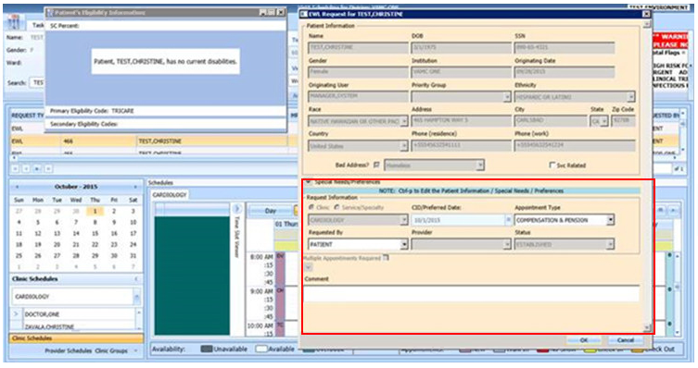

Figure 68: EWL Request Dialog

### Disposition or Removing a Patient from the EWL

If a patient is on the EWL for an appointment or a consult, and information is received that the patient no longer needs the appointment, EWL request can be removed and no longer appears in the Request Management Grid.

To disposition or remove the EWL Request, follow the below steps:

1. Log on to VS GUI as a Scheduler.
2. In the **Tasks** tab display, in the **Search** text box, type the patient’s last name or patient’s first initial of last name and last four of SSN (e.g. S1234), click the **Search** button, and select the requested patient name.
3. Click **Search**.
4. Select the requested patient name from drop down list. The patient must have an existing EWL request.
5. In the request grid, right click on the desired EWL request and select EWL Disposition.
6. The following EWL Disposition options are available for selection:

* Death
* Removed/Non-VA Care
* Removed/Scheduled-Assigned
* Removed/VA Contract Care
* Removed/No longer Necessary
* Entered in Error
* Transferred

The EWL Request is removed from the RM Grid and the next APPT Request is moved up and highlighted.

### Adding Patient-Centered Scheduling Request

Use the following procedure to add a new Patient-Centered Scheduling request for a patient.

1. Log on to VS GUI as a Scheduler.
2. In the **Tasks** tab display, in the **Search** text box, type the patient’s last name or patient’s first initial of last name and last four of SSN (e.g. S1234), click the **Search** button, and select the requested patient name. Click **Search**.
3. Click **Search**.
4. Select the requested patient name from drop down list.
5. In the **Request Type** dialog box, select **PATIENT-CENTERED SCHEDULING** and click **OK**.



Figure 69: Request Type–PATIENT-CENTERED SCHEDULING

1. Enter a **Patient-Centered Scheduling Date**. Enter the date the provider requested.
2. Enter a **Patient-Centered Scheduling Date** (per patient). Enter the date the patient prefers.
3. Enter a Patient-Centered Scheduling Appt Type.
   * Follow up
   * Consultation
   * Routine
   * Evaluation
4. Check **Fasting** if patient needs to be fasting for the appointment.
5. Enter the Length of the Appointment.
6. Select **Clinic** (Clinic can be searched by Clinic Name with 6 character minimum or by Clinic abbreviation with 4 character minimum).   
   **Note:** Clinic does not appear for selection if Patient-Centered Scheduling Reminders Letter is not defined for the clinic.
7. Select **Patient-Centered Scheduling Provider** (3 character minimum).
8. Enter a **Comment**.
9. View the **Special Needs/Preferences** window by entering **Ctrl + P** for the Patient Info dialog box and add or edit preferences as appropriate.
10. Click **OK**. The request grid shows requests of the selected patient. The newly added request is selected. The calendar defaults to the desired date and the selected clinic and defaults, and shows the clinic schedules.
11. View the **Special Needs/Preferences** window in the ribbon bar to confirm it is updated.

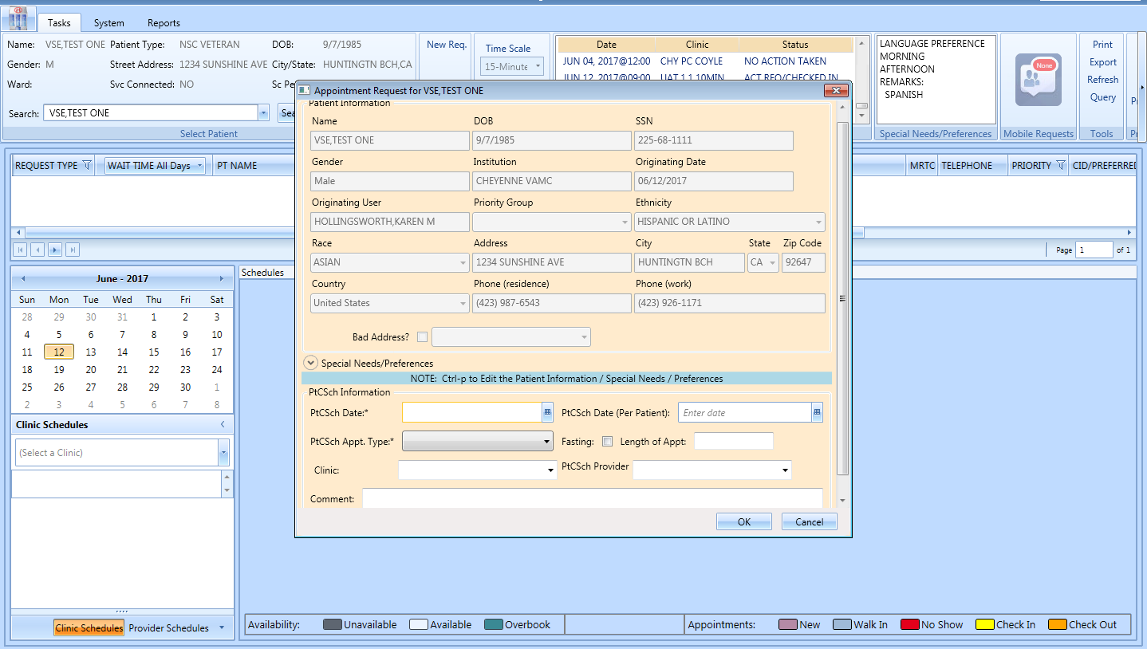

Figure 70: Patient-Centered Scheduling APPT Request Dialog

### Viewing/Editing Patient-Centered Scheduling Request

If a Patient-Centered Scheduling request needs to be reviewed or modified before being booked, you can View/Edit the request in the Request Grid using the following steps:

1. Log on to VS GUI as a Scheduler.
2. In the **Tasks** tab display, in the **Search** text box, type the patient’s last name or patient’s first initial of last name and last four of SSN (e.g. S1234), click the **Search** button, and select the requested patient name. Click **Search**.
3. Click **Search**.
4. Select the requested patient name from drop down list.  
   **Note:** When **Spacebar + Search** is used, the Ribbon Bar and RM grid adjust to that selected patient.
5. In **Request Type** dialog, select **Cancel**.
6. In the **Request Management** grid, right click on the applicable **Patient-Centered Scheduling** request.
7. Select **Patient-Centered Scheduling Disposition** option.
8. The following options appear for selection:

* View Request
* Edit Request
* Failure to respond
* Moved
* Deceased
* Doesn’t want VA services
* Received care at another VA
* Other

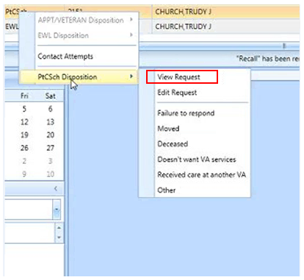

Figure 71: Patient-Centered Scheduling Disposition Dialog

1. Select **View Request**. The **Patient-Centered Scheduling Request** dialog box appears with everything greyed out as the dialog box is Read-Only.

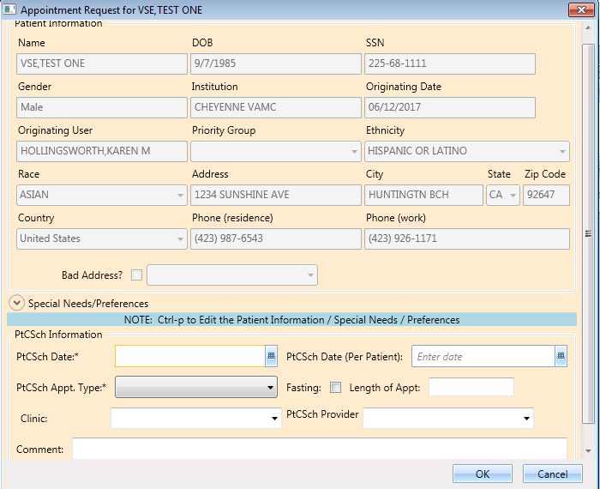

Figure 72: Patient-Centered Scheduling Appointment View Request Dialog

1. Click **OK**. You return to the RM Grid.
2. Right click on the applicable **Patient-Centered Scheduling** request.
3. Select Patient-Centered Scheduling Disposition option.
4. The following options appear for selection:

* View Request
* Edit Request
* Failure to respond
* Moved
* Deceased
* Doesn’t want VA services
* Received care at another VA
* Other

1. Select **Edit Request.** The Patient-Centered Scheduling Request dialog displays.

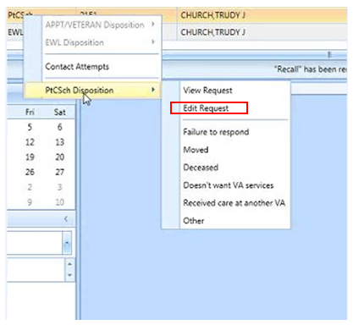

Figure 73: Patient-Centered Scheduling Disposition Dialog

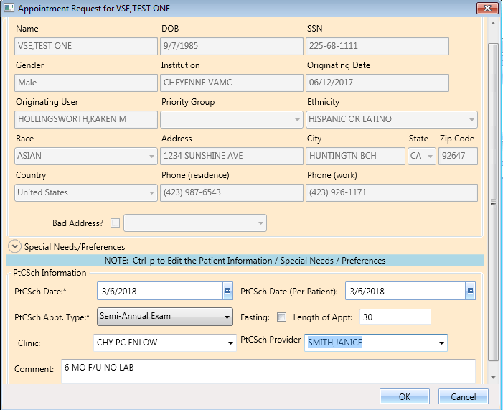

Figure 74: Patient-Centered Scheduling Appointment Edit Request Dialog

**Note:** The editable fields are PtCSch Appt. Type, Fasting, Length of Appt., Clinic, PtCSch Provider, and Comment. Note the PtCSch Date and PtCSch Date (Per Patient) are not editable.

1. Click **OK**. The request returns to the **Request Grid** with the altered information listed.

### Disposition or Remove Patient-Centered Scheduling Request

Perform the following procedure to cancel or delete a Patient-Centered Scheduling request.

1. Log on to VS GUI as a Scheduler.

In the **Tasks** tab display, in the **Search** text box, type the patient’s last name or patient’s first initial of last name and last four of SSN (e.g. S1234), click the **Search** button, and select the requested patient name.

1. Click **Search**.
2. Select the requested patient name from drop down list.
3. In the RM Grid, right click the **Patient-Centered Scheduling** request and select **PtCSch Disposition**. The following dispositions are available for selection:

* Failure to respond
* Moved
* Deceased
* Doesn’t want VA services
* Received care at another VA
* Other

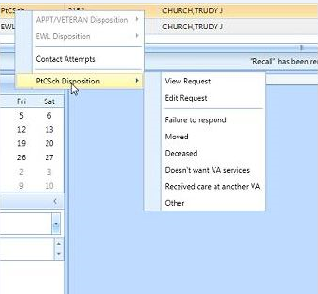

Figure 75: Patient-Centered Scheduling Disposition Options

1. From the **PtCSch Comment** dialog box, enter comments as necessary.

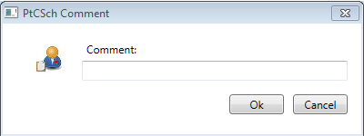

Figure 76: PtCSch Comment Comment Dialog Box

1. Click **OK**. The patient is removed from the request grid.
2. Certain dispositions will present a **Patient Contacts** message pop-up if the business rules were not met. The user can proceed to disposition the request by clicking **Yes** to acknowledge the warning.

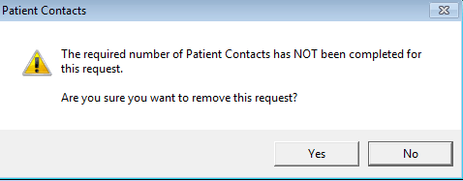

Figure 77: Warning Pop-Up If Business Rules Were Not Met

**Note** the below Request Type, Dispositions, Contact Message information.

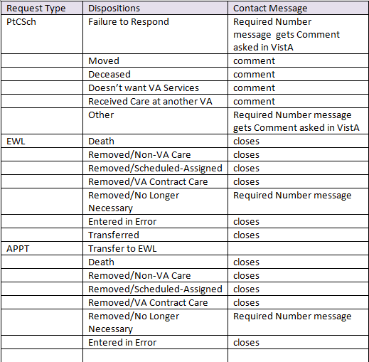

Figure 78: Request Type/Dispositions/Contact Message Reference

## Contacting a Patient

A patient may need to be contacted by phone or letter to schedule an appointment. Contact efforts can be added to the patient record for APPT and EWL requests. They are viewable in the GUI and are storedin the **SDEC APPT REQUEST file.**

### New Contact Attempt

Use the following procedure to document **New Contact Attempt** information.

1. Log on to VS GUI as a Scheduler.
2. From the **Tasks** tab display, in the **Search** text box, type the patient’s last name (or patient’s first initial of last name) and last four of SSN (e.g. S1234).
3. Click **Search**.
4. Select the requested patient name from drop down list.
5. In the Request Type dialog box, click Cancel.
6. In the request grid, right click APPT, PtCSch, or EWL request type, and then select **Contact Attempts**. The following Contact Types are available for selection:

* Call
* Letter

1. Select **Call or Letter**

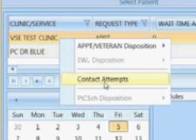

Figure 79: Contact Attemps

1. The **New Contact Attempt** dialog displays showing, Patient Name, Clinic Name, Desired Appt. Date, Request Type, and Patient phone numbers. Select Call or Letter and accept the default contact date/time (which is time the New Contact Attempt dialog was opened) or change as appropriate (can change the Date/Time to a past Date/Time to document when the contact attempt was actually made).

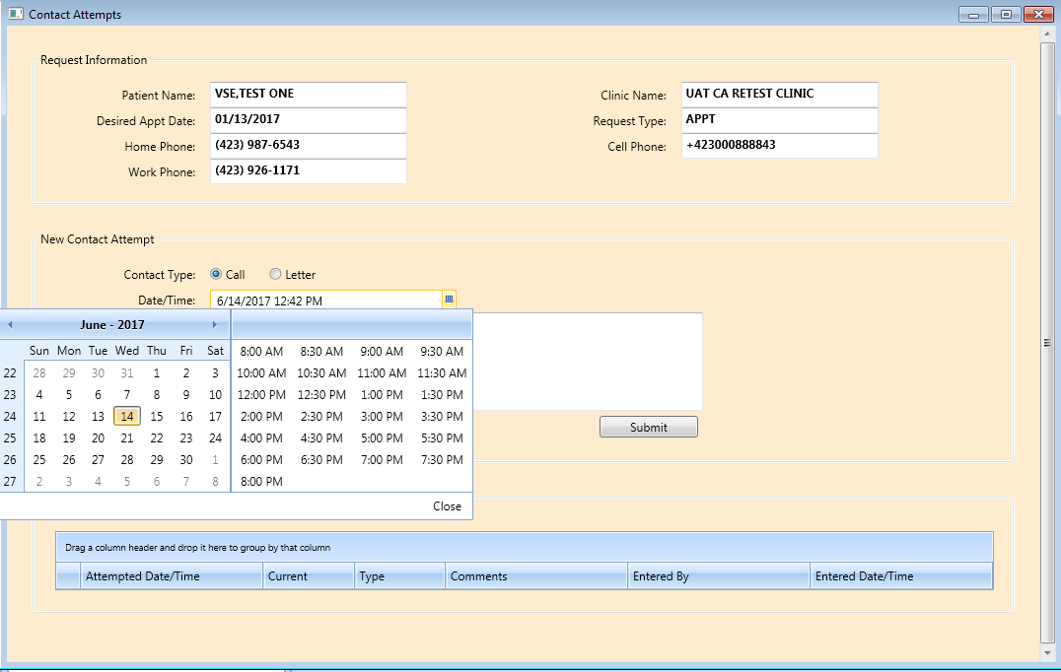

Figure 80: Patient Contact Dialog

1. Enter phone number that was contacted, if desired, and provide any appropriate information in the Comments section.
2. Click Submit to enter the Call Attempt details which will be displayed at bottom of the New Contact Attempt screen and highlighted in Green.
3. The above process can be repeated as many times as is needed to attempt to contact the patient, there is no limit to the number of attempts that can be created.

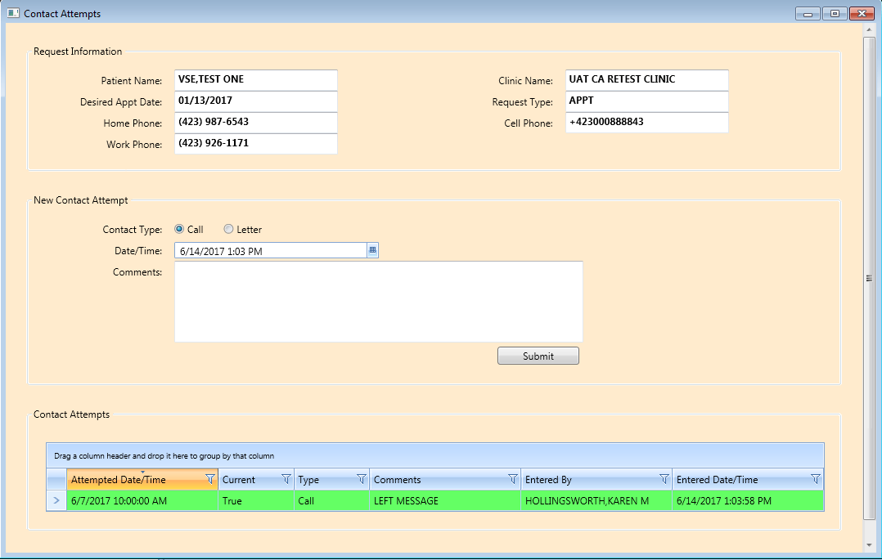

Figure 81: New Contact Attempt Submitted and Displayed

1. After adding two call attempts and a letter, the Attempted Date/Time reflects what the scheduler changed it to, the name of the person entering the contacts and the date the contact was entered are shown.

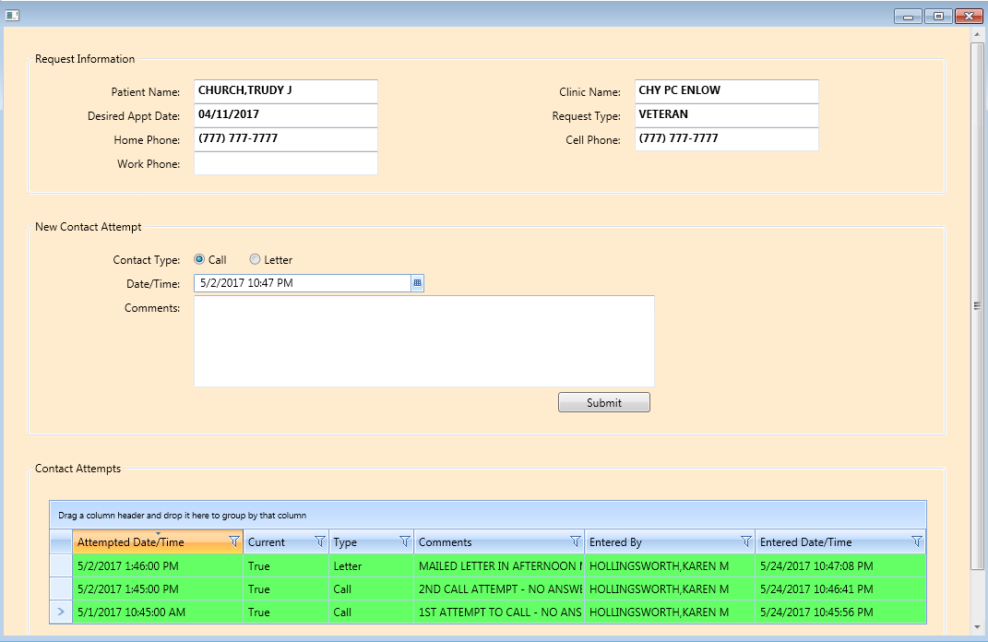

Figure 82: Displaying Name of Person Entering Contacts

1. After making an appointment the request is dispositioned and removed from the RM Grid. If the appointment is cancelled the request returns to the grid and the current field in **Contact Attempts** changes to false and is a tan color.

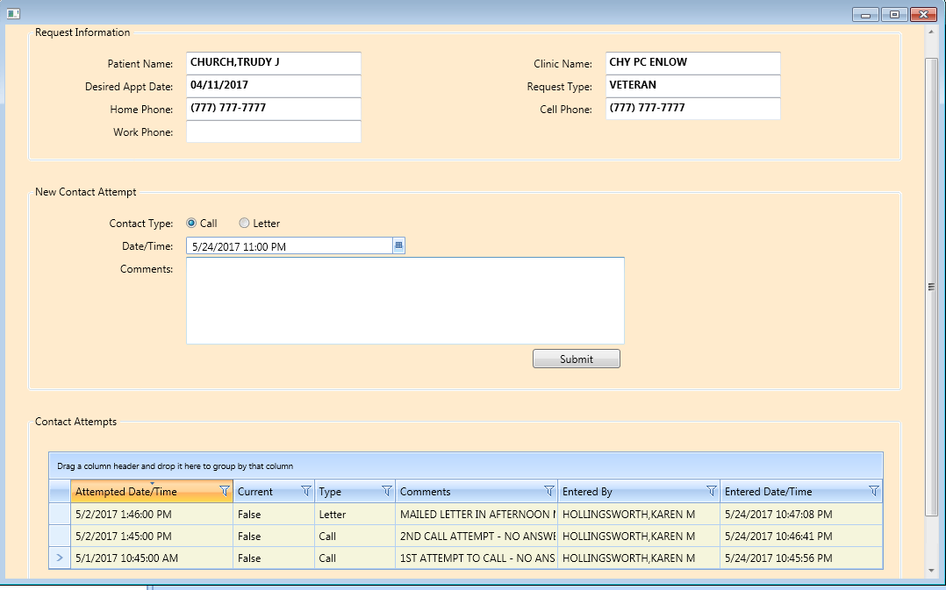

Figure 83: Appointment Canceled

1. After making a New Contact Attempt after the cancellation, the new attempt will be green and the **Current** field will be “True”.

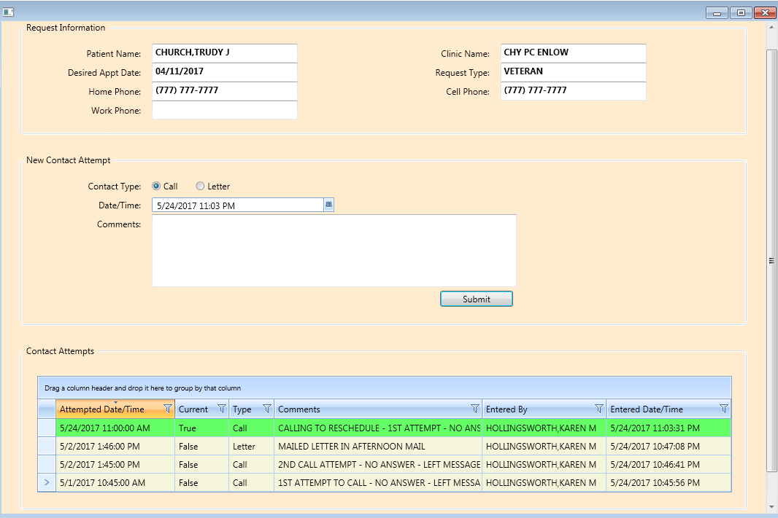

Figure 84: New Contact Attempt After Cancellation

# Appointment Management

## Adding Appointments

### Add Appointment for Appointment Request

1. Log into VS GUI as a Scheduler.
2. In the Tasks tab display, type the patient’s last name, first name in the Search text box, click Search button, and then select the requested patient name from drop down list.
3. In the **Request Type** dialog box, select **APPT** and click **OK** to create new request or click **Cancel** for existing request.

**Note:** Refer to Section 5.1.2  for steps on adding new APPT Request.



Figure 85: Request Type

1. In Request Management Grid, select **APPT** request. The Clinic Schedule Grid displays the clinic schedule based upon CID/Preferred date of request. For past dates, the clinic schedule opens defaulted to current date. For current date (or CID/Preferred date less than three days in future), the clinic schedule displays defaulted to current date. For future dates, the clinic schedule displays -/+ three days of CID/Preferred date.

**Note:** For newly created APPT requests, the system automatically highlights APPT request and Clinic Schedule displays.

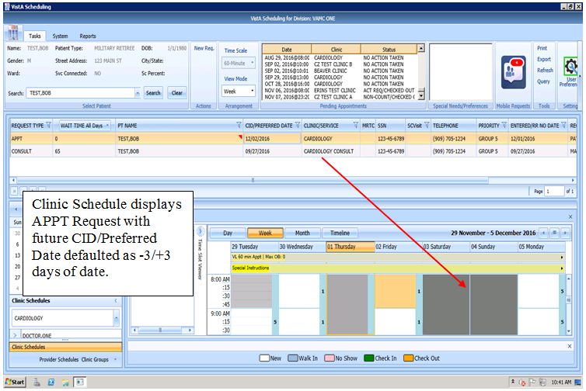

Figure 86: Select APPT Request – Clinic Schedule Grid Display

1. In Clinic Schedule Grid, select available time slot. Time Slot details display in Time Slot Viewer.

**Note:** Refer to Section 7.1.7 for detailed information on Time Slot Viewer functionality.

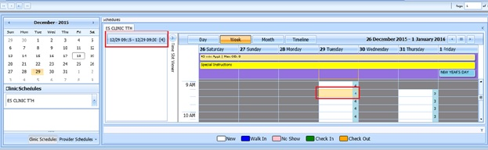

Figure 87: Select Time Slot

1. Right click in time slot. **Add Appointment** option displays. Create Walk In Appointment option is only available for selection on current date. It is not available for past or future CID/Preferred dates.

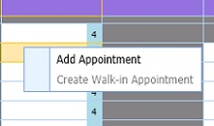

Figure 88: Right Click Options – Add Appointment

1. Select **Add Appointment**.
2. New Appointment dialog displays as well as Patient Eligibility dialog.

* **Appointments Tab**:
* **Patient Information** Section displays Name, DOB, SSN, Svc Connected, Sc Percent, Global Assessment of Function (score) (GAF) (read only), and Svc Related check box.
* **Appointment** information section displays Benefit/Eligibility (provides drop down for patients with multiple eligibility), Start Time, Appt Type, Duration, Clinic and Notes (Appointment Start Time; Duration on for appointments to VL Clinics; and Notes are editable fields). Information can be added pertinent to appointment.
* **Appointment Conflicts** section displays any appointments already scheduled that potentially conflict with appointment being added.

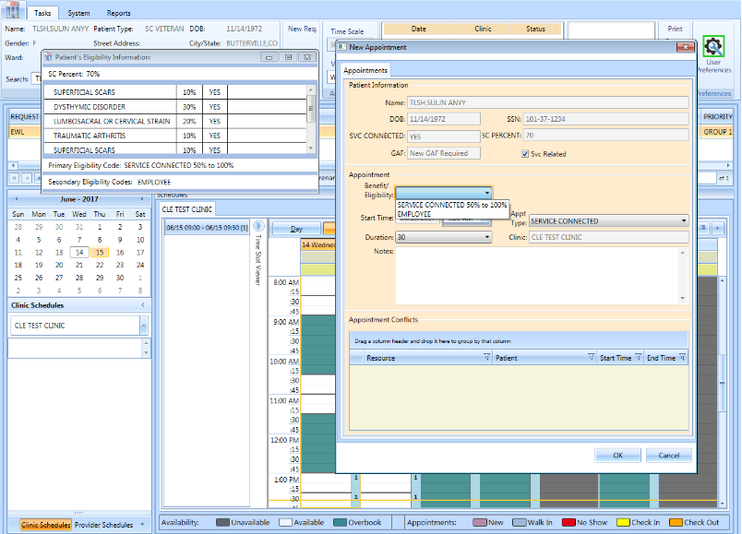

Figure 89: New Appointment Dialog

1. Add any applicable notes to appointment. Click **OK**.
2. Print Letter? Dialog displays. Click **OK** to send Letter to patient. Click **Cancel** to not send letter.

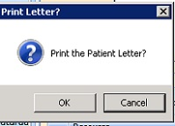

Figure 90: Print Letter? Dialog

1. Closing Request dialog displays. Click **OK**.

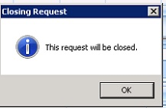

Figure 91: Closing Request Dialog

1. APPT Request is removed from Patient Request Management Grid. Next request for patient is moved up and highlighted.
2. Clinic Schedule closes and next appointments clinc schedule is opened.
3. New appointment displays in Pending Appointment Window in Ribbon Bar.
4. Select appointment from the Pending Appointment window to view the appointment in the Clinic S chedule Grid. The clinic schedule opens. For past dates, the clinic schedule opens defaulted to appointment date. For current date (or appointment date less than three days in future), the clinic schedule displays defaulted to current date. For future dates, the clinic schedule displays -/+ three days of appointment date.

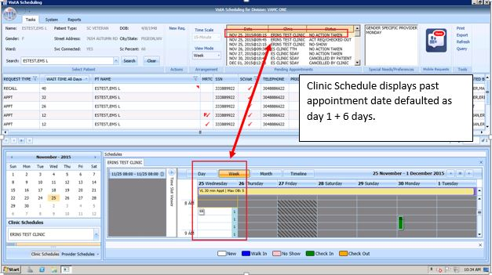

Figure 92: Clinic Schedule Grid – Past Appointment Display

For current date (or appointment date less than three days in future), the clinic schedule displays defaulted to current date. See below.

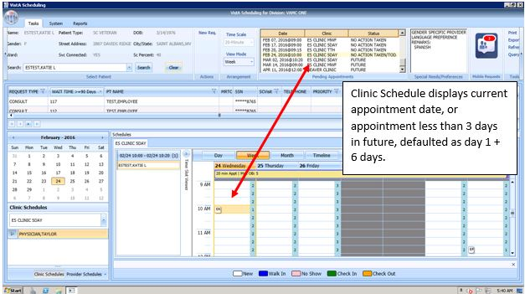

Figure 93: Clinic Schedule Grid – Current Appointment Display

For future dates, the clinic schedule displays -/+ three days of appointment date. See below.

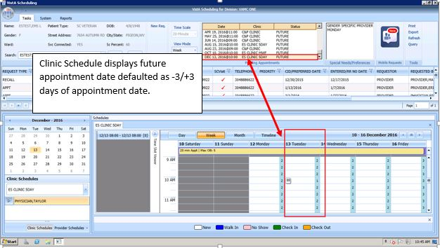

Figure 94: Clinic Schedule Grid – Future Appointment Display

### Add Appointment for EWL Request

1. Log into VS GUI as a Scheduler.
2. In the Tasks tab display, type the patient’s last name, first name in the Search text box, click the **Search** button, and then select the requested patient name from drop down list.
3. In the **Request Type** dialog box, select **APPT** and then click **OK** to create new request or click **Cancel** for existing request.

**Note:** Refer to Section 5.1.5 for steps on transferring APPT request to new EWL Request.



Figure 95: Request Type

1. In **Request Management** Grid select **EWL** request. The Clinic Schedule Grid displays the clinic schedule based upon CID/Preferred date of request. For past dates, the clinic schedule opens defaulted to CID/Preferred date. For current date (or CID/Preferred date less than three days in future), the clinic schedule displays defaulted to current date. For future dates, the clinic schedule displays -/+ three days of CID/Preferred date.

**Note:** For newly created Patient-Centered Scheduling request the system automatically highlights APPT request and Clinic Schedule displays. If EWL is for a service/specialty, no grid is displayed and the clinic must be searched and selected.

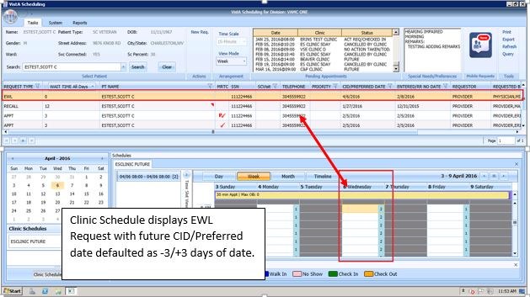

Figure 96: Select EWL Request

1. In Clinic Schedule Grid, select available time slot. Time Slot details display in Time Slot Viewer.

**Note:** See Section 7.1.7 for detailed information on Time Slot Viewer functionality.

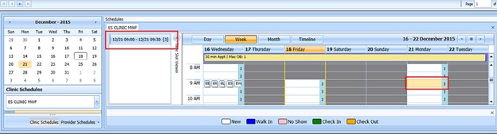

Figure 97: Select Time Slot

1. Right click in time slot. **Add Appointment** option displays.   
   **Note:** Create Walk In Appointment option is only available for selection on current date. It is not available for past or future CID/Preferred dates.



Figure 98: Right Click Options – Add Appointment

1. Select **Add Appointment**.
2. New Appointment dialog contains the following sections:

* **Appointments Tab:**
* **Patient Information** section displays Name, DOB, SSN, Svc Connected, Sc Percent, GAF (read only), and Svc Related check box.
* **Appointment** information section displays Start Time, Appt Type, Duration, Clinic and Notes (Appointment Start Time; Duration on for appointments to VL Clinics; and Notes are editable fields).
* **Appointment Conflicts** section displays any appointments already scheduled that conflict with appointment being added.

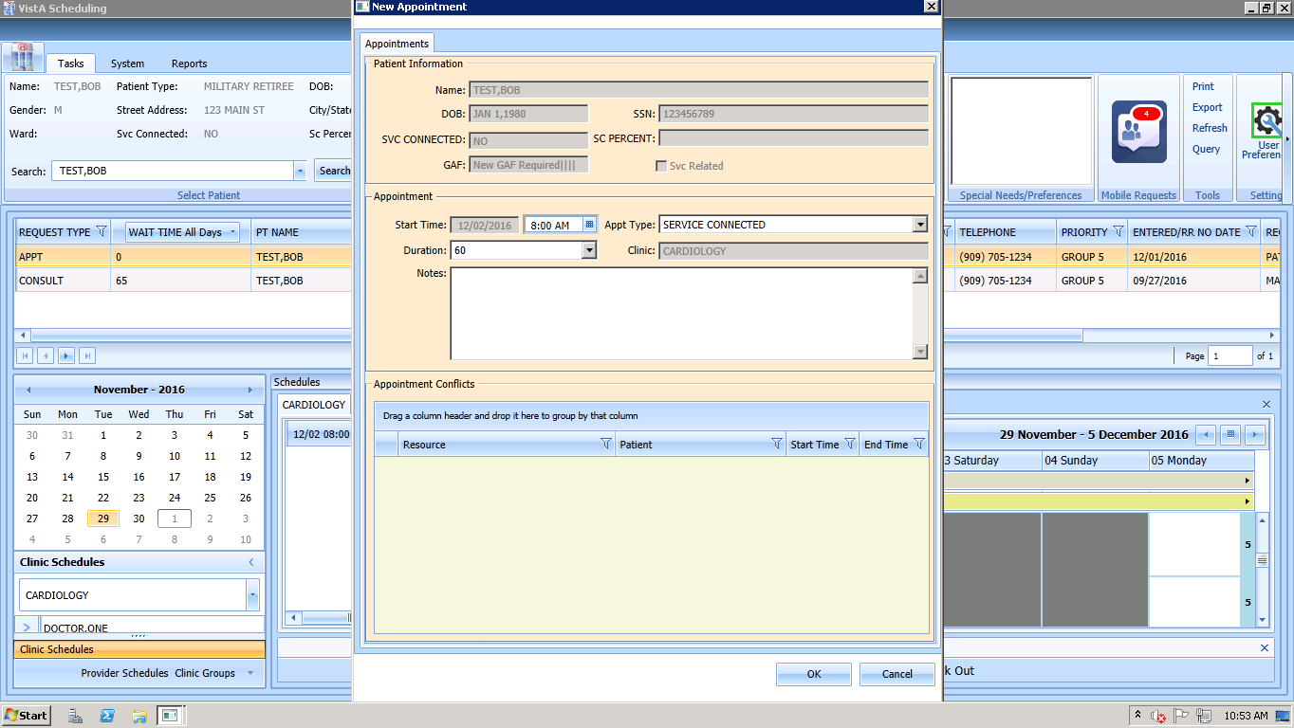

Figure 99: New Appointment Dialog

1. Add any applicable Notes to appointment. Click **OK**.
2. Print Letter? Dialog displays. Click **OK** to send Letter to patient. Click **Cancel** to not send letter.



Figure 100: Print Letter? Dialog

1. Closing Request dialog displays. Click **OK**.



Figure 101: Closing Request Dialog

1. EWL Request is removed from Patient Request Management Grid. The EWL request is dispositioned as scheduled. Next request for patient is moved up and highlighted.
2. Clinic Schedule closes and the clinic for the next request displays.
3. New appointment displays in Pending Appointment Window in Ribbon Bar.
4. Select appointment from the Pending Appointment window to view the appointment in the Clinic Schedule Grid. The clinic schedule opens. For past dates, the clinic schedule opens defaulted to appointment date.



Figure 102: EWL Appointment Past Date Display

For current date (or appointment date less than three days in future), the clinic schedule displays defaulted to current date. See below.

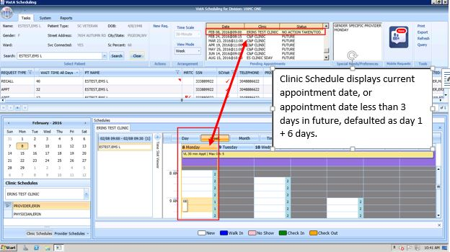

Figure 103: EWL Appointment Current Date

For future dates, the clinic schedule displays -/+ three days of appointment date. See below.



Figure 104: EWL Appointment Future Date Display

### Add Appointment for Patient-Centered Scheduling Request

1. Log into VS GUI as a Scheduler.
2. In the **Tasks** tab display, in the **Search** text box, type the patient’s last name or patient’s first initial of last name and last four of SSN (e.g. S1234), click the **Search** button, and select the requested patient name. Click **Search**.
3. In the Request Type dialog box, select **Patient-Centered Scheduling** and then click **OK** to create new request or click **Cancel** for existing request.

**Note:** Refer to Section 5.1.7 for steps on adding new Patient-Centered Scheduling Request.



Figure 105: Request Type

1. In **Request Management** Grid select **Patient-Centered Scheduling** request. The Clinic Schedule Grid displays the clinic schedule based upon CID/Preferred date of request. For past dates, the clinic schedule opens defaulted to the CID/Preferred date. For current date (or CID/Preferred date less than 3 days in future), the clinic schedule displays defaulted to current date. For future dates, the clinic schedule displays -/+3 days of CID/Preferred date.

**Note:** For newly created Patient-Centered Scheduling request the system automatically highlights PATIENT-CENTERED SCHEDULING request in Request Management Grid and Clinic Schedule displays.

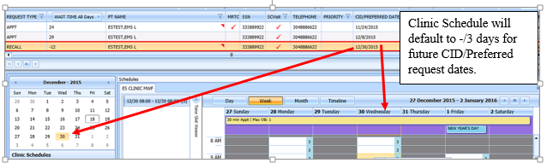

Figure 106: Select Patient-Centered Scheduling Request

1. In Clinic Schedule Grid, select available time slot. Time Slot details display in Time Slot Viewer.

**Note:** See Section 7.1.7 for detailed information on Time Slot Viewer functionality.

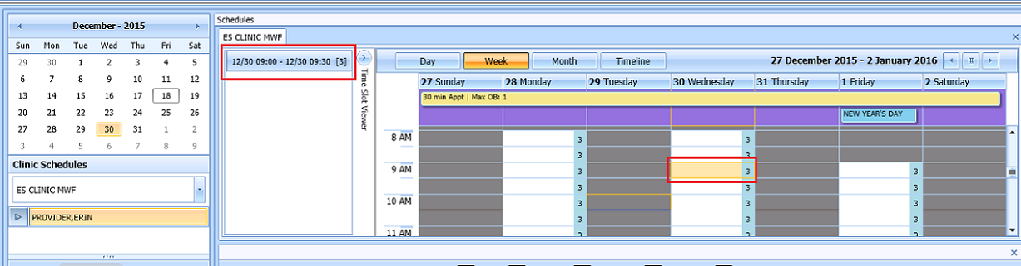

Figure 107: Select Time Slot

1. Right click in time slot. **Add Appointment** option displays.   
   **Note: Create Walk In Appointment** option is only available for selection on current date. It is not available for past or future CID/Preferred dates.

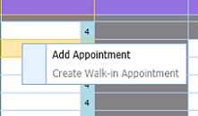

Figure 108: Right Click Options – Add Appointment

1. Select **Add Appointment**.
2. New Appointment dialog contains the following sections:

* **Appointments Tab:**
* **Patient Information Section displays** Name, DOB, SSN, SVC Connected, SC Percent, GAF (read only), and Svc Related check box**.**
* **Appointment** information section displays Start Time, Appt Type, Duration, Clinic and Notes (Appointment Start Time; Duration on for appointments to VL Clinics; and Notes are editable fields).
* **Appointment Conflicts** section displays any appointments already scheduled that conflict with appointment being added.



Figure 109: New Appointment Dialog

1. Add any applicable Notes to appointment. Click **OK**.
2. Print Letter? Dialog displays. Click **OK** to send Letter to patient. Click **Cancel** to not send letter.

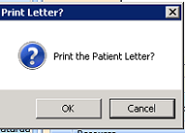

Figure 110: Print Letter? Dialog

1. Closing Request dialog displays. Click **OK**.

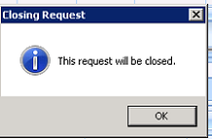

Figure 111: Closing Request Dialog

**Note:** The Patient-Centered Scheduling request is not immediately removed from the request grid. The request is removed when the task “CLEAN UP CLINIC PATIENT-CENTERED SCHEDULING ENTRIES” has been run and when the appointment is made within the CLEAN UP DAY SETTING in ENTER/EDIT CLINIC PATIENT-CENTERED SCHEDULING SITE PARAMS menu option.

1. Clinic Schedule closes and the clinic for the next request displays.
2. New appointment displays in Pending Appointment Window in Ribbon Bar.
3. Select appointment from the Pending Appointment window to view it in Clinic Schedule Grid. The clinic schedule opens. For past dates, the clinic schedule displays defaulted to appointment date.



Figure 112: Clinic Schedule Display – Past Date Appointment

For current date (or appointment date less than three days in future), the clinic schedule displays. appointment date as Day 1 + six days to current date.



Figure 113: Clinic Schedule Display – Current Date Appointment

For future dates, the clinic schedule displays -/+ three days of appointment date. See below.



Figure 114: Clinic Schedule Display – Future Date Appointment

### Add Appointment for Consult Request

1. Log into VS GUI as a Scheduler.
2. Log into VS GUI as a Scheduler.
3. In the **Tasks** tab display, in the **Search** text box, type the patient’s last name or patient’s first initial of last name and last four of SSN (e.g. S1234), click the **Search** button, and select the requested patient name. Click **Search**.
4. In the **Request Type** dialog box, click **Cancel** and select existing **Consult**.

**Note:** Consult requests are added from CPRS.



Figure 115: Request Type

1. In Request Management Grid select ConsultRequest.

**Note:** Clinic Schedule does NOT display when selecting Consult request.

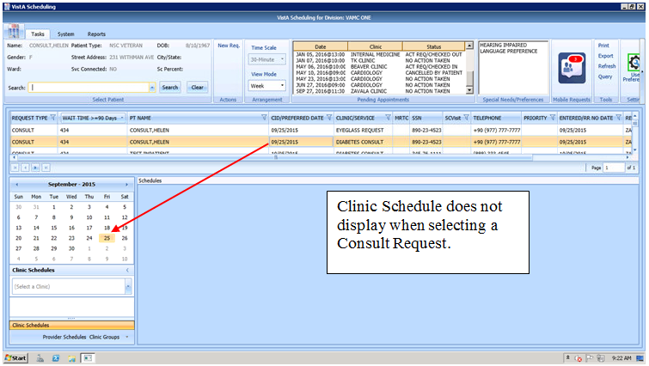

Figure 116: Select Consult Request

1. From Clinic Schedules, enter clinic name (six character minimum).

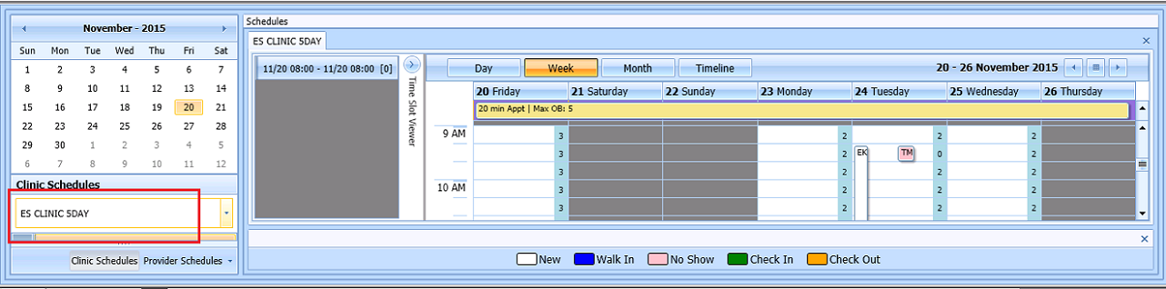

Figure 117: Clinic Schedules

1. In Clinic Schedule displays, left click available time slot. Time Slot details display in Time Slot Viewer.

**Note:** See Section 7.1.7 for detailed information on Time Slot Viewer functionality.

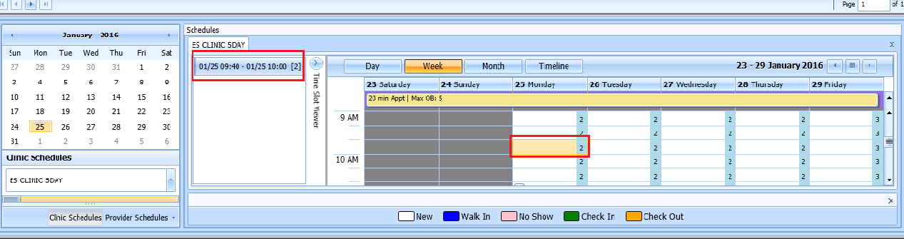

Figure 118: Select Time Slot

1. Right click in time slot. **Add Appointment** option displays.  
   **Note: Create Walk-In Appointment** option is only available for selection on current date. It is not available for past or future CID/Preferred dates.



Figure 119: Right Click Options – Add Appointment

1. Select **Add Appointment**.
2. New Appointment dialog displays as well as Patient Eligibility dialog.

* **Appointments Tab:**
* **Patient Information Section displays** Name, DOB, SSN, SVC Connected, SC Percent, GAF (read only), and Svc Related check box**.**
* **Appointment** information section displays Start Time, Appt Type, Duration, Clinic and Notes (Appointment Start Time; Duration on for appointments to VL Clinics; and Notes are editable fields).
* **Appointment Conflicts** section displays any appointments already scheduled that conflict with appointment being added.



Figure 120: New Appointment Dialog

1. Add any applicable Notes to appointment. Click **OK**.
2. Print Letter? Dialog displays. Click **OK** to send Letter to patient. Click **Cancel** to not send letter.



Figure 121: Print Letter? Dialog

1. Consult Request is removed from Patient Request Management Grid. Next request for patient is moved up and highlighted.
2. Clinic Schedule closes and clinic for the next request displays, if applicable.
3. New appointment displays in Pending Appointment Window in Ribbon Bar.
4. Select appointment from the Pending Appointment window to view it in the Clinic Schedule Grid. The clinic schedule opens. For past dates, the clinic schedule opens defaulted to appointment date.

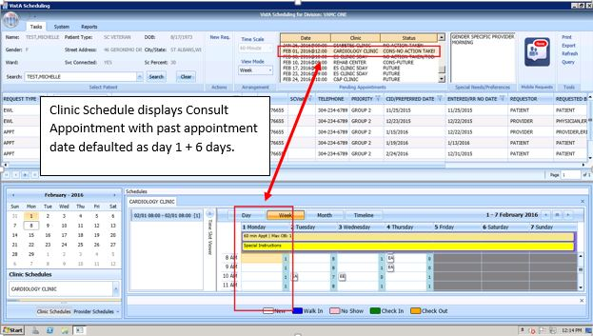

Figure 122: Clinic Schedule Display – Consult Past Appointment Date

For current date (or appointment date less than three days in future), the clinic schedule displays defaulted to current date. See below.

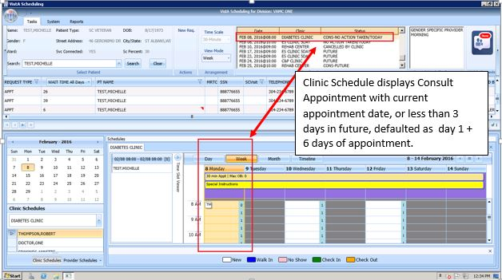

Figure 123: Clinic Schedule Display – Consult with Current Date

For future dates, the clinic schedule displays -/+ three days of appointment date. See below.

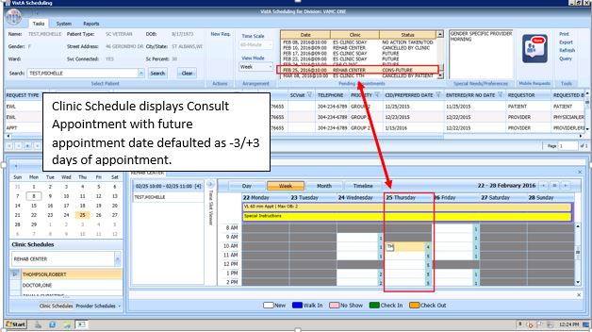

Figure 124: Clinic Schedule Display – Consult Future Appointment Date

## Disposition Appointments

### Edit Appointment Information

Editing appointment information can be done within the VS GUI.

Perform the following procedure to edit appointment information:

1. Log on to VS GUI as a Scheduler.
2. In the Tasks tab display, type the patient’s last name, first name in the Search text box, click the **Search** button, and then select the requested patient name from drop down list.
3. In **Request Type** dialog, click **Cancel**.
4. Locate the appointment to be edited in the Pending Appointments Window in the Ribbon Bar.
5. The clinic schedule displays. For past appointment dates, the clinic schedule opens defaulted to appointment date. For current date (or appointment date less than three days in future), the clinic schedule displays defaulted to current date. For future dates, the clinic schedule displays -/+ three days of appointment date.
6. In the Clinic Schedule Grid, locate the appointment, right click on the appointment, and then select **Edit Appointment**.

**Note:** See Section 7.1.7 for detailed information on Time Slot Viewer functionality.

1. 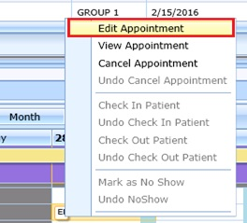

Figure 125: Appointment Right Click Options – Edit Appointment

1. Edit Appointment dialog displays.
2. The only field that is editable is Notes. Make any necessary edits to the appointment information and click OK.

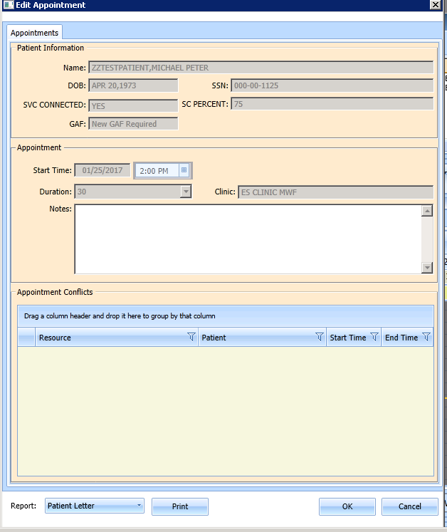

Figure 126: Edit Appointment Dialog

### View Appointment Information

Viewing appointment information can be done in the Clinic Schedule Grid in the VS GUI.

Perform the following procedure to view appointment information:

1. Log on to VS GUI.
2. In the **Tasks** tab display, in the **Search** text box, type the patient’s last name or patient’s first initial of last name and last four of SSN (e.g. S1234), click the **Search** button, and select the requested patient name. Click **Search**.
3. In Request Type dialog, click **Cancel**.
4. Locate the appointment to be viewed in the Pending Appointments Window in the Ribbon Bar.
5. The clinic schedule displays. For past appointment dates, the clinic schedule defaults to appointment date as Day 1 + six days. For current date (or appointment date less than three days in future), the clinic schedule displays defaulted to current date as Day 1 + six days. For future dates, the clinic schedule displays -/+ three days of appointment date.
6. In the Clinic Schedule Grid, locate the appointment, hover over the appointment, and the appointment details display in the hover box.

**VS GUI Hover Box Displaying Appointment Details window**

Figure 127: Hover Box Displaying Appointment Details

1. Right click appointment.
2. Select **View Appointment**.

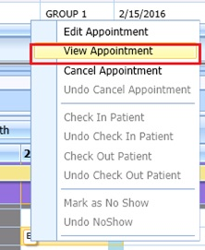

Figure 128: Appointment Right Click Options – View Appointment

1. **View Appointment** dialog displays. It is in read-only mode. No fields are editable. Click **OK** to close View Appointment dialog.

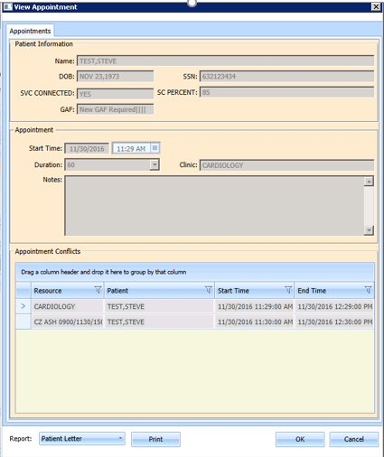

Figure 129: View Appointment Dialog

### Cancelling an Appointment

You can cancel an appointment without rebooking it.

1. Log on to VS GUI as a Scheduler.
2. In the **Tasks** tab display, in the **Search** text box, type the patient’s last name or patient’s first initial of last name and last four of SSN (e.g. S1234), click the **Search** button, and select the requested patient name. Click **Search**. .In Request Type dialog, click **Cancel**.
3. In Request Type dialog, click **Cancel**.
4. Select a scheduled appointment from Pending Appointment Window in Ribbon Bar.
5. The clinic schedule displays. For past appointment dates, the clinic schedule opens defaulted to appointment date. For current date (or appointment date less than three days in future), the clinic schedule displays defaulted to current date. For future dates, the clinic schedule displays -/+ three days of appointment date.
6. Select appointment from Clinic Schedule Grid.
7. Right click and select **Cancel**.

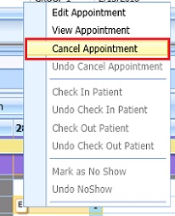

Figure 130: Appointment Right Click Options – Cancel Appointment

1. In the **Cancel Appointment** dialog box, select a cancellation option:
   * **Cancelled by Clinic**: The original CID/Preferred appointment date defaults to the patient desired date. The date cannot be edited.
   * **Cancelled by Patient**: The patient CID/Preferred date is available and defaults to original CID/Preferred date request. You can edit the date to change it.
2. Select **Reason for Cancellation** from list.
3. Edit CID/Preferred dates if applicable.
4. Add Remarks as needed.
5. Click **OK**. The appointment is canceled and not rebooked. If the appointment is linked to a consult, the consult status changes to Active.

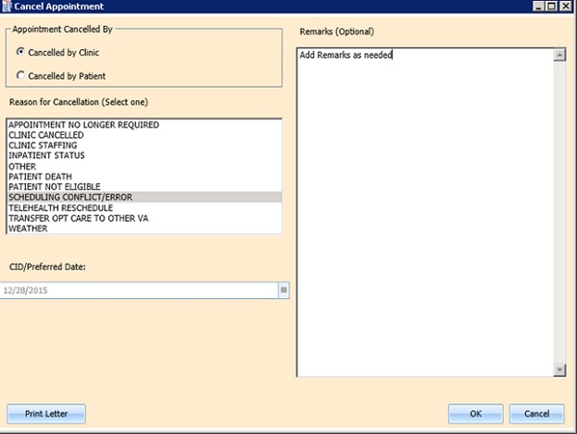

Figure 131: Cancel Appointment Dialog

1. Appointment displays in Pending Appointment with status of Cancelled by Clinic or Cancelled by Patient (as applicable).

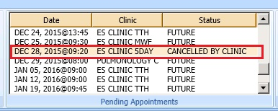

Figure 132: Pending Appointment Window – Appointment Status Cancelled by Clinic

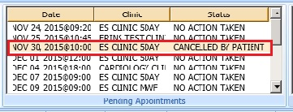

Figure 133: Pending Appointment Window – Appointment Status Cancelled by Patient

1. Clinic Schedule closes.
2. The patient’s appointment request reappears on the request grid for future rescheduling.
3. Select **APPT Request** and Clinic Schedule displays again.

**Note:** Time Slot count increases when appointment is canceled.

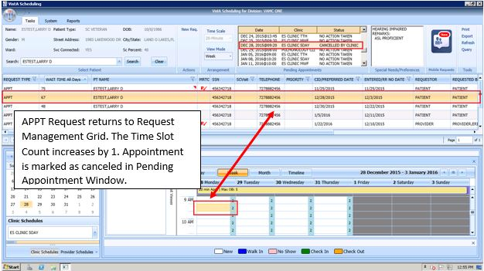

Figure 134: APPT Request – Time Slot Count Increase

### Mark as No Show Appointment

Perform the following procedure to record a no show appointment.

1. Log on to VS GUI as a Scheduler.
2. In the Tasks tab display, type the patient’s last name, first name in the Search text box, click the **Search** button, and then select the requested patient name from drop down list.
3. In the **Request Type** dialog box, click **Cancel**.
4. From **Pending Appointment** Window select appointment to mark as no show.
5. The clinic schedule displays. For past appointment dates, the clinic schedule Clinic Schedule displays defaulted to appointment date. For current date (or appointment date less than 3 days in future), the clinic schedule displays defaulted to current date.
6. Select appointment from Clinic Schedule Grid.
7. Right click **Appointment**.
8. Select **Mark as No Show**. The appointmet MUST be in the past from the current date/time.

**Note: “**Mark as No Show” is not available to select on future dated appointments.

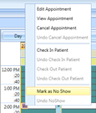

Figure 135: Appointment Right Click Options – Mark as No Show

1. **Mark as No Show** dialog displays.

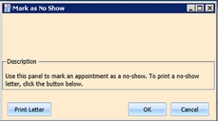

Figure 136: Mark as No Show Dialog

1. Click **OK**.
2. Appointment displays in red in Clinic Schedule Grid and Time Slot Viewer.

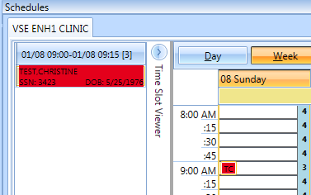

Figure 137: Clinic Schedule Display – No-Show Red

1. Status in Pending Appointment Window in Ribbon Bar changes to No-Show.
2. Request returns to Request Management Grid for patient.

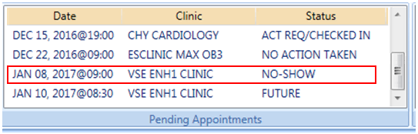

Figure 138: Pending Appointment Window – Appointment Status No-Show

1. Inpatient appointments CANNOT be dispositioned as No-Show.
2. The User will receive a warning message if attempting to flag an Inpatient as a No-Show that it is Not Allowed to flag an Inpatient as a No-Show.
3. Click OK to close the message block and the appointment should not show as a No-Show.

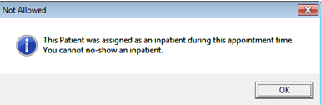

Figure 139: No-Show Warning Message

### Undo No-Show Appointment

If a patient is recorded as a no-show but arrives in time to be seen, a previously recorded no show can be undone. Perform the following procedure to undo a no-show appointment.

1. Log on to VS GUI as a Scheduler.
2. In the **Tasks** tab display, in the **Search** text box, type the patient’s last name or patient’s first initial of last name and last four of SSN (e.g. S1234), click the **Search** button, and select the requested patient name. Click **Search**.
3. In Request Type dialog, click **Cancel**.
4. In the Pending Appointments Window in Ribbon Bar, locate the No Show appointment to undone.
5. The clinic schedule displays. For past appointment dates, the clinic schedule displays defaulted to appointment date. For current date (or appointment date less than 3 days in future), the clinic schedule displays defaulted to current date.
6. Right click **Appointment**.
7. Select **Undo NoShow**.

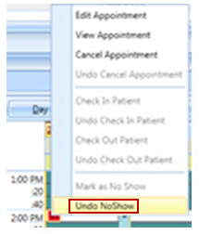

Figure 140: Appointment Right Click Options – Undo NoShow

1. In Clinic Schedule Grid, the appointment changes from red to purple.

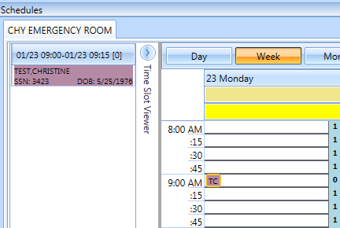

Figure 141: Appointment Clinic Schedule Display – Undo NoShow as Purple

1. Appointment status in Pending Appointment Window changes to No Action Taken.

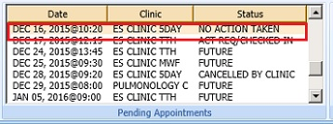

Figure 142: Undo NoShow – Appointment Status No Action Taken

1. Request closes and is relinked to appointment.

### Checking In a Patient

Perform the following procedure to check in a patient for an appointment.

1. Log on to VS GUI as a Scheduler.
2. In the **Tasks** tab display, in the **Search** text box, type the patient’s last name or patient’s first initial of last name and last four of SSN (e.g. S1234), click the **Search** button, and select the requested patient name. Click **Search**.
3. In the Request Type dialog box, click **Cancel**.
4. In the Pending Appointments Window in Ribbon Bar, locate the appointment to be checked in.
5. The clinic schedule displays. For past appointment dates, the clinic schedule Clinic Schedule opens defaulted to appointment date. For current date (or appointment date less than three days in future), the clinic schedule displays defaulted to current date.
6. Right click **Appointment.**
7. Select **Check In Patient**.

**Note:** Check In is not available for future dated appointments.

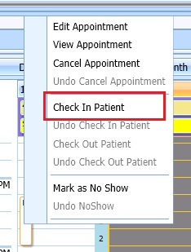

Figure 143: Appointment Right Click Options – Check In Patient

1. **Appointment Check In** dialog displays. Edit the check in date and time as needed.

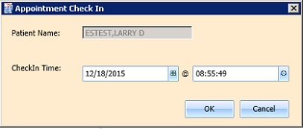

Figure 144: Appointment Check In Dialog

1. Click **OK**. The appointment color changes to yellow, signifying the patient has checked in for the appointment.

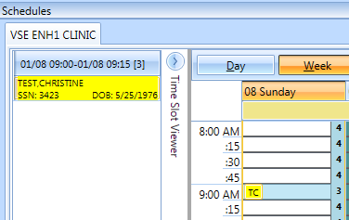

Figure 145: Clinic Schedule Display – Check In Yellow

1. In **Pending Appointment Window** in Ribbon Bar, appointment status changes to ACT REQ/CHECKED IN.

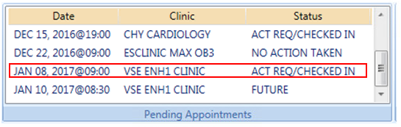

Figure 146: Pending Appointment Window – Status ACT REQ/CHECKED IN

### Undo a Patient Check In

If a patient is checked in by mistake, the check in can be undone.

Perform the following steps to undo a patient check in:

1. Log on to VS GUI as a Scheduler.
2. In the Clinic Schedule Grid, select the patient check in that needs to be undone.
3. Right-click and select **Undo Check In Patient**.

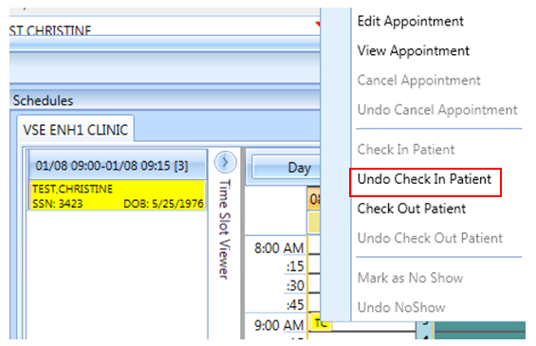

Figure 147: Appointment Right Click Options – Undo Check In Patient

1. Appointment changes color display from yellow to purple.

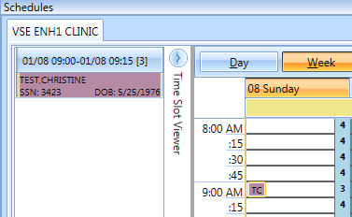

Figure 148: Clinic Schedule Display – Undo Check In Patient Purple

1. From Pending Appointment Window, appointment status changes to No Action Taken.

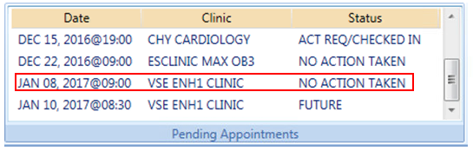

Figure 149: Pending Appointment Window – Appointment Status No Action Taken

### Check Out a Patient

Perform the following procedure to check out a patient.

1. Log on to VS GUI as a Scheduler.
2. In the **Tasks** tab display, in the **Search** text box, type the patient’s last name or patient’s first initial of last name and last four of SSN (e.g. S1234), click the **Search** button, and select the requested patient name. Click **Search**.
3. In the Request Type dialog box click **Cancel**.
4. In the Pending Appointments Window in Ribbon Bar, locate the appointment to be checked out.
5. Clinic Schedule displays. For past appointment date, Clinic Schedule opens defaulted to appointment date. For current date (or appointment date less than three days in future), schedule displays defaulted to current date. For future dates, schedule displays -/+ three days of appointment date.
6. Right click and select **Check Out Patient**.

**Note:** Check Out is not available to select if Check In has not been performed.

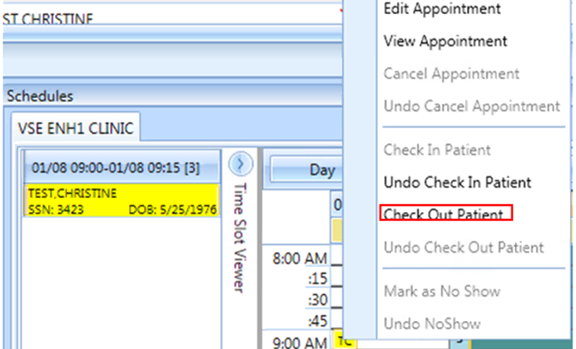

Figure 150: Appointment Right Click Option – Check Out Patient

1. Update the **Appointment Check Out** dialog box.
   * Confirm the date and time. Edit as needed.
   * Check **Follow-up Needed**, if applicable.

**Note:** Check Out must be at least one minute after Check In.

1. Click **OK**. The appointment status is changed to ACT REQ/**Checked Out** in Pending Appointment Window and the color changes to orange in Clinic Schedule.

**Note:** When Scheduler clicks OK, if Follow-up Needed was checked, then the New APPT Request dialog displays. This APPT Request dialog needs to be completed before Patient Check Out is complete.

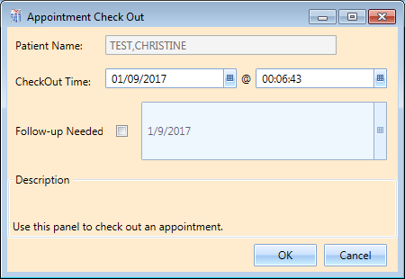

Figure 151: Appointment Check Out Dialog

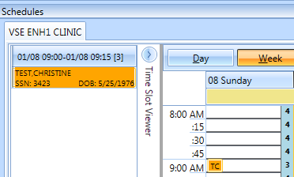

Figure 152: Clinic Schedule Display – Check Out Patient Orange

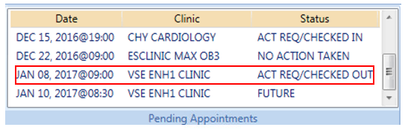

Figure 153: Pending Appointment Window – Status ACT REQ/CHECKED OUT

### Undo a Patient Check Out

If a patient is checked out by mistake, the check out can be undone.

Perform the following steps to undo a patient check out:

1. Log on to VS GUI as a Scheduler.
2. In the Clinic Schedule Grid, select the patient check in that needs to be undone.
3. Right click and select **Undo Check Out Patient**.

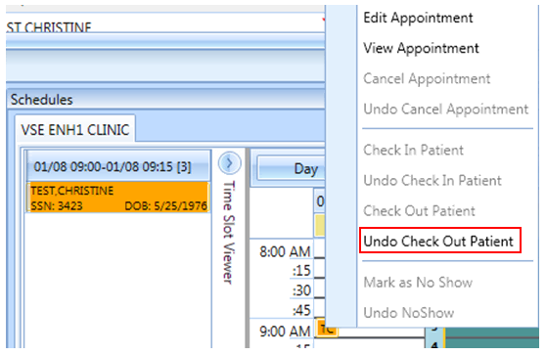

Figure 154: Appointment Right Click Options – Undo Check Out Patient

1. Appointment changes display from orange to yellow.

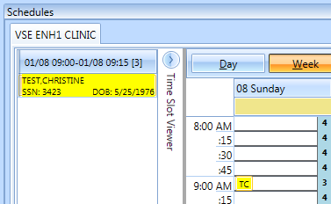

Figure 155: Clinic Schedule Display – Undo Check Out Patient Yellow

1. From Pending Appointment Window, appointment status changes to ACT REQ/CHECKED IN.

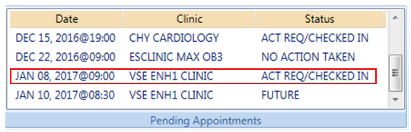

Figure 156: Pending Appointment Window – Status ACT REQ/CHECKED IN

**Note:** Undoing the check out will also delete all the encounter information that has been entered up to this point.

### Rescheduling an Appointment

You can cancel an appointment and reschedule it for another time.

1. Log on to VS GUI as a Scheduler.
2. In the **Tasks** tab display, in the **Search** text box, type the patient’s last name or patient’s first initial of last name and last four of SSN (e.g. S1234), click the **Search** button, and select the requested patient name. Click **Search**.
3. In Request Type dialog, click **Cancel**.
4. In the **Pending Appointments** Window in Ribbon Bar, locate and select the appointment to be rescheduled.
5. The Clinic Schedule displays. For past appointment date, Clinic Schedule opens defaulted to appointment date. For current date (or appointment date less than three days in future), schedule displays defaulted to current date. For future dates, schedule displays -/+ three days of appointment date.
6. In Clinic Schedule Grid, select the scheduled appointment, drag and drop it to another open time slot.
7. **Move Appointment** dialog displays.
8. Click **OK** to confirm new appointment time.

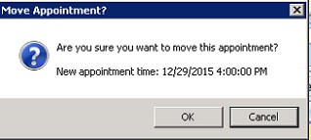

Figure 157: Move Appointment? Dialog

1. In the **Cancel Appointment** dialog box, define the fields as appropriate to cancel the original appointment.

**Note:** Refer to Section 6.2.3 Cancelling an Appointment for detailed instructions.

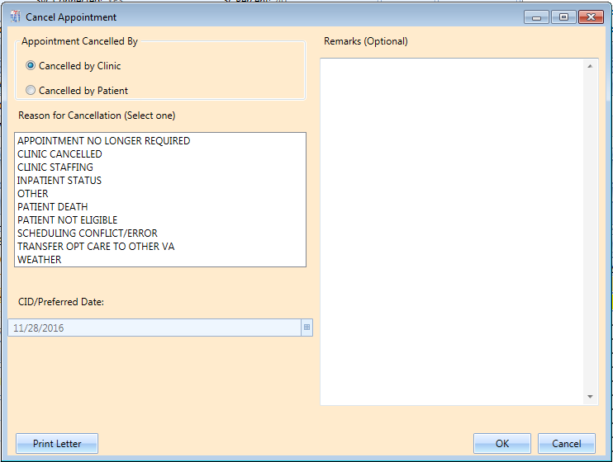

Figure 158: Cancel Appointment Dialog

1. Click **OK**. In Pending Appointment Window in Ribbon Bar, the original appointment is canceled and a new appointment is created. If the appointment is linked to a consult, the consult status changes to Scheduled and the cancellation and reschedule are recorded in the consult.

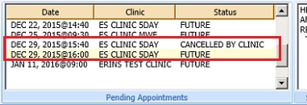

Figure 159: Pending Appointment Window – Appointment Status Cancelled and Future

1. The patient’s appointment request no longer appears on the request grid.

## Multiple Appointment Requests and Appointments

Multiple Appointment Requests allow the scheduler to create requests and book a series of appointments at one time for a patient.

### Multiple Appointment Request

1. Log into VS GUI as a Scheduler.
2. In the **Tasks** tab display, in the **Search** text box, type the patient’s last name or patient’s first initial of last name and last four of SSN (e.g. S1234), click the **Search** button, and select the requested patient name. Click **Search**.
3. In the Request Type dialog box, select APPT to create a new request.
4. **Patient’s Eligibility Information** dialog displays.
5. In the **Appointment Request** dialog confirm Patient Information details.
6. In the **Appointment Request** dialog box, complete the Request Information section.

* Select **Clinic** or **Service/Specialty** radio button. For Clinic enter clinic name (minimum of six characters required). For Service/Specialty enter service or specialty (minimum of six characters required).
* Enter **CID/Preferred Date** for the preferred appointment date. Scheduler can enter date directly or select date from Calendar control option.
* Select **Appointment Type** if not defaulted by patient eligibility and clinic selection then choose from drop down list.
* In **Request By**, select either Provider or Patient.
* If **Provider** selected then enter provider name (three character minimum) and select from list.   
  **Note:** If, Patient was selected in Request By field, then Provider field is dimmed and not editable.
* **Status** is automatically populated.

1. Established – The patient has been seen at that clinic in the past 24 months
2. New – The patient has not been seen at that clinic in the past 24 months

* **Multiple Appointments Required** check box is enabled. Click box to enter check mark.
  + **Number of Appointments Required** drop down is visible. Up to 60 appointments can be requested at one time.
  + **Interval Between Appointments** (In days) drop down is visible. Up to 30 days between appointments can be requested at one time.

**Note:** The combination of Number of Appointments Required and Interval Between Appointments cannot exceed 24 months. If the selected combination does exceed 24 months to complete, when the Scheduler selects OK to complete the Appointment Request the MRTC Interval/Appt.# Dialog displays, “The combination of requested appointments and the interval between appointments exceeds 24 months. Please adjust the number of requested appointments and/or the interval between appointments so that the combined duration is less than 24 months.” The adjustment must be made before the Multiple Appointment Request can be completed.

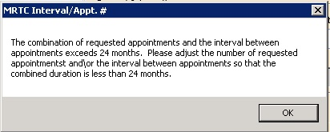

Figure 160: MRTC Interval/Appt. # Dialog

* Text can be added in **Comment** field up to 80 characters to add information regarding Appointment Request. For MRTC Requests the text displays in Request Management Grid under Comment column after the {Day, Interval} information.

1. Click **OK. Find Appointment** dialog displays to allow Scheduler to book Multiple Appointments at one time. See Section 6.3.2 for booking appointments from Find Appointment Dialog.

#### Note Regarding Parent and Child Appointment Requests

When booking Multiple Appointment Requests the scheduler can click **Close** in the Find Appointment dialog. If this is done prior to the first appointment in the series being booked the Parent MRTC Request is placed in the Request Grid with a “P” and check mark in MRTC Column. The {Day, Interval} requested in the Appointment Request displays in the Comment column. Any text entered into Comment field of Appointment Request dialog displays in the Comment column after the {Day, Interval} information. MRTC APPT Requests with Comments are flagged with a red arrow in the Request Management Grid.

If the scheduler books the first appointment in the series and then clicks CLOSE in the Find Appointment Dialog the Parent Request displays in the Request Grid. Additionally, the remaining unbooked appointments display as individual Child MRTC Requests in the Request Grid with a check mark in the MRTC Column but not a “P”. The appointment placement in the series as well as the number of total appointments requested display in the Comments column. Any comments entered in the original MRTC Appointment Request dialog display in each individual Child Request after the {Day, Interval} information.

Selecting the Parent MRTC Request launches the **Find Appointment** dialog and the scheduler can continue booking all remaining appointments for the series from Find Appointment. However, selecting a Child MRTC Request opens the Clinic Schedule and the Scheduler can only book the individual appointment following the same steps as adding an appointment for an APPT Request (refer to Section 6.1.1). The Parent MRTC Request is not removed from the Request Grid until all appointments in the series have been booked. A Child MRTC Request is removed from the Request Grid at the time the appointment is booked.

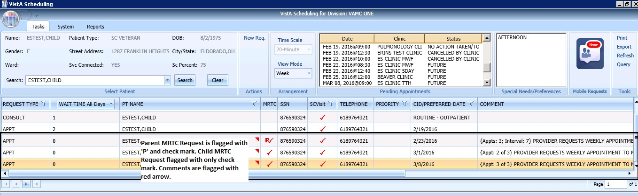

Figure 161: MRTC Requests displayed in Request Management Grid

### Adding Multiple Appointments from Find Appointment Dialog

When Scheduler clicks **OK** in **Appointment Request Dialog** with **Multiple Appointment Required** checked**,** the **Find Appointment** dialog displays to allow Scheduler to book Multiple Appointments at one time.

1. In the Find Appointment dialog the following information is displayed:

* **Calendar** in upper left corner. The CID/Preferred date entered in Appointment Request is highlighted.
* The **Clinic** is defaulted in drop down field from Appointment Request in Resources Section in the upper middle pane of Find Appointment dialog. This field is editable and Clinics can be switched between appointments as needed.
* Patient’s **Time of Day** and **Day of Week** preferences are defaulted in upper right pane of Find Appointment dialog. These can be edited/adjusted as needed.
* The CID/Preferred date entered in Appointment Request is displayed under the Time of Day and Day of Week preferences in Find Appointment dialog with tag labeled **Original CID:**. This is data not editable.
* **Search** button is available if availability needs recalculated due to date or clinic changes.
* **Multiple Appointment Required** information is defaulted from Appointment Request in middle of Find Appointment dialog. This information is not editable.
* **CID** drop down displays list of unbooked appointment dates. These dates are calculated based upon the original CID/Preferred Date + Number of Appointments + Interval Between Appointments.
* For clinics with special instructions defined, the **Special Instructions Button** displays in Search Results section of Find Appointment dialog. When clicked, a Special Instruction dialog displays with the defined information available to review.
* The clinic’s **appointment length, variable length, and Max Overbook** settings display in label in Search Results section.
* In **Search Results** section, availability results display -/+ three Days of CID date for future dates. For current CID dates availability display Day 1 + six days in Search Results field.   
  **Note:** Time of Day and Day of Week preferences limit availability results.
  + Book Column allows Scheduler to select time slot for booking appointment.
  + Start Time Column displays start time of time slot.
  + End Time Column displays end time of time slot.
  + Resource Column displays name of Clinic currently selected.
  + Slots Column displays available time slot count. Slots available for overbooking display based upon the Scheduler’s security key allowances.

**Note:** Time Slots do not display if no availability is defined for that time period for the clinic or overbooking has been reached beyond the Scheduler’s security key allowances.

* **Number of Available Slots**: Count displays at bottom of Find Appointment dialog notifying Scheduler how many slots are displaying as available for the selected CID date.
* **Next** and **Book** buttons are disabled until first Time Slot(s) is selected for booking.

1. Select time slot in Booking Column.   
   **Note:** If Clinic DISPLAY INCREMENTS PER HOUR is defined for a count less than the defined LENGTH OF APP'T then multiple Time Slots may need to be selected to satisfy the Appointment Booking Requirements and enable the Book Button.
2. Click **Book** button.   
   **Note:** If the selected time slot has reached its defined slot count and scheduler has appropriate security keys to overbook, then a dialog displays alerting scheduler that continuing with scheduling appointment will result in overbooking the selected time slot. Scheduler can click **OK** to confirm overbooking and continue to New Appointment dialog.

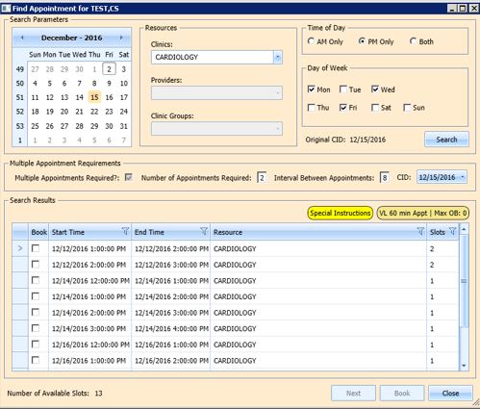

Figure 162: Find Appointment Dialog

1. New Appointment dialog displays. New Appointment dialog has one tab:

* **Appointments Tab:**
* **Patient Information Section displays** Name, DOB, SSN, SVC Connected, SC Percent, GAF (read only), and Svc Related check box**.**
* **Appointment** information section displays Start Time, Appt Type, Duration, Clinic and Notes (Appointment Start Time; Duration on for appointments to VL Clinics; and Notes are editable fields).
* **Appointment Conflicts** section displays any appointments already scheduled that conflict with appointment being added.

1. Confirm information in New Appointment dialog and add any applicable text to Notes section. Click **OK**.
2. Print Letter? Dialog displays. Click **OK** to Print the Patient Letter. Click **Cancel** to close dialog and not print Patient Letter.
3. Closing Request dialog displays “This request will be closed.”
4. Click **OK**.
5. First MRTC Appointment is booked. CID date in Find Appointment dialog changes to next appointment date in series. MRTC Booking Status dialog displays to track appointments as they are booked. An arrow points to date in MRTC Series that is being booked and automatically updates as appointments are completed. The following information displays in the MRTC Booking Status dialog:

* CID Date—Calculated by first booked appointment date and Interval Requested.
* Appointment Date—date selected when booking appointments.
* Resource—Clinic name where appointment was booked.

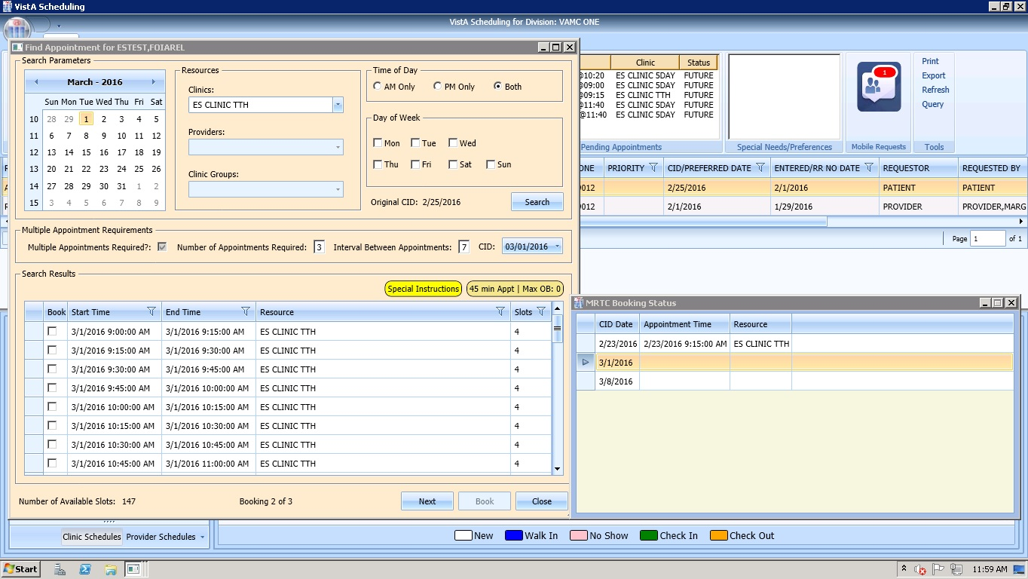

Figure 163: Find Appointment Dialog and MRTC Booking Status Dialog

1. Select time slot for second MRTC appointment in series.
2. Click **Book**.
3. New Appointment dialog displays.
4. Confirm information in New Appointment dialog and add any applicable text to Notes section. Click **OK**.
5. Print Letter? Dialog displays. Click **OK** to Print the Patient letter. Click **Cancel** to close dialog and not print Patient Letter.
6. Closing Request dialog displays “This request will be closed.”
7. Click **OK**.
8. Second MRTC Appointment is booked. CID date in Find Appointment dialog changes to next appointment date in series. Appointment date is added in MRTC Booking Status dialog for second appointment and arrow progress to next appointment (if applicable).
9. Once all MRTC Appointments have been booked for the series, the Closing Request dialog displays, “The Parent MRTC Request will be closed.”
10. If a clinic has a future inactive date and the CID date falls + three days after the Inactivate Date, a grey label displays in the Search Results section of the Find Appointment dialog, “There are no slots available. The selected Clinic will be deactivated on {Inactivation Date}. Please select another clinic and click **Search** to complete the MRTC request.” To complete adding appointments for the series, the Scheduler needs to change to an appropriate clinic in the Resources section with availability and continue adding appointments for the remainder of the series’ requests.

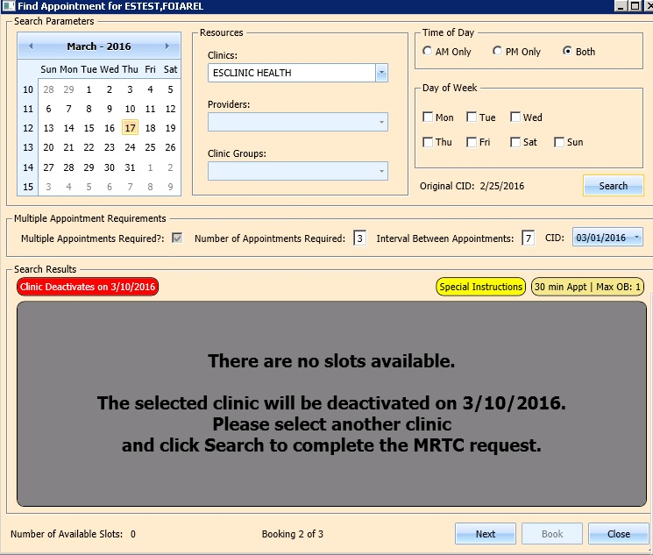

Figure 164: Future Clinic Inactivation Date

## Overbooking Appointments

Schedulers can overbook appointments based upon the following rules:

1. The Scheduler must have the Scheduling Overbook (SDOB) security key to overbook up to the clinic’s Maximum (Max) Overbook (OB) definition. Schedulers must have the Scheduling Master Overbook security key (SDMOB) security key to schedule beyond the clinic’s Max OB definition. Schedulers with both overbook security keys can overbook on any day that has availability defined regardless of the clinic’s Max OB definition. Schedulers cannot overbook if they are not assigned an overbooking security key.
2. The Clinic must have availability defined for the day in question. If there is no availability defined, then Schedulers will not be able to overbook appointments on that day regardless of the security key assigned to them.
3. Appointments cannot be overbooked prior to the start of the day’s clinic availability.

### Overbooking Appointments with SDMOB Security Key

Schedulers assigned the SDMOB can overbook anytime outside of clinic availability from clinic start time to 11:59 p.m. even if the Max Overbook Limit defined for a clinic has been reached.

Perform the following steps to overbook an appointment with the SDMOB security key:

1. Log into VS GUI as a Scheduler.
2. In the **Tasks** tab display, in the **Search** text box, type the patient’s last name or patient’s first initial of last name and last four of SSN (e.g. S1234), click the **Search** button, and select the requested patient name. Click **Search**.
3. In the **Request Type** dialog box, select **APPT**, and then click **OK**. To create new request or click **Cancel** for existing request.

**Note:** Refer to Section 5.1.2 Adding Appointment Request for steps on adding new APPT Request.



Figure 165: Request Type

1. In Request Management Grid select **APPT** request. The Clinic Schedule Grid displays the clinic schedule based upon CID/Preferred date of request. For past dates, the clinic schedule opens defaulted to CID/Preferred date as Day 1 + six days. For current date (or CID/Preferred date less than three days in future), the clinic schedule displays defaulted to current date as Day 1 + six Days. For future dates, the clinic schedule displays -/+ three days of CID/Preferred date.

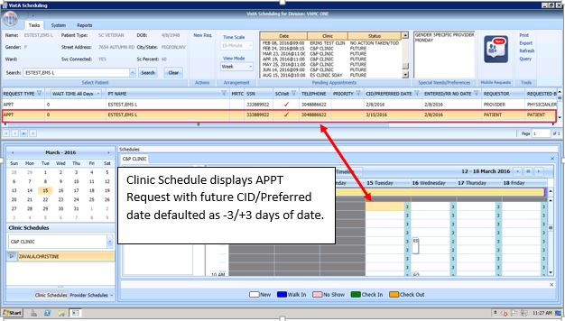

Figure 166: Clinic Schedule Display – APPT Request Future CID/Preferred Date

**Note:** For newly created APPT request, the system automatically highlights APPT request and Clinic Schedule displays.

1. In Clinic Schedule Grid, select time slot in grey that is within the clinic hours, from clinic start time to 11:59, or a date/time slot that has existing overbooks.

**Note:** Clinic Max Overbook limit displays in Clinic Day Event notes.

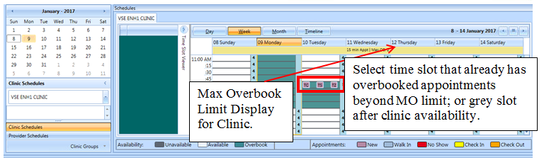

Figure 167: Max Overbook Limit

1. Right click in time slot. **Add Appointment** option displays.   
   **Note: Create Walk In Appointment** option is only available for selection on current date. It is not available for past or future CID/Preferred dates.  
   **Note:** Right click options do not display if selected time slot is for a day that has no availability defined or is prior to the clinic start time.



Figure 168: Appointment Right Click Options – Add Appointment

1. Select Add Appointment.
2. Overbook message displays.
3. Click OK.
4. New Appointment dialog displays as well as Patient Eligibility dialog.

* **Appointments Tab:**
* **Patient Information Section displays** Name, DOB, SSN, SVC Connected, SC Percent, GAF (read only), and Svc Related check box**.**
* **Appointment** information section displays Start Time, Appt Type, Duration, Clinic and Notes (Appointment Start Time; Duration on for appointments to VL Clinics; and Notes are editable fields).
* **Appointment Conflicts** section displays any appointments already scheduled that conflict with appointment being added.

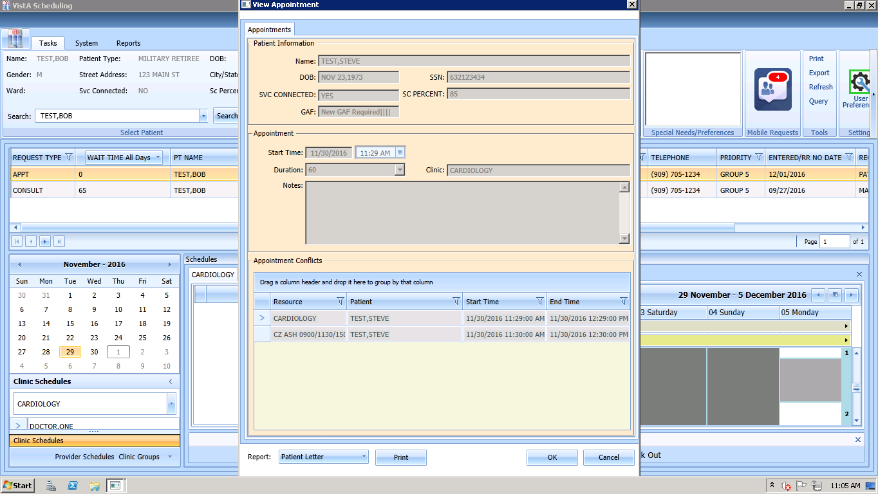

Figure 169: New Appointment Dialog – Appointments

1. Add any applicable **Notes** to appointment. Click **OK**.
2. Print Letter? Dialog displays. Click **OK** to send Letter to patient. Click **Cancel** to not send letter.



Figure 170: Print Letter? Dialog

1. Closing Request dialog displays. Click **OK**.



Figure 171: Closing Request Dialog

1. APPT Request is removed from Patient Request Management Grid. Next request for patient is moved up and highlighted.
2. Clinic Schedule closes.
3. New appointment displays in Pending Appointment Window in Ribbon Bar.
4. Select appointment from the Pending Appointment window to view it in the Clinic Schedule Grid. The clinic schedule opens. For past dates, the clinic schedule opens defaulted to appointment date. For current date (or appointment date less than three days in future), the clinic schedule displays defaulted to current date. For future dates, the clinic schedule displays -/+ three days of appointment date.
5. Overbook count increases in Clinic Schedule time slot and in Time Slot Viewer. If the appointment count has filled the time slot, a hover window displays showing the slot count.

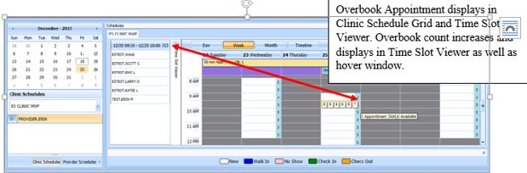

Figure 172: Clinic Schedule Display – Overbook Appointment

### Overbooking Appointments with SDOB Security Key

Schedulers assigned the SDOB security key can overbook outside of clinic availability from clinic start time to 11:59 p.m. They cannot overbook past the Max Overbook Limit defined for a clinic.

Perform the following steps to overbook an appointment with the SDOB security key:

1. Log into VS GUI as a Scheduler.
2. In the **Tasks** tab display, in the **Search** text box, type the patient’s last name or patient’s first initial of last name and last four of SSN (e.g. S1234), click the **Search** button, and select the requested patient name. Click **Search**.
3. In the **Request Type** dialog box, select **APPT** and then click **OK** to create new request or click **Cancel** for existing request.

**Note:** Refer to Section 5.1.2 Adding Appointment Request for steps on adding new APPT Request.



Figure 173: Request Type

1. Select APPT request in the Request Management Grid. The Clinic Schedule Grid displays the clinic schedule based upon CID/Preferred date of request. For a past date, clinic schedule opens defaulted to CID/Preferred date as Day 1 + six days. For a current date (or CID/Preferred date less than three days in future), the clinic schedule displays defaulted to current date as Day 1 + six days. For future dates, the clinic schedule displays -/+ three days of CID/Preferred date.

**Note:** For newly created APPT request the system automatically highlights the APPT request and the Clinic Schedule displays.

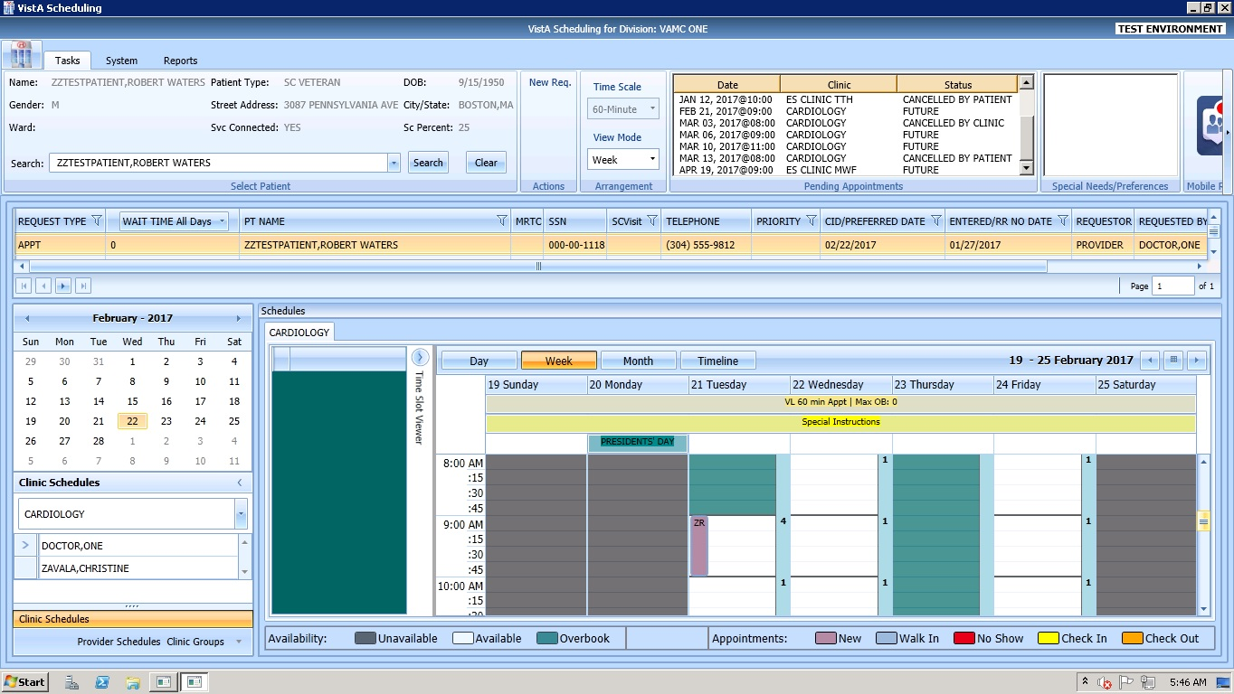

Figure 174: Clinic Schedule Display – APPT Request Future CID/Preferred Date

In Clinic Schedule Grid, select time slot in teal that is within the clinic hours, close of clinic hours to 11:59 p.m., or a date that does not already have existing overbooks. **Note:** Clinic Max Overbook limit displays in Clinic Day Event notes.

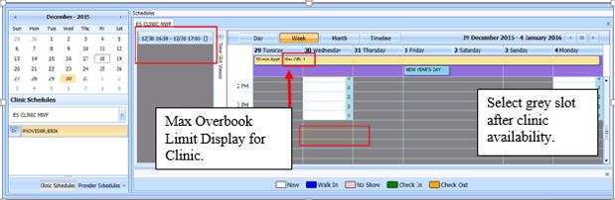

Figure 175: Overbook After Hours Time Slot

1. Right click in time slot. Add Appointment option displays. The Create Walk In Appointment option is only available for selection on current date. It is not available for past or future CID/Preferred dates.   
     
   **Note:** Right click options do not display if selected time slot is for a day that has no availability defined, is prior to the clinic start time, or the Max Overbook limit has been met for the day.



Figure 176: Appointment Right Click Options – Add Appointment

1. Select **Add Appointment**.
2. Overbook message displays.

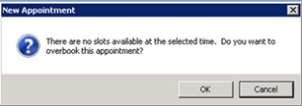

Figure 177: Overbook Confirmation Dialog

1. Click **OK**.
2. New Appointment dialog displays as well as Patient Eligibility dialog.

* **Appointments Tab:**
* **Patient Information Section displays** Name, DOB, SSN, SVC Connected, SC Percent, GAF (read only), and Svc Related check box**.**
* **Appointment** information section displays Start Time, Appt Type, Duration, Clinic and Notes (Appointment Start Time; Duration on for appointments to VL Clinics; and Notes are editable fields).
* **Appointment Conflicts** section displays any appointments already scheduled that conflict with appointment being added.



Figure 178: New Appointment Dialog

1. Add any applicable Notes to appointment. Click **OK**.
2. Print Letter? Dialog displays. Click **OK** to print Patient Letter. Click **Cancel** to exit dialog and not print Patient Letter.



Figure 179: Print Letter? Dialog

1. Closing Request dialog displays. Click **OK**.



Figure 180: Closing Request Dialog

1. APPT Request is removed from the Patient Request Management Grid. Next request for patient is moved up and highlighted.
2. Clinic Schedule closes.
3. New appointment displays in Pending Appointment window in Ribbon Bar.
4. Select appointment from the Pending Appointment window to view it in the Clinic Schedule Grid. The clinic schedule opens. For past dates, the clinic schedule opens defaulted to appointment date. For current date (or appointment date less than three days in future), the clinic schedule displays defaulted to current date. For future dates, the clinic schedule displays -/+ three days of appointment date.
5. Overbook count increases in clinic schedule time slot and in Time Slot Viewer. If the appointment count has filled the time slot, a hover window displays showing the slot count.

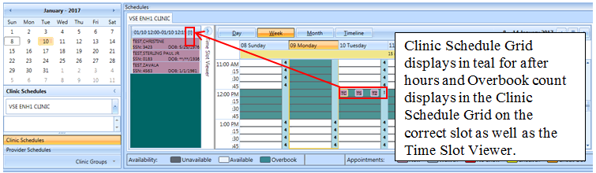

Figure 181: Clinic Schedule Display – Overbook Appointment After Hours

## VL APPT

Scheduling appointments can typically be done in fixed length intervals based upon the clinic definitions. However, a clinic can be setup as a VL clinic, allowing a user to schedule an appointment for an extended amount of time as needed rather than scheduling multiple appointments.

### Identifying a VL Clinic

In order to identify if a clinic is set up for VL scheduling, perform the following steps:

1. Log on to VS GUI.
2. From Clinic Schedules, search and select clinic by typing clinic name (six character minimum) or by typing clinic abbreviation (four character minimum).

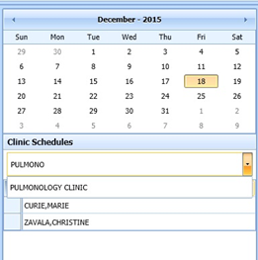

Figure 182: Clinic Schedules – Clinic Search

1. The selected clinic’s schedule displays defaulted to current date as Day 1 + six days.

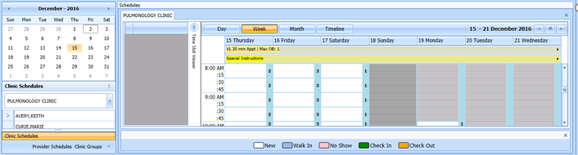

Figure 183: Clinic Schedule Grid

1. To confirm clinic is able to book VL appointments, view the All Day Event Bar in Clinic Schedule Grid. A label displays the clinic’s defined appointment length and max overbooking limit. If the clinic is designated as a variable length clinic, the letters “VL” display before the appointment length.

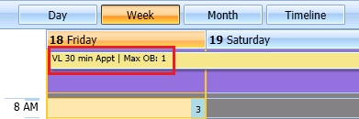

Figure 184: VL Indicator

### Add a VL APPT

Perform the following steps to add a VL APPT:

1. In the clinic schedule, select the time slot that the APPT shall begin.
2. Right click and select **Add Appointment**. The New Appointment dialog displays.

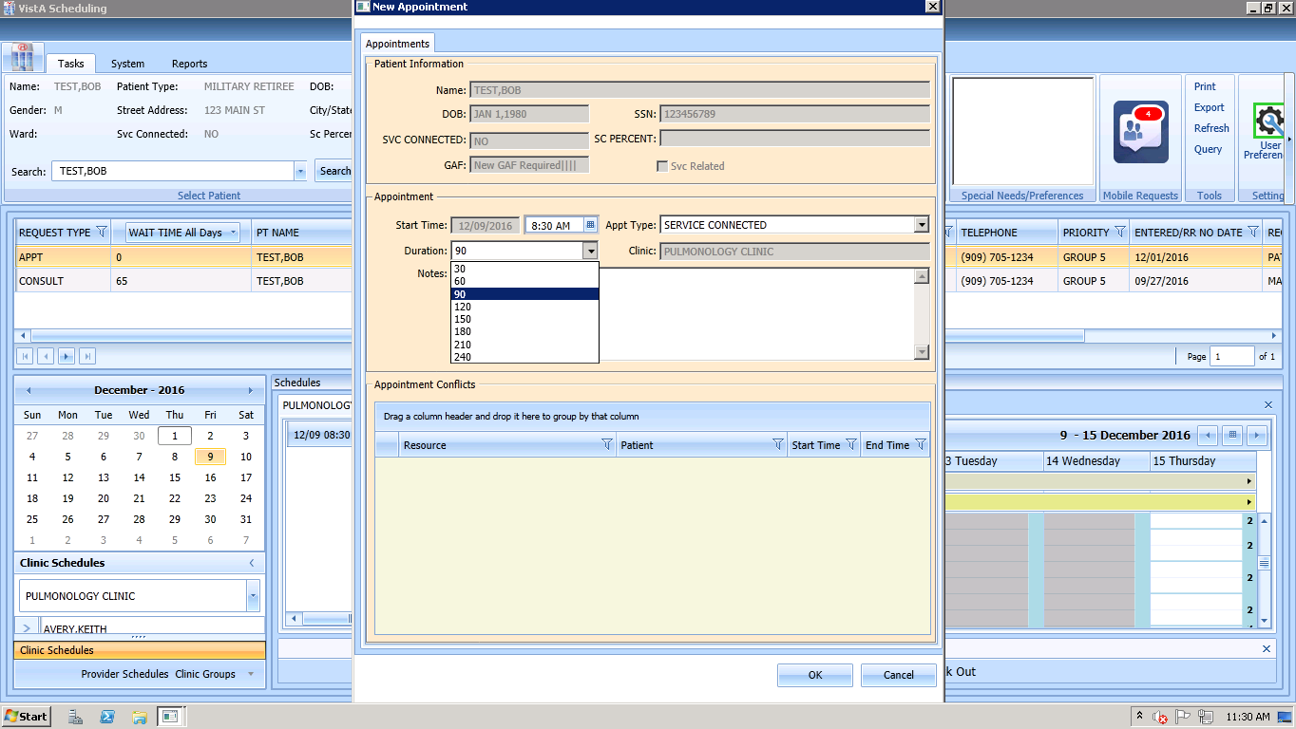

Figure 185: New Appointment Dialog

1. Select the Duration drop down box and select the appropriate duration of APPT.

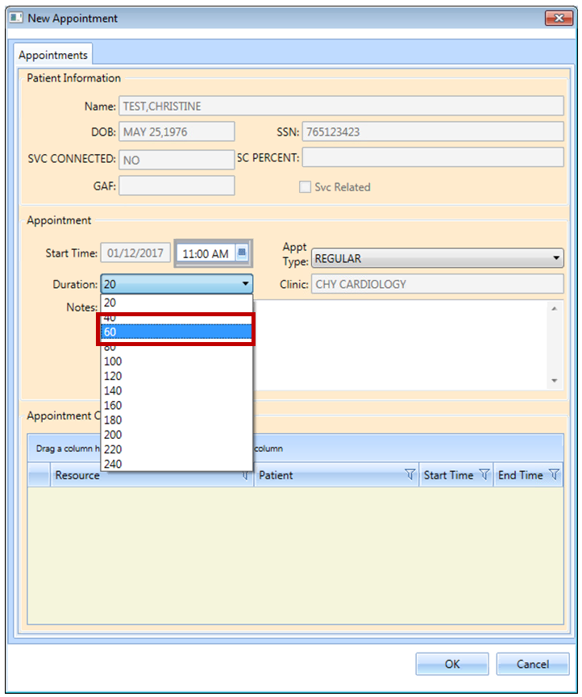

Figure 186: Clinic Schedule Display – Multiple Time Slot Selected

1. The New Appointment dialog box appears. Confirm that the appointment duration reflects the correct amount of time.

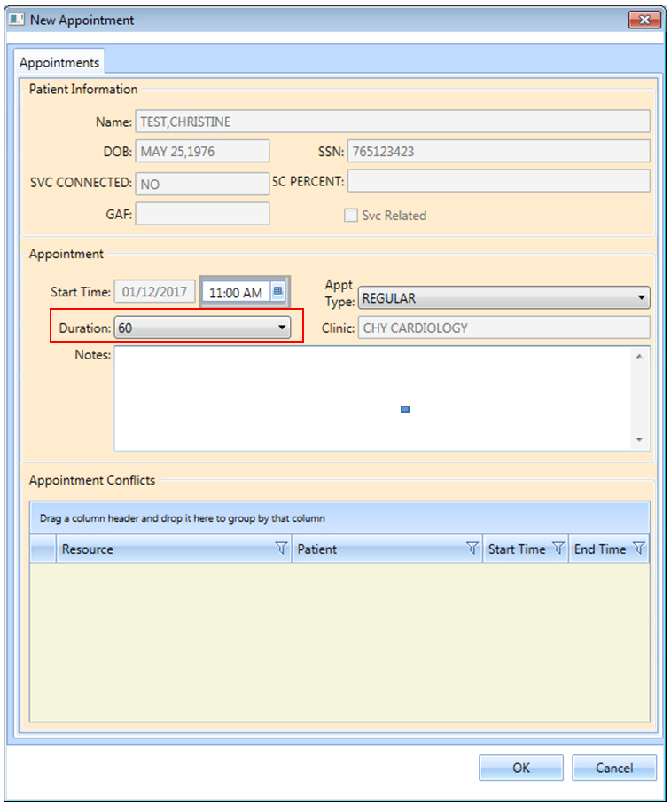

Figure 187: New Appointment Dialog – VL APPT Duration

1. Click **OK**. The Print Letter? Dialog box displays.
2. Click **Cancel**. The Closing Request dialog box displays “This request will be closed”.
3. Click **OK**. New APPT displays in Pending Appointment window.
4. Select APPT from Pending Appointment window. Clinic Schedule displays with booked APPT spanning two time slots, indicating a VL APPT.

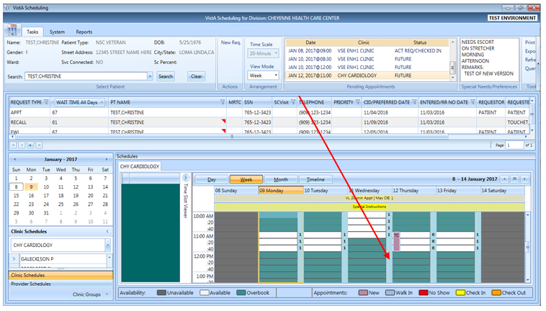

Figure 188: Clinic Schedule Display – Appointment Length Extended

## Compensation and Pension (C&P) APPTs

### Add a C&P APPT Request

1. Log into VS GUI.
2. In the Tasks tab display, type the patient’s last name, first name in the Search text box, click the **Search** button, and then select the requested patient name from drop down list.
3. Select APPT Request Type.
4. Complete APPT Request dialog. Refer to Section 5.1.2 for instructions on completing APPT Request dialog.
5. Select appropriate Clinic for C&P appointment.
6. Enter CID/Preferred Date.
7. In Appointment Type drop down, select C&P.
8. Click **OK**.
9. APPT Request is displayed in patient’s Request Management Grid.

### Add a C&P APPT for Pending 2507 Request NOT Previously Linked to Appointment

1. Log into VS GUI.
2. In the **Tasks** tab display, in the **Search** text box, type the patient’s last name or patient’s first initial of last name and last four of SSN (e.g. S1234), click the **Search** button, and select the requested patient name. Click **Search**.
3. In Request Type click **Cancel**.
4. In Request Management Grid, select pending C&P APPT Request.
5. In Clinic Schedule Grid, left click open time slot.
6. Right click, select **Add Appointment**.   
   **Note:** Create Walk-In Option is available if current day is selected in Clinic Schedule.
7. New Appointment dialog displays.
8. Confirm Appointment Type is listed as C&P. If not, select from drop down list.
9. Add any applicable APPT information to Notes section.
10. Click **OK**.
11. Dialog displays:

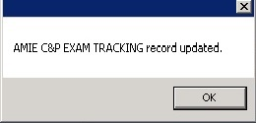

Figure 189: TRACKING Record Updated

**Note:** If patient did NOT have pending 2507 Request on file a dialog displays:

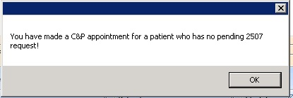

Figure 190: C&P Appointment for Patient with No Pending 2507 Request

1. Click **OK**.
2. Print Letter? Dialog displays.
3. Click **OK** to print Patient Letter. Click **Cancel** to exit out of dialog and not print patient letter.
4. Closing Request Dialog displays:

“This request will be closed.”

1. Click **OK**.
2. New C&P APPT displays in Pending Appointment window. Automated Medical Information Exchange (AMIE) Tracking Link is updated.

### Add a C&P APPT for Pending 2507 Request Already Linked to APPT NOT Due to Cancellation

1. Log into VS GUI.
2. In the Tasks tab display, type the patient’s last name, first name in the Search text box, click the **Search** button, and then select the patient name with pending C&P APPT Request from drop down list.
3. In Request Type click **Cancel**.
4. In Request Management Grid, select pending C&P APPT Request.
5. In Clinic Schedule Grid left click open time slot.
6. Right click, select **Add Appointment**.   
   **Note:** Create Walk-In Option is available if current day is selected in Clinic Schedule.
7. New Appointment dialog displays.
8. Confirm Appointment Type is listed as C&P. If not, select from drop down list.
9. Click **OK**.
10. C&P requests dialog displays with the following information:

* Name: Veteran name
* Request Date: Date 2507 Request created

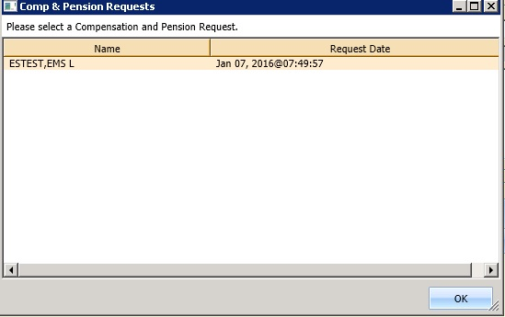

Figure 191: C&P Requests Dialog

1. Select appropriate 2507 Request from list.
2. Click **OK**.
3. C&P request displays with option to select Yes or No:

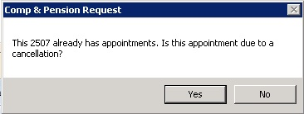

Figure 192: C&P Request Due to Cancellation Dialog

1. Click **No**.
2. Dialog displays:



Figure 193: AMIE C&P EXAM TRACKING Record Updated

1. Click **OK**.
2. Print Letter? Dialog displays.
3. Click **OK** to print Patient Letter. Click **Cancel** to exit out of dialog and not print Patient Letter.
4. Closing Request dialog displays: “This request will be closed.”
5. New C&P Appointment displays in Pending Appointment window. AMIE Tracking Link is updated.

### Add a C&P APPT for Pending 2507 Request due to Clinic Cancellation

1. Log into VS GUI.
2. In the **Tasks** tab display, in the **Search** text box, type the patient’s last name or patient’s first initial of last name and last four of SSN (e.g. S1234), click the **Search** button, and select the requested patient name. Click **Search**.
3. In Request Type click **Cancel**.
4. In Request Management Grid, select pending C&P APPT Request.
5. In Clinic Schedule Grid, left click open time slot.
6. Right click time slot, select Add Appointment.   
   **Note:** Create Walk-In Option is available if current day is selected in Clinic Schedule.
7. New Appointment dialog displays.
8. Confirm Appointment Type is listed as C&P. If not, select from drop down list.
9. Click **OK**.
10. C&P Requests dialog displays with the following information:

* Name: Veteran name
* Request Date: Date 2507 Request created



Figure 194: C&P Requests Dialog

1. Select appropriate 2507 Request from list.
2. Click **OK**.
3. C&P Request displays with option to select Yes or No:



Figure 195: C&P Request Due to Cancellation Dialog

1. Click **Yes**.
2. C&P APPT Links dialog displays with the following information and OK or Cancel is available to select with the following information:

* Initial Appointment Date
* ClockStop Appointment Date
* Current Appointment Date
* Clinic Name

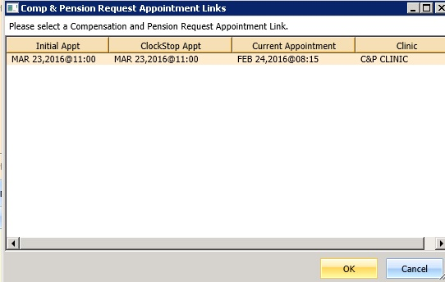

Figure 196: C&P Request APPT Links Dialog

1. Click **OK**.

**Note:** If Scheduler clicks **Cancel** instead of OK, the following dialog displays:

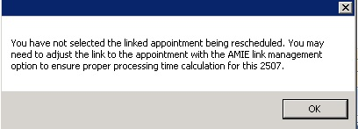

Figure 197: C&P APPT Links Due to Veteran Cancellation or No Show

1. C&P APPT Links dialog displays with option to select Yes or No:

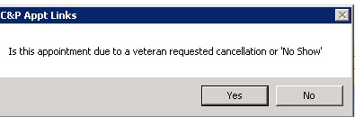

Figure 198: C&P APPT Links Due to Cancellation Dialog

1. Click **No**.
2. Dialog displays:

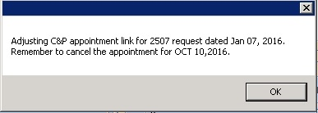

Figure 199: C&P APPT Links Adjustment Dialog

1. Click **OK**.
2. Print Letter? Dialog displays.
3. Click **OK** to print Patient Letter. Click **Cancel** to exit out of dialog and not print Patient Letter.
4. Closing Request dialog displays: “This request will be closed.”
5. New C&P APPT displays in Pending Appointment window. AMIE Tracking Link is updated.

**Note:** Previous appointment linked to 2507 Request must be manually dispositioned.

### Add C&P APPT for Pending 2507 Request due to Veteran Cancellation/No Show

1. Log into VS GUI.
2. In the **Tasks** tab display, in the **Search** text box, type the patient’s last name or patient’s first initial of last name and last four of SSN (e.g. S1234), click the **Search** button, and select the requested patient name. Click **Search**.
3. In Request Type click **Cancel**.
4. In Request Management Grid, select pending C&P APPT Request.
5. In Clinic Schedule Grid, left click open time slot.
6. Right click time slot, select **Add Appointment**.   
   **Note**: Create Walk-In Option is available if current day is selected in Clinic Schedule.
7. New Appointment dialog displays.
8. Confirm Appointment Type is listed as C&P. If not, select from drop down list.
9. Click **OK**.
10. C&P Requests dialog displays with the following information:

* Name: Veteran name
* Request Date: Date 2507 Request created



Figure 200: C&P Requests Dialog

1. Select appropriate 2507 Request from list.
2. Click **OK**.
3. C&P Request displays with option to select Yes or No:



Figure 201: C&P Request Due to Cancellation Dialog

1. Click **Yes**.
2. Comp & Pension Appointment Links dialog displays with the following information:

* Initial Appointment Date
* ClockStop Appointment Date
* Current Appointment Date
* Clinic Name



Figure 202: C&P Request APPT Links Dialog

1. Click **OK**.

**Note:** If Scheduler clicks **Cancel** instead of OK, the following dialog displays:



Figure 203: C&P Canceled APPT Links Dialog Warning

1. C&P Appt Links dialog displays with option to select Yes or No:



Figure 204: C&P APPT Links Due to Veteran Cancellation or No Show

1. Click **Yes**.
2. Dialog displays:



Figure 205: AMIE C&P EXAM TRACKING Record Updated

1. Click **OK**.
2. Print Letter? Dialog displays.
3. Click **OK** to print Patient Letter. Click **Cancel** to exit out of dialog and not print Patient Letter.
4. Closing Request dialog displays: “This request will be closed.”
5. New C&P APPT displays in Pending Appointment window. AMIE Tracking Link is updated.

**Note:** Previous appointment linked to 2507 Request must be manually dispositioned.

### Disposition APPT Linked to Pending 2507 Request

1. Log into VS GUI.
2. In the **Tasks** tab display, in the **Search** text box, type the patient’s last name or patient’s first initial of last name and last four of SSN (e.g. S1234), click the **Search** button, and select the requested patient name. Click **Search**.
3. In Request type click **Cancel**.
4. In Pending Appointment window, select pending C&P APPT linked to pending 2507 Request.
5. In Clinic Schedule Grid, left click appointment.
6. Right click and the following options are available to select:

* Edit Appointment
* View Appointment
* Cancel Appointment

1. Select **Cancel Appointment**.
2. Cancel Appointment dialog displays. See Section 6.2.3 for detailed instructions on completing Cancel Appointment dialog.
3. Select **Appointment Cancelled By**.
4. Select **Reason for Cancellation**.
5. Edit CID/Preferred Date if applicable.
6. Enter Remarks.
7. Click **OK**.
8. Dialog displays:

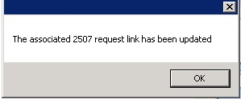

Figure 206: C&P Cancel APPT Associated 2507 Request Updated

**Note:** If C&P APPT was NOT linked to 2507 request, the following message displays in dialog:

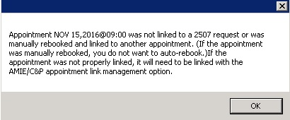

Figure 207: C&P Cancel APPT NOT Linked to Pending 2507 Request

1. Click **OK**.
2. APPT status is updated in Pending Appointment window. APPT is removed from Clinic Schedule. AMIE Link is updated.

## VAR Scheduling

Note: VAR functionality will not be used in the intitial release of VS GUI due to a number of enhancements that will be added at a later date.

The VAR Interface will provide an interface between the VS GUI and the VAR appointment request database, including:

* Link the appointment requested in VAR and processed in VistA so that the state of the appointment in VistA (e.g., cancelled, checked out) can be displayed in the GUI application.
* View appointment requests within the GUI.
* Communicate or message the Veteran from within the GUI up to a limit of four times.
* Close out requests from within the GUI.

# Clinics

## Tasks Tab

### Viewing Clinic Schedule Availability

The VS GUI displays a consistent color visual indicator for a clinic’s workable hours including bookable holidays, non-workable hours including non-bookable holiday, clinic cancellation, and no availability as follows:

Table 1: Clinic Schedule Availability

|  |  |
| --- | --- |
| **Appointment Availability Type** | **Color** |
| Available/Hours of Operation | White |
| Unavailable/ Non-workable hours during day with availability defined (i.e. clinic lunch breaks). | Grey |
| Cancelled Availability for Clinic—Partial and All Day Cancellation. | Cancelled-Grey + hash mark (\\) |
| Holiday but bookable | White |
| Holiday but NOT bookable | Grey |
| No availability defined for day (i.e. Saturday or Sunday). | Grey |
| No availability defined for the clinic | Grey |

Use the following procedure to search for a clinic and view the clinic schedule:

1. In the **Tasks** tab, from Clinic Schedules, enter a partial name of a clinic (six characters minimum).

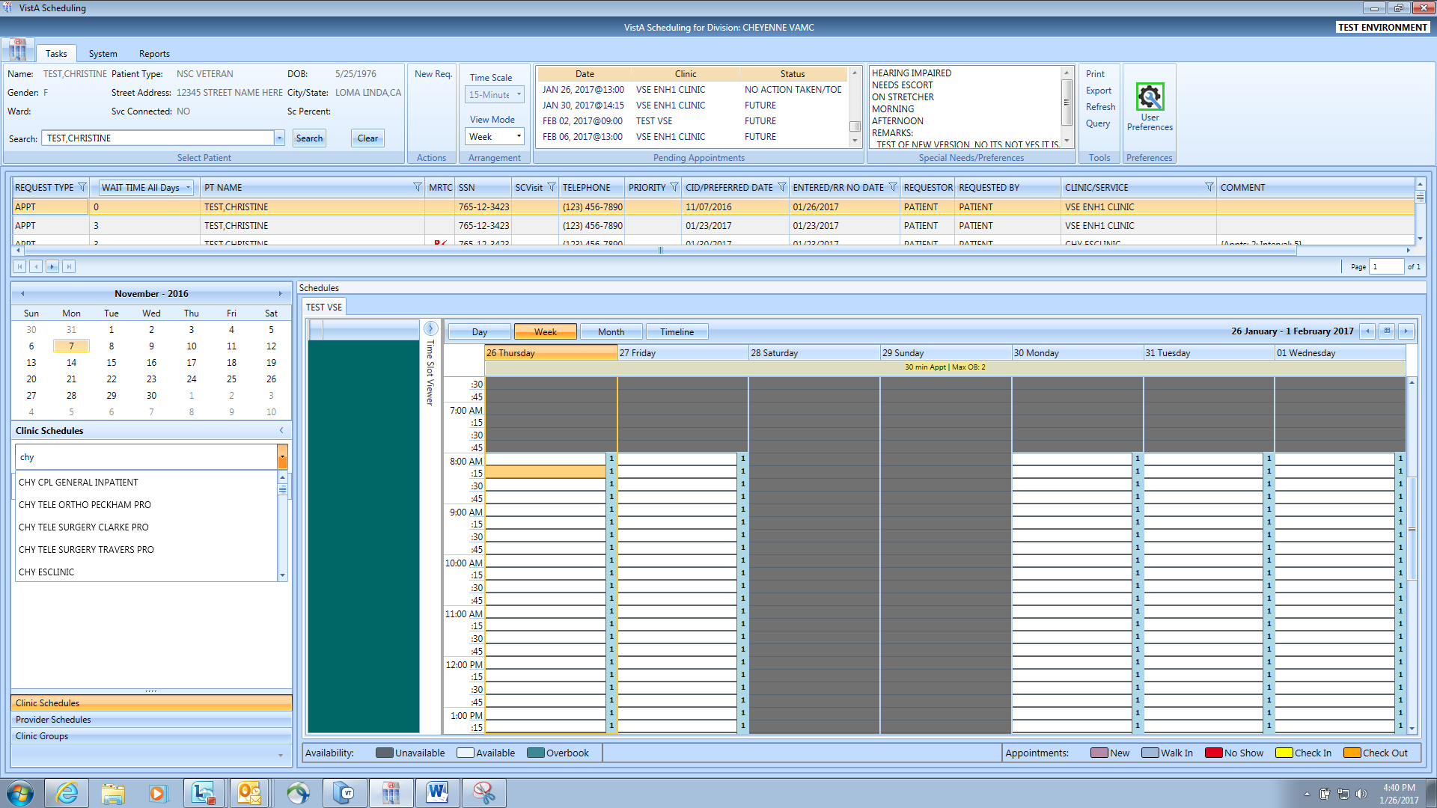

Figure 208: Clinic Schedules Search

1. Select the desired clinic from the returned list.
2. The selected clinic schedule displays.

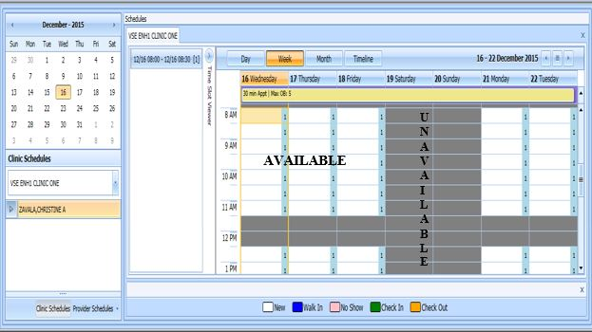

Figure 209: Clinic Schedules Display – Available and Unavailable

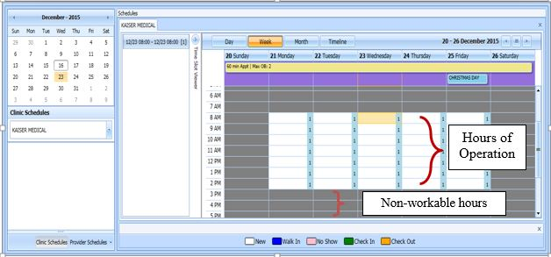

Figure 210: Clinic Schedules Display – Hours of Operation

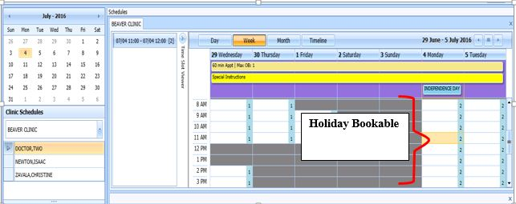

Figure 211: Clinic Schedules Display – Holiday Bookable

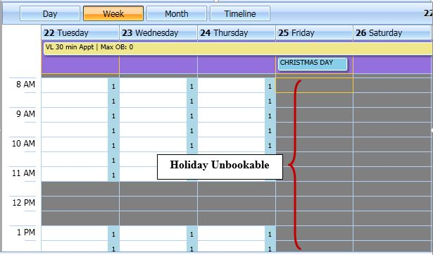

Figure 212: Clinic Schedules Display – Holiday Unbookable

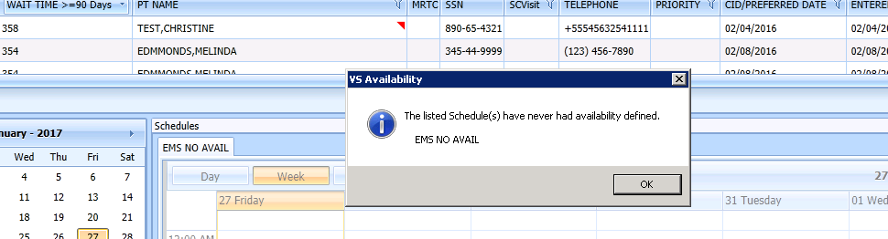

Figure 213: Clinic Schedule Display – No Availability Defined

### Viewing Clinic’s Availability Cancellation

Clinic Schedule displays full or partial day cancellation with grey + \\ over the cancelled time slots.

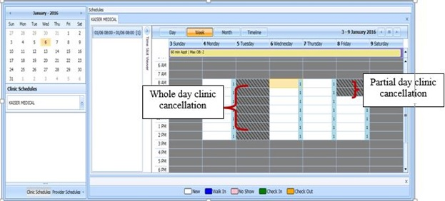

Figure 214: Clinic Schedule Display – Cancel Availability

### Viewing Clinic’s Length of APPT and Max OB

A label in the All Day Event Bar displays Length of APP and Max OB values defined for the selected clinic.

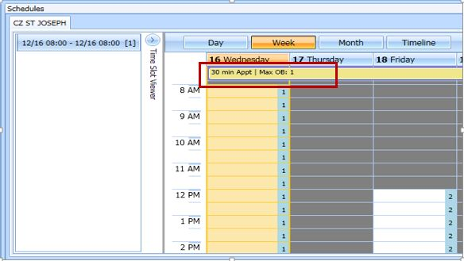

Figure 215: APPT Length and Max OB Allowed

### Viewing Clinic’s VL Indicator

For clinics defined as Variable Length, a flag “VL” displays before the Length of Appointment information in the All Day Event Bar in the Clinic Schedule Grid.   
  
**Note:** Refer to Section 6.5.2 on How to Add VL APPT.

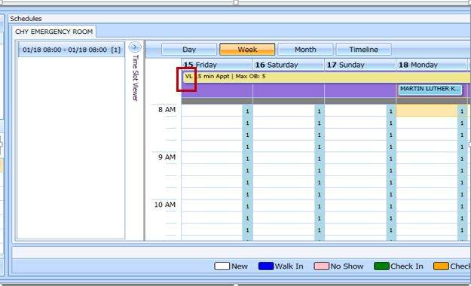

Figure 216: VL Indicator

### Viewing Clinic’s Special Instructions

Use the following procedure to display a clinic’s special instructions:

1. In the **Tasks** tab, from Clinic Schedules, enter a partial name of a clinic (six characters minimum).
2. Select the desired clinic from the returned list.
3. The selected clinic schedule displays to the user. Special Instruction Indicator displays in All Day Event Bar in Clinic Schedule.
4. Click the **Special Instructions** indicator.

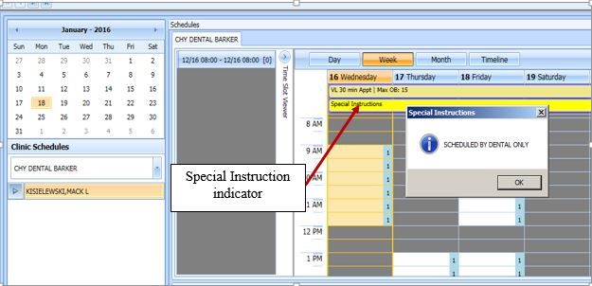

Figure 217: Special Instructions Indicator

### Viewing Clinic’s Available Slots

Time Slot Count for availability displays as follows: 0-9 and j-z –denote available slots where j=10,k=11…z=26. Upper Case Letters A-W denote overbooks, with A being the first slot to be overbooked and B being the second for that same time, etc. Special characters *,$,!,@,# denote overbooks or appointments that fall outside of a cli’ic’s regular hours.

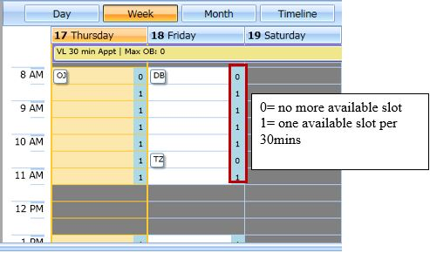

Figure 218: Time Slot Count

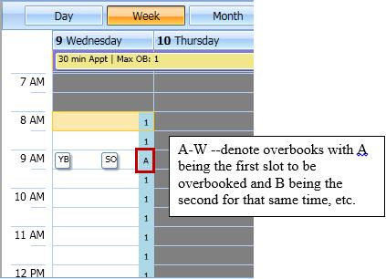

Figure 219: Overbook Time Slot Count

### Time Slot Viewer

The Time Slot Viewer displays to the left of the Clinic Schedule Grid. It displays APPT information per selected time slot. For APPTs booked in the time slot, the full patient name displays in a list in the order they were added to the time slot.

1. In the **Tasks** Tab, from Clinic Schedules, enter a partial name of a clinic (six characters minimum).
2. Select the desired clinic from the returned list.
3. The selected clinic schedule displays.  
   **Note:** Time Slot Viewer can be expanded or minimized in Clinic Schedule Grid.

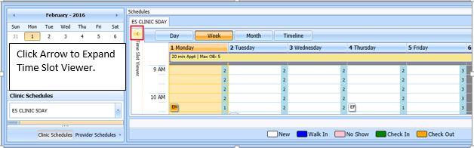

Figure 220: Minimized Time Slot Viewer

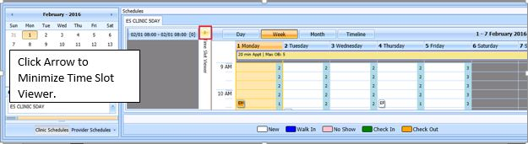

Figure 221: Expanded Time Slot Viewer

1. Selecting a time slot from the Clinic Schedule populates the Time Slot Viewer with the following information:

* Date/Time of Time Slot.
* Available slot count left for time slot.
* Patient names are listed, in the order they were booked, for any APPTs scheduled in the time slot.

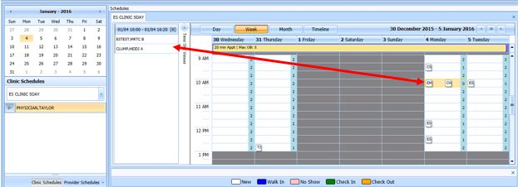

Figure 222: Time Slot Viewer Displays Slot Details

1. Appointments can be added from Time Slot Viewer.

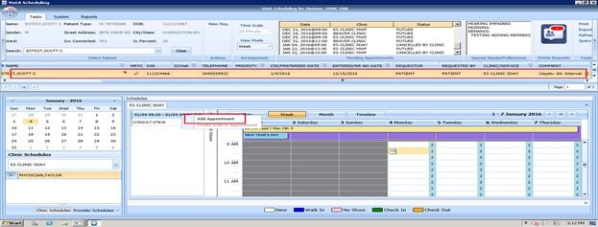

Figure 223: Time Slot Viewer Right Click Options – Add APPT

1. For booked APPTs, right click extended action options are available from Time Slot Viewer, the same as in Clinic Schedule Grid.

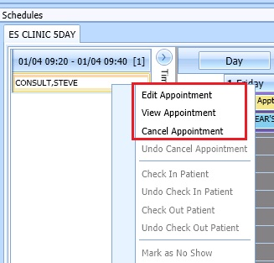

Figure 224: Time Slot Viewer Right Click–Edit, View, Cancel

1. Check In Patient from Time Slot Viewer is the same as from Clinic Schedule Grid.

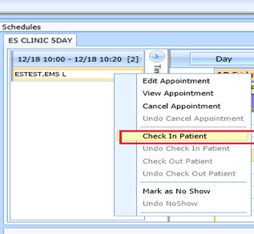

Figure 225: Time Slot Viewer – Check In Patient

1. Check Out from Time Slot Viewer is the same as from Clinic Schedule Grid.

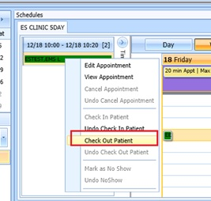

Figure 226: Time Slot Viewer – Check Out Patient

1. Mark as No Show from Time Slot Viewer the same as from Clinic Schedule Grid.

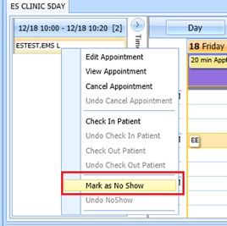

Figure 227: Time Slot Viewer – Mark as No Show

### Viewing Provider Availability

Use the following procedure to search for a provider and view the provider’s schedule.

1. In the **Tasks** tab, under the request grid calendar, select **Provider Schedules**.

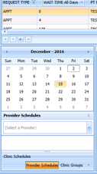

Figure 228: Provider Schedules

1. Enter a partial name of a provider (three characters minimum). Select the desired provider from the returned drop down list.

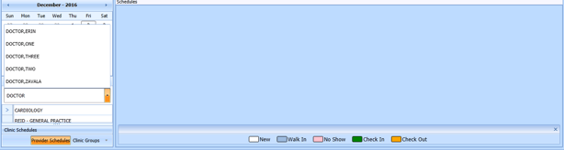

Figure 229: Provider Schedules Selection List

1. The selected provider schedule displays.

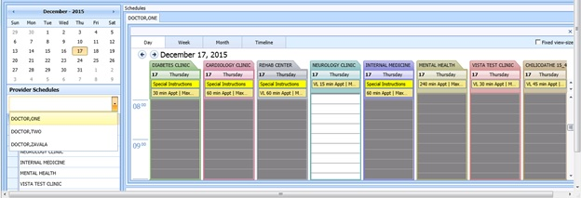

Figure 230: Provider Schedule Display

1. The provider’s availability across all clinics displays. If provider has only one clinic, that clinic’s schedule and availability appear.

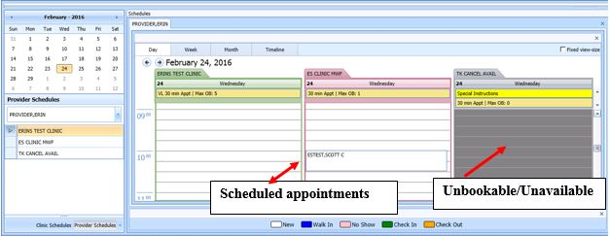

Figure 231: Provider Schedules Booked APPTs

1. Available APPT slots display as white space, which a Scheduler can select to add an APPT.
2. APPTs display with the name of the patient in a specific Clinic Schedule time slot.
3. Greyed time slots in the Clinic Schedule indicate no availability and Scheduler is unable to add APPTs for those specific slots.

**Note:** Refer to Section 6 for APPT Management instructions on how to Add, Check-In, Check-Out, and Cancel APPTs.

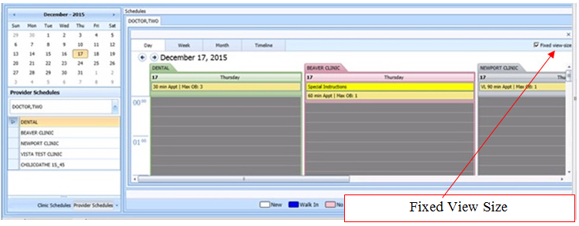

Figure 232: Fixed View Size

1. By selecting the Fixed View Size option, when viewing multiple provider schedules for different clinics, the system adjusts all the slots to the same expanded width view.

### Viewing Clinic Group Availability

Use the following procedure to search for a clinic group and view the clinic group’s schedule.

1. In the **Tasks** tab, under the request grid calendar, select **Clinic Groups**.

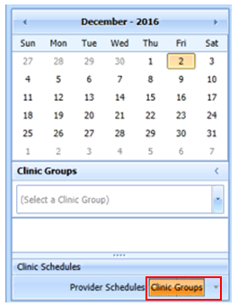

Figure 233: Clinic Groups

1. Enter a partial name of a clinic group (six character minimum). Select the desired Clinic Group from the returned list.

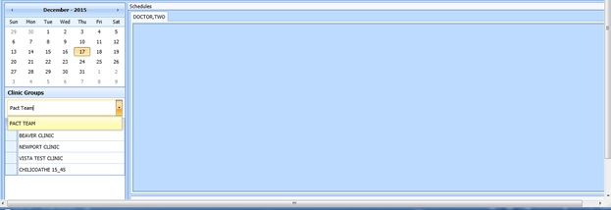

Figure 234: Clinic Groups Search Result List

1. The selected clinic group schedule(s) displays, starting with today’s date in the Day view.

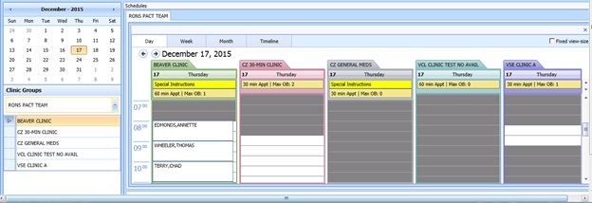

Figure 235: Clinic Groups Schedule Display

**Note:** Refer to Section 6 for APPTs Management instructions on how to Add, Check-In, Check-Out, and Cancel APPTs.

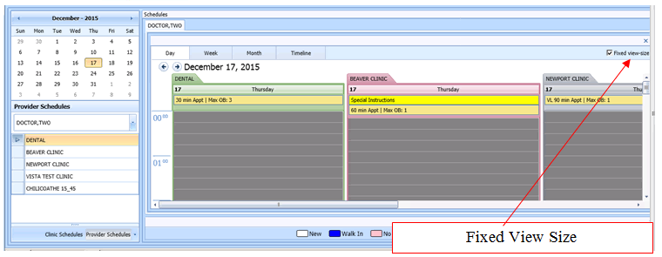

Figure 236: Provider Schedules – Fixed View Size

1. By selecting Fixed View Size, when viewing multiple Clinic Group schedules for different clinics, the system adjusts all the slots to the same expanded width view.

## System Tab

The **System** tab requires the SDECZMGR security key in order to access the tab.

### Viewing Clinic Availability Information

Use the following procedure to quickly search for clinic availability. Clinic availability cannot be modified from the VS GUI.

1. In the **Systems** tab display, click **Availability** in the **Resource Schedules** section.
2. In the **Availability Selection** dialog, type in the desired clinic name.
3. Select the desired clinic and click **OK**.

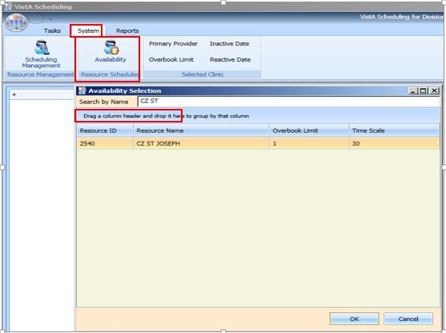

Figure 237: Clinic Availability Search

1. The Schedule displays for the selected clinic. Primary Provider, Overbook Limit, Inactive Date, and Reactive Date, as applicable, also display in the **Selected Clinic** section of the window. **Schedule** also displays the number of APPTs per slot and the number of slots total per APPT length (in minutes and total number of bookable minutes). **Schedule** uses the same visual coloration as **Clinic Schedule** for workable hours, non-workable hours, and no availability.

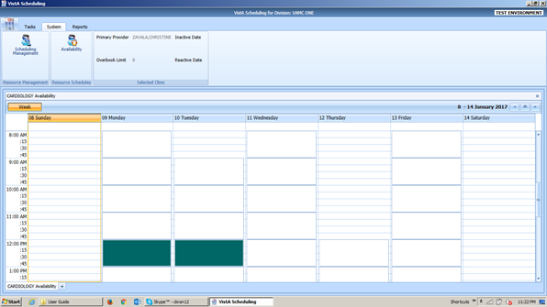

Figure 238: Clinic Availability

### Adding and Removing Privileged Users

#### Add Privileged User

Perform the following procedure to add a privileged user(s) to a prohibited clinic.

1. In the Systems tab display, click **Scheduling Management**.
2. In the **Prohibited Clinic** search box, type in a partial or full name of the clinic (minimum six characters).
3. Click **Find**. A list of prohibited clinics displays.
4. Select the appropriate prohibited clinic. A list of privileged users for the selected clinic displays.

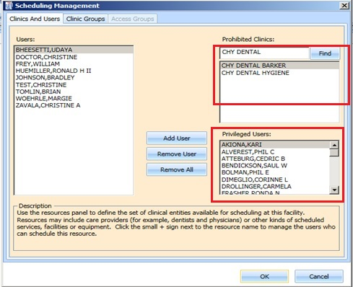

Figure 239: Clinics and Users

1. Select a user from the left and click **Add User**.

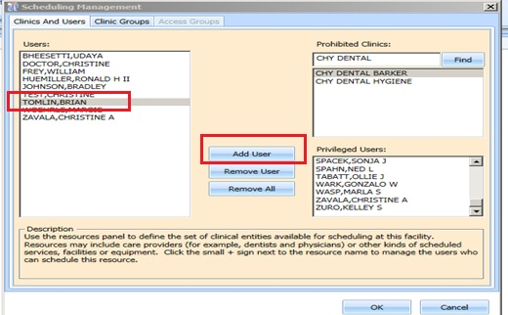

Figure 240: Add Privileged User

1. Click **OK** to file the change.

#### Remove Privileged User

Perform the following procedure to remove a privileged user(s) from a prohibited clinic.

1. In the Systems tab display, Click **Scheduling Management**.
2. In the **Prohibited Clinic** search box, type in a partial or full name of the clinic (minimum six characters).
3. Click **Find**. A list of prohibited clinics displays.
4. Select the appropriate prohibited clinic. A list of privileged users for the selected clinic displays.
5. Select a user from the **Privileged User** list for the selected prohibited clinic and click **Remove User** or, if all privileged users need to be removed, click **Remove All.**

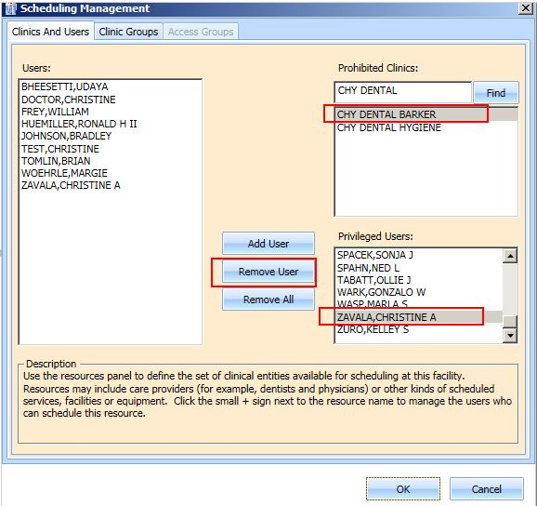

Figure 241: Remove Privileged User

### Creating Clinic Groups

Perform the following procedure to create a Clinic Group.

1. In the Systems tab display, Click **Scheduling Management**.
2. Select **Clinic Groups** tab.
3. Click **New Group**.
4. Enter name in the **Clinic Group Name** text box.

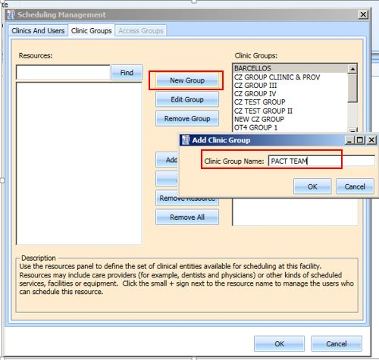

Figure 242: Create New Clinic Group

1. Click **OK**.
2. Select the newly added **Clinic Group**.
3. Enter partial name search for a **Resource** and click **Find.** A resource can be a clinic or a provider that is active with an active person class.

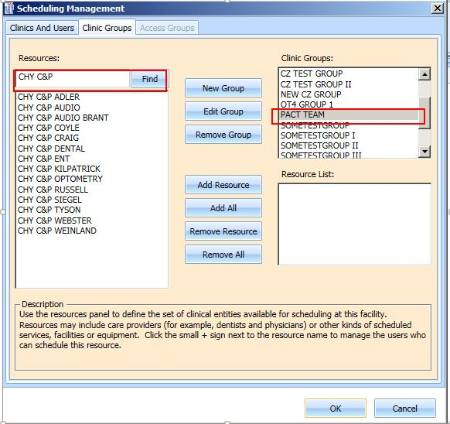

Figure 243: Find Resource

1. Select the appropriate resource to add to the Clinic Group and click **Add Resource**. If all of the resources listed from the search need to be added, click **Add All**.

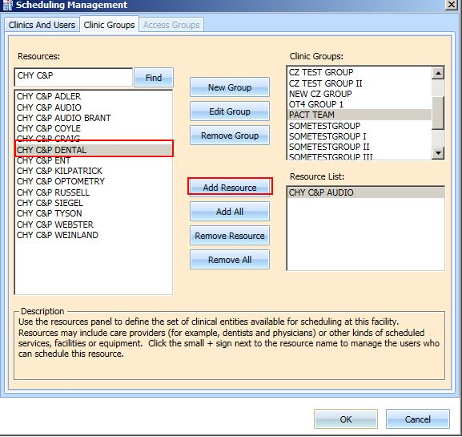

Figure 244: Add Resource to Clinic Group

1. Click **OK** to file.

### Removing Resource(s) from a Clinic Group

Perform the following procedure to remove a resource(s) from a Clinic Group.

1. In the Systems tab display, click **Scheduling Management**.
2. Select **Clinic Groups** tab.
3. Select a clinic group to be edited from the **Clinic Group** list. Resources defined for the Clinic Group are displayed in the **Resource List** box.
4. Select a resource to remove and click **Remove Resource**. If all resources need to be removed, click **Remove All**.

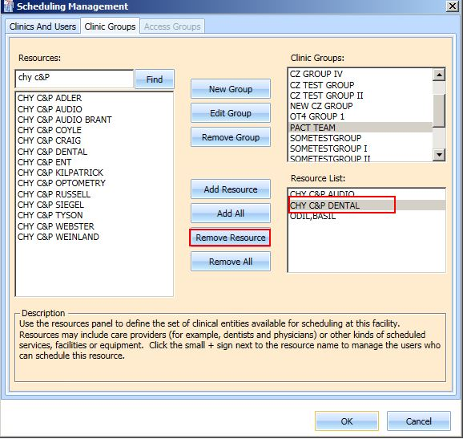

Figure 245: Remove Resource from Clinic Group

# Reports

The **Reports** tab display provides a means to view and print various reports. The Reports tab requires the SDECZMGR manager security key in order to access the tab. The following selections and reports are available:

1. Audit Activity
2. Clinics

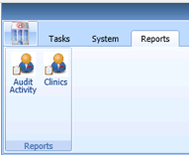

Figure 246: Reports Tab Selections

## Audit Activity Report

Audit Activity reports can be generated for individual schedulers by name or for all schedulers.

### Generating an Audit Activity Report for Individual Scheduler

Perform the following procedure to view Audit Activity for an individual scheduler.

1. From the **Reports** tab display, select **Audit Activity**. The Audit Activity dialog displays.
2. Select the individual **Scheduler** name from drop down list.
3. Select **Start** **Date** and **End** **Date** either by typing or by calendar control.

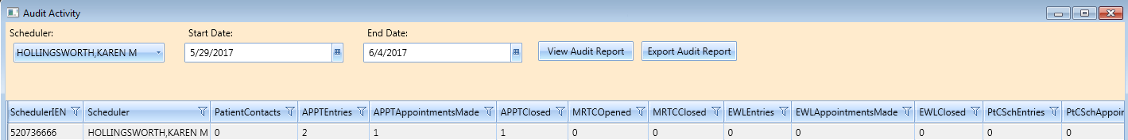

Figure 247: Audit Activity Report – Individual Scheduler

1. The following columns display data for the selected scheduler, based upon time frame specified:

* SchedulerIEN (New Person File)
* SchedulerName
* PatientContacts
* APPTEntries
* APPTAppointmentsMade
* APPTClosed
* EWLEntries
* EWLAppointmentsMade
* EWLClosed
* Patient-Centered SchedulingAppointmentsMade
* ConsultAppointmentsMade
* AppointmentsCancelled
* TotalActions

1. Click **Close** to exit the Audit Activity report dialog.

### Generating Audit Activity Report for All Schedulers

1. From Reports tab select **Audit Activity**. The Audit Activity dialog displays.
2. In **Scheduler** drop down list select **All**.
3. Enter **Start Date** and **End Date** for audit report.
4. Click **View Audit Report** button.
5. The following columns display data for All Schedulers based upon time frame specified:

* SchedulerIEN (Internal Entry Number – New Person File)
* SchedulerName
* PatientContacts
* APPTEntries
* APPTAppointmentsMade
* APPTClosed
* EWLEntries
* EWLAppointmentsMade
* EWLClosed
* Patient-Centered SchedulingAppointmentsMade
* ConsultAppointmentsMade
* AppointmentsCancelled
* TotalActions

1. Click **Close** to exit the Audit Activity report dialog.

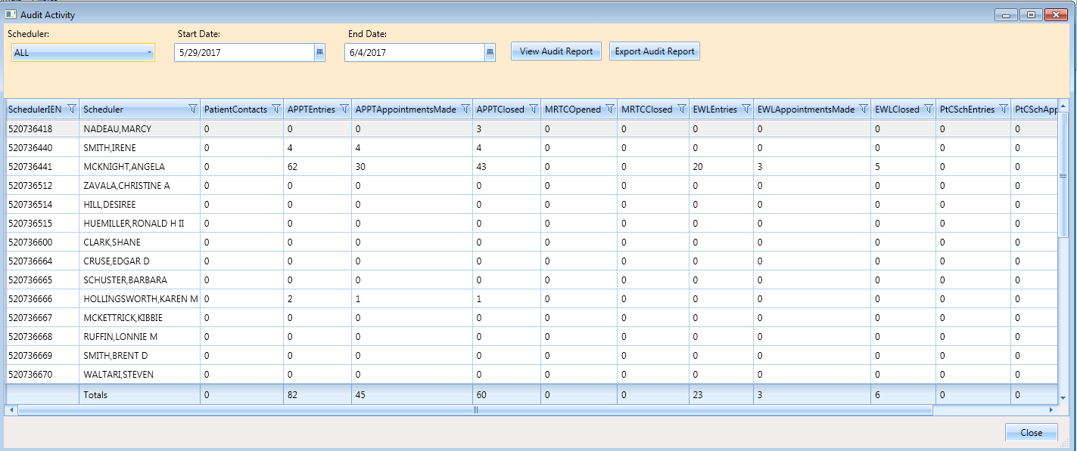

Figure 248: Audit Activity Report – All Schedulers

### Working with Audit Activity Report Data

#### Sorting by Column Header

1. Log into VS GUI.
2. Select **Reports** tab.
3. Select **Audit Activity** from Reports section. Audit Activity dialog displays for all schedulers defined in the New Person file (#200).
4. The following data displays on screen for the selected scheduler(s):

* SchedulerIEN (New Person File)
* SchedulerName
* PatientContacts
* APPTEntries
* APPTAppointmentsMade
* APPTClosed
* EWLEntries
* EWLAppointmentsMade
* EWLClosed
* Patient-Centered SchedulingAppointmentsMade
* ConsultAppointmentsMade
* AppointmentsCancelled
* TotalActions

1. To change the sort for the report by data specified in a different column, select the applicable column header. The first click of the column header sorts the report by data in the specified column in ascending order. The second click of the column header sorts the report by data in the specified column in descending order.
2. Click **Close** to exit the Audit Activity Report dialog.

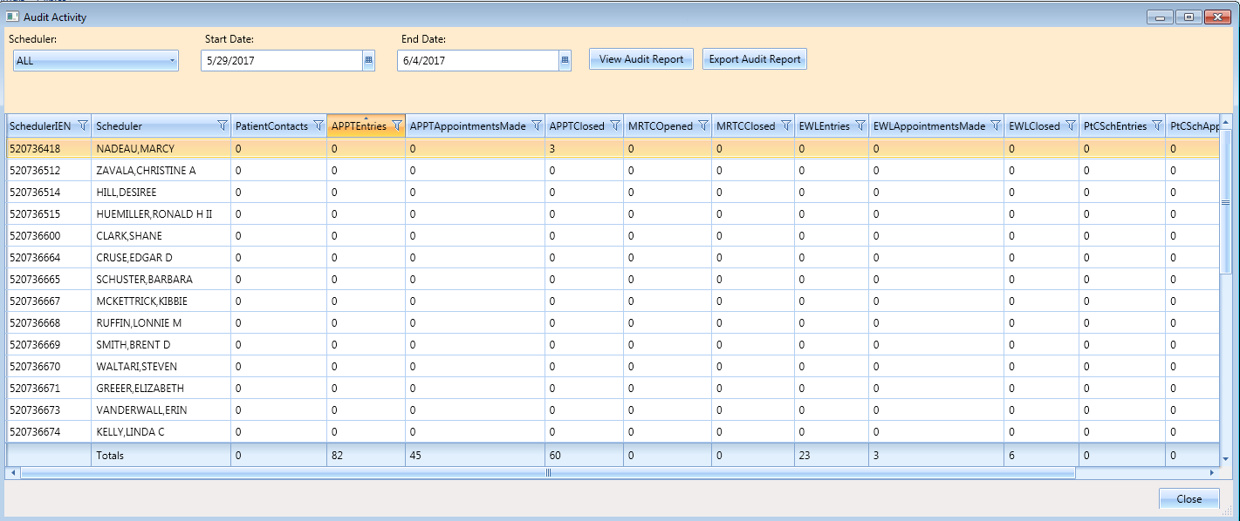

Figure 249: Audit Activity Sort – Ascending

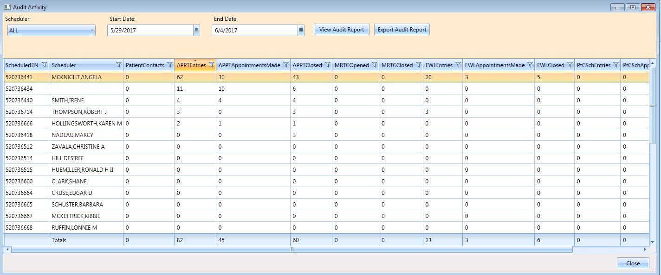

Figure 250: Audit Activity Sort – Descending

#### Filtering by Column Data

1. Data in Audit Activity report can be filtered by selecting a filter option available in each column header.

**Note**: All Schedulers who have greater than or equal to 10 APPTAppointmentMade in

the selected date range).

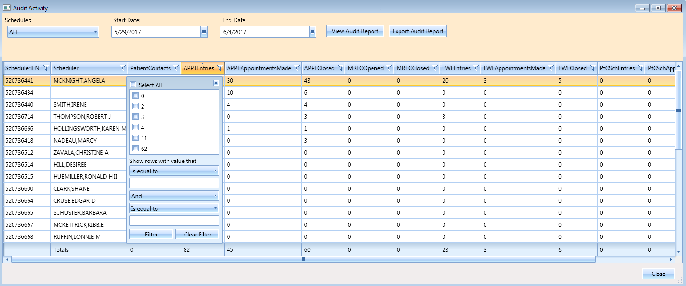

Figure 251: Audit Activity Report – Filtered

1. Multiple filters can be selected to refine results (i.e., All Schedulers who have greater than or equal to 10 APPTEntries but less than or equal to 30 APPTClosed for the selected date range).
2. Selected filters are highlighted in column headers.
3. To remove filters, select filter option in column header and click **Clear Filter** button.
4. Click **Close** to exit the Audit Activity report dialog.

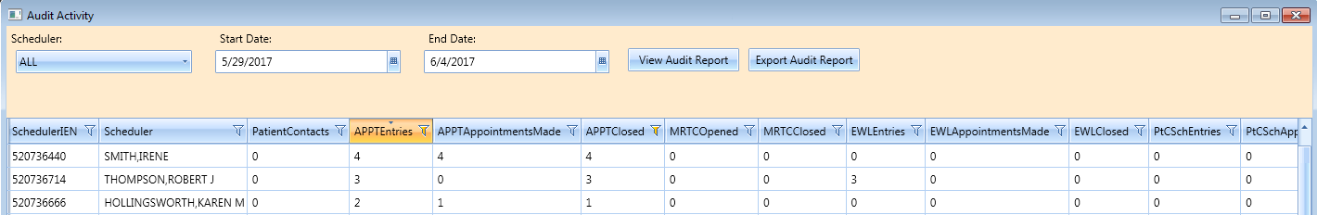

Figure 252: Audit Activity Report – Multiple Filters

### Export Audit Activity Report for Individual or All Schedulers

The data displayed on screen can be exported to an Excel spreadsheet.

1. To export audit report, click **Export Audit Report** button.
2. Save As dialog displays.
3. Select location to save report file.
4. File name defaults as “Audit Report” (edit as necessary).
5. Confirm “Save As Type” is Excel files.
6. Click **Save**.
7. Report is generated containing data displayed on screen in the Audit Activity dialog and saved to the location specified in the Save As dialog.
8. Click **Close** to exit the Audit Activity report dialog.

## Clinics Report

The Clinic Report is accessed in the **Reports** tab display by selecting **Clinics** from the Reports section. The report displays clinic activity for all clinics defined in Hospital Location file as the default. The Clinic Report can be limited to individual clinics using the following steps.

### Clinic Activity Report – Individual Clinic

1. Log into VS GUI.
2. Select **Reports** tab.
3. From Reports section, click **Clinics**.
4. In Clinic Activity dialog, enter clinic name (six character minimum) that is defined in Hospital Location file. Click the **Search** button.
5. The following data displays on screen for the selected clinic:

* Clinic name
* Division
* Stop Code
* Service
* CreateDT
* InactiveDT
* ReactiveDT
* AppType
* DefaultProv
* AdditionalProv
* ApptLength
* Variable
* MaxDays

1. Click **Clear** button to remove search criteria and return to the Clinic Activity report for all clinics.
2. Click **Exit** to close the Clinic Activity Report dialog.

### Working with the Clinic Activity Report

#### Sorting by Column Headers

1. Log into VS GUI.
2. Select **Reports** tab.
3. Select **Clinics** from Reports section. Clinic Activity dialog displays for all clinics defined in the Hospital Location file (File #44).
4. The following data displays on screen for the selected clinic:

* Clinic name
* Division
* Stop Code
* Service
* CreateDT
* InactiveDT
* ReactiveDT
* AppType
* DefaultProv
* AdditionalProv
* ApptLength
* Variable
* MaxDays

**Note:** The sort default is by alphabetical order by Clinic name.

1. To change the sort for the report by data specified in a different column, select the applicable column header. The first click of the column header sorts the report by data in the specified column in ascending order. The second click of the column header sorts the report by data in the specified column in descending order.
2. Click **Exit** to close the Clinic Activity Report dialog.

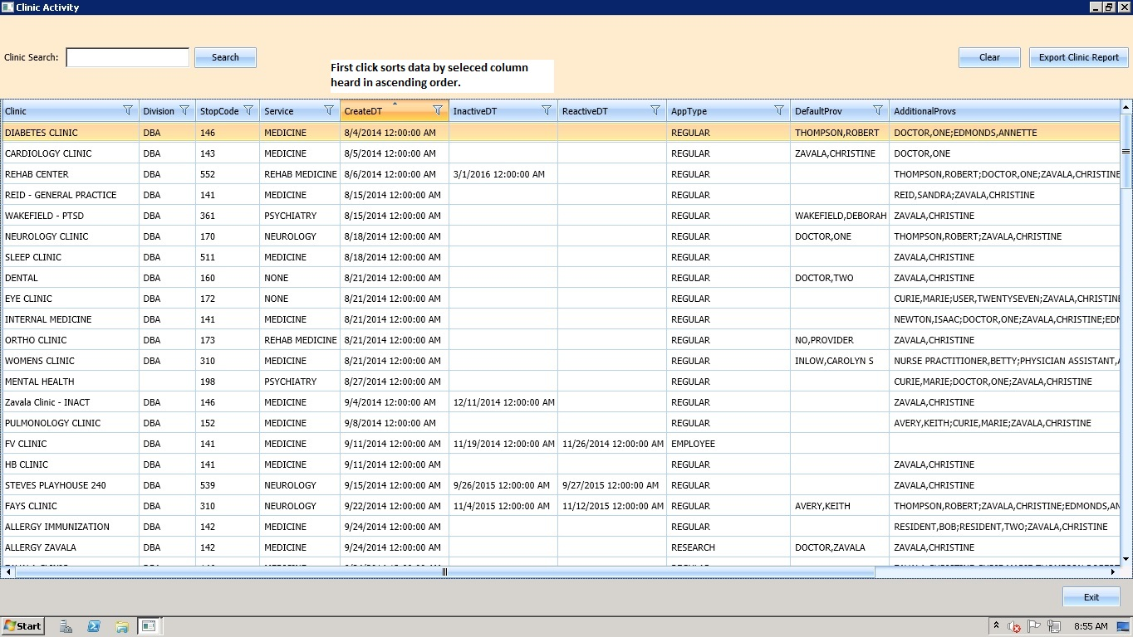

Figure 253: Clinic Activity Report Sort – Ascending Order

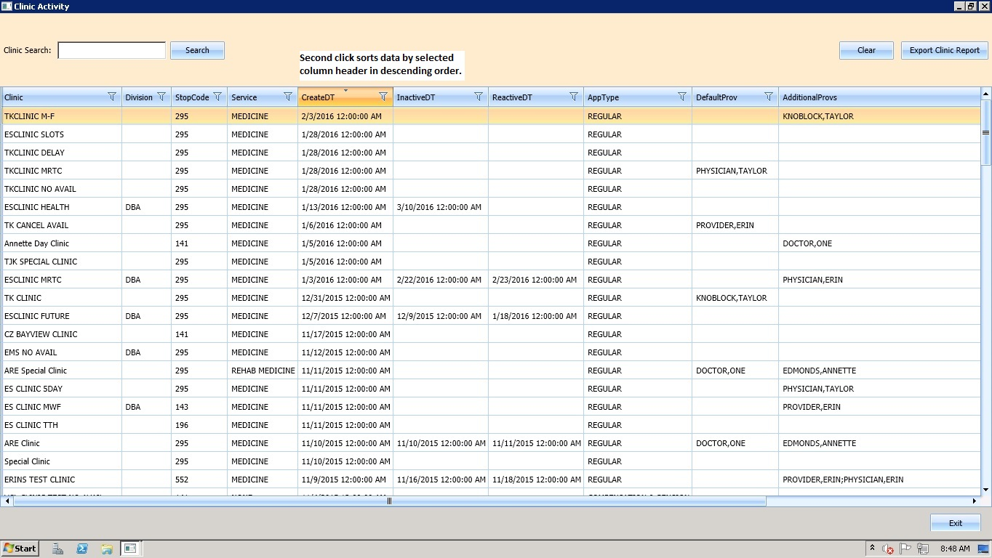

Figure 254: Clinic Activity Report Sort – Descending Order

#### Filtering by Column Data

1. Data in Clinics Activity report can be filtered by selecting the filter option in each column header (e.g., Clinic Activity data can be filtered by all Clinics with a defined Service of Rehab Medicine).

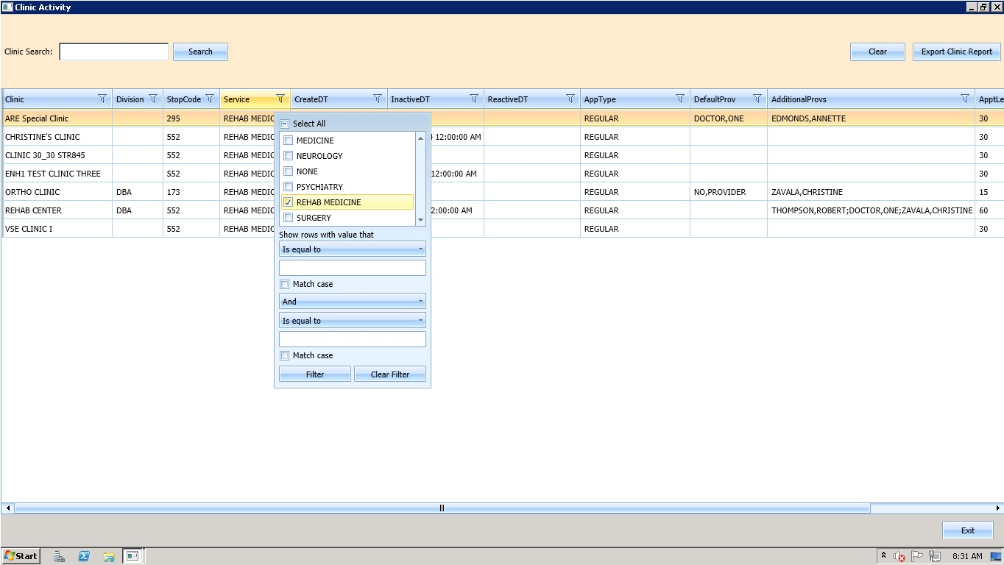

Figure 255: Clinic Activity Report – Filtered

1. Multiple filters can be selected to refine results (e.g., Clinic Activity data can be filtered by all Clinics with a defined Service of Rehab Medicine that also have no DefaultProv defined).
2. Selected filters are highlighted in column headers.
3. To remove filters, select filter option in column header and click the **Clear Filter** button.
4. Click **Exit** to close the Clinic Activity report dialog.

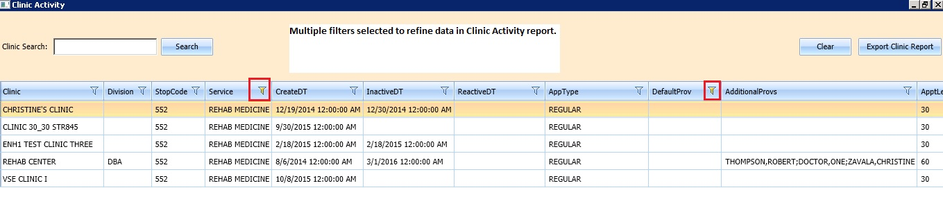

Figure 256: Clinic Activity Report – Multiple Filters

### Exporting a Clinic Report

Use the following procedure to export a Clinic Report.

1. In the **Reports** tab display, in the **Reports** section, select **Clinics.**
2. The **Clinic Activity** dialog opens, displaying the report.

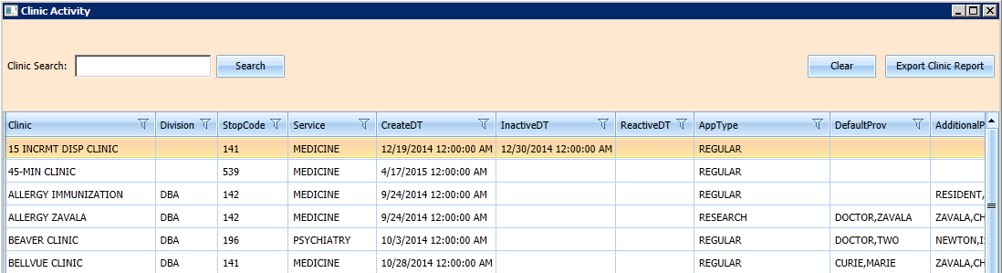

Figure 257: Clinic Activity

1. If applicable, search for specific clinic in the Clinic Search field. Click the **Search** button.
2. Click **Export Clinic Report**.
3. A **Save As** dialog box displays.
4. Select location to save the report.
5. Confirm file name (defaults to “Clinic Report”).
6. Confirm Save as Type is Excel files.
7. Click **Save**.
8. Data displayed on screen is exported into file and saved to the specified location with the defined name.
9. Click **Exit** to close the Clinic Activity report dialog.

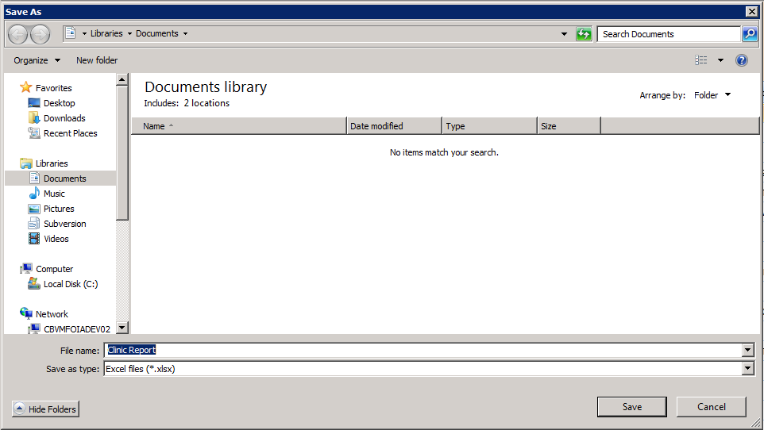

Figure 258: Save As

# Trash Queue Cleanup

For administrators who need to identify and purge unresolved requests, the solution allows a task to be run to identify open appointment requests or duplicate appointment requests and close them, producing a report for administrators. This excludes VAR requests which are called Veteran or Mobile requests – all stored in the SDEC APPT REQUEST file.

## Compile List of Re-Opened REQUEST Records that Can Be Closed

The following dialog allows the user to find open appointment requests or duplicate appointment requests in order to produce a report for administators to review/verify.

Use the following procedure:

1. Log on to the VistA Legacy System.
2. Enter **TEST an option not in your menu**.
3. Follow the steps shown below.

Select Option: SDEC INITIAL CLEANUP UTILITY VS GUI Initial Cleanup Utility

The following Utility will allow the Closing of Re-Opened SDEC APPT REQUEST

records which have resulted from a Cancellation in VistA of a corresponding

SDEC APPOINTMENT.

* 1. Select one of the following Compile List of Re-Opened REQUEST records that can be Closed

2 Commit Records to Be Closed from Compiled List

What Would You like to Do?: **1 Compile List of Re-Opened REQUEST records that can be Closed**

Please enter in, one by one, a list of Clinics to EXCLUDE from Compilation.

Enter CLINIC to EXCLUDE: <Hit **Enter** to not exclude any Clinics>

You did not choose any Clinics to Exclude.

Are you sure you want to run cleanup for ALL clinics? (Y OR N):? NO// y YES

Compiling for all Clinics excluding the following:

DEVICE: HOME// HOME (CRT)

(You may enter a device that prints to a file, a printer, email message, or you may print on the screen.)

*** Open SDEC APPT REQUESTs List run Jan 09, 2017@02:48:47 ***

LAST 4 APPT REQ IEN

CLINIC PATIENT SSN APPT IEN CID DA==

VSE ENH1 CLINIC FAULCON,GONZALO J 2916 1747 ; 1985 12/27/2016

VSE ENH1 CLINIC TEST,STERLING PAUL JR 0183 1752 ; 1988 12/27/2016

Reopened REQUEST Records that Can Be Closed

## Commit Records to Be Closed from Compiled List

The following dialog allows the user to commit Records to Be Closed from the Compiled List created via SDEC INITIAL CLEANUP UTILITY.

Use the following procedure:

1. Log on to the VistA Legacy System.
2. Enter **TEST an option not in your menu**.
3. Follow the steps shown below.

Select Option: SDEC INITIAL CLEANUP UTILITY VS GUI Initial Cleanup Utility

The following Utility will allow the Closing of Re-Opened SDEC APPT REQUEST

records which have resulted from a Cancellation in VistA of a corresponding

SDEC APPOINTMENT.

* 1. Select one of the following Compile List of Re-Opened REQUEST records that can be Closed

2 Commit Records to Be Closed from Compiled List

What Would You like to Do?: **2 Commit Records to Be Closed from Compiled List**

Open SDEC APPT REQUEST Compilation Lists to Choose From:

Batch # Run User Start Date Finish Da==

1 STUCK,ERIN Dec 14, 2016@07:41:56 Dec 14, 2016@07:41:56

2 KRON,CAROLYN S Dec 16, 2016@23:54:52 Dec 16, 2016@23:54:53

3 KRON,CAROLYN S Dec 22, 2016@11:47:18 Dec 22, 2016@11:47:19

4 KRON,CAROLYN S Jan 09, 2017@02:34:05 Jan 09, 2017@02:34:05

5 KRON,CAROLYN S Jan 09, 2017@02:48:47 Jan 09, 2017@02:48:47

Enter Batch #:**5**

Committing Open records for Batch # 5 to Closed...Done

Once the task completes, the CURRENT STATUS is changed to “CLOSED” and the DISPOSITION fields in the SDEC APPT REQUEST file are set accordingly.

To verify the record has been closed, go to VA FileMan and Inquire to view the SDEC APPT REQUEST File (#409.85). View the following fields:

* CURRENT STATUS
* DATE DISPOSITIONED
* DISPOSITIONED BY
* DISPOSITION
* DISPOSITION CLOSED BY CLEANUP

Select Systems Manager Menu <TEST ACCOUNT> Option: fm VA FileMan

VA FileMan Version 22.0

Enter or Edit File Entries

Print File Entries

Search File Entries

Modify File Attributes

Inquire to File Entries

Utility Functions ...

Data Dictionary Utilities ...

Transfer Entries

Other Options ...

Select VA FileMan <TEST ACCOUNT> Option: inquire to File Entries

OUTPUT FROM WHAT FILE: SDEC APPT REQUEST//

Select SDEC APPT REQUEST PATIENT: TEST,STERLING PAUL JR

* 1. TEST,STERLING PAUL JR

2 TEST,STERLING PAUL JR

3 TEST,STERLING PAUL JR

4 TEST,STERLING PAUL JR

* 1. TEST,STERLING PAUL JR

Press <RETURN> to see mor‘,’’^’ to exit this list, OR

CHOOSE 1-5:

.

.

.

Press <RETURN> to see mor‘,’’^’ to exit this list, OR

CHOOSE 10-15:

16 TEST,STERLING PAUL JR

17 TEST,STERLING PAUL JR

18 TEST,STERLING PAUL JR

19 TEST,STERLING PAUL JR

20 TEST,STERLING PAUL JR

Press <RETURN> to see mor‘,’’^’ to exit this list, OR

CHOOSE 1-20: 16 TEST,STERLING PAUL JR

ANOTHER ONE:

STANDARD CAPTIONED OUTPUT? Yes// (Yes)

Include COMPUTED fields: (N/Y/R/B): NO// b BOTH Computed Fields and Record Num

ber (IEN)

DISPLAY AUDIT TRAIL? No// y YES

NUMBER: 1752 PATIENT: TEST,STERLING PAUL JR

CREATE DATE: DEC 23, 2016 INSTITUTION: CHEYENNE VAMC

REQUEST TYPE: APPOINTMENT

REQ APPOINTMENT TYPE: REGULAR

Created on Dec 23, 2016@14:37:43 by User #520736464 (SDECRPC Option)

PATIENT STATUS: NEW

Created on Dec 23, 2016@14:37:43 by User #520736464 (SDECRPC Option)

REQ SPECIFIC CLINIC: VSE ENH1 CLINIC

Created on Dec 23, 2016@14:37:43 by User #520736464 (SDECRPC Option)

ORIGINATING USER: KRON,CAROLYN S PRIORITY: FUTURE

REQUESTED BY: PATIENT

Created on Dec 23, 2016@14:37:43 by User #520736464 (SDECRPC Option)

CID/PREFERRED DATE OF APPT: DEC 27, 2016

Created on Dec 23, 2016@14:37:43 by User #520736464 (SDECRPC Option)

**CURRENT STATUS: CLOSED**

**Changed fr“m “O”EN” on Jan 09, 2017@02:49:09 by User #520736464**

**(SDEC INITIAL CLEANUP UTILITY Option)**

Changed fr“m “CLO”ED” on Dec 23, 2016@14:47:01 by User #520736464

(SDCANCEL Option)

Changed fr“m “O”EN” on Dec 23, 2016@14:38:10 by User #520736464

(SDECRPC Option)

Enter RETURN to continue ‘r’’^’ to exit:

Created on Dec 23, 2016@14:37:43 by User #520736464 (SDECRPC Option)

COMMENTS: TEST

Created on Dec 23, 2016@14:37:43 by User #520736464 (SDECRPC Option)

ENROLLMENT PRIORITY: GROUP 8 MULTIPLE APPOINTMENT RTC: NO

DATE/TIME ENTERED: DEC 23, 2016@13:37

DATE EDITED: DEC 23, 2016@14:37 EDITED BY: KRON,CAROLYN S

REQ SPECIFIC CLINIC: VSE ENH1 CLINIC

**DATE DISPOSITIONED: JAN 09, 2017 DISPOSITIONED BY: KRON,CAROLYN S**

**DISPOSITION: ENTERED IN ERROR DISPOSITION CLOSED BY CLEANUP: YES**

SERVICE CONNECTED PERCENTAGE: 0 SERVICE CONNECTED PRIORITY: NO

## View Unresolved APPT Requests Reopened by the SDCANCEL Option

The following dialog allows a user that holds the new SDEC REQ REOPENED BY SDCANCEL menu option within their Scheduling Outputs menu to view unresolved appointment requests.

To view, use the following procedure:

1. Go to the **Outputs** option under the Scheduling Manager’s Menu.
2. Select **VS GUI Requests Reopened by Cancel Availability**.
3. Follow the steps shown below.

Select Scheduling Mana’er’s Menu <TEST ACCOUNT> Option: outputs

AQK Encounter Activity Report (R’no’s)

AQK2 ACRP Stop Code Report

CAAR Clinic Appointment Availability Report

Appointment List

Appointment Management Report

Cancelled Clinic Report

Clinic Assignment Listing

Clinic List (Day of Week)

Clinic Next Available Appt. Monitoring Report

Clinic Profile

Display Clinic Availability Report

Enrollments > X Days

File Room List

Future Appointments for Inpatients

Inpatient Appointment List

Management Report for Ambulatory Procedures

No-Show Report

Patient Profile MAS

PCMM Main Menu ...

Print Scheduling Letters

Provider/Diagnosis Report

Radiology Pull List

Routing Slips

Visit Rpt by Transmitted OPT Encounter

VS GUI Requests Reopened by Cancel Availability

Workload Report

Select Outputs <TEST ACCOUNT> Option: **vs guI Requests Reopened by Cancel Availab**

**ility**

* 1. Select CLINIC: **vse**  VSE ENH1 CLINIC

2 VSE ENH1 CLINIC ONE ZAVALA,CHRISTINE A

3 VSE ENH1 CLINIC TWO

CHOOSE 1-3: **1 VSE ENH1 CLINIC**

Select CLINIC:

DEVICE: HOME// HOME (CRT)

VS GUI Requests Re-Opened by Cancel Availability (SDCANCEL) Option

for clinics: VSE ENH1 CLINIC

PATIENT SSN TELEPHONE CID/PREF DATE

TEST,CHRISTINE 000-12-1234 (555)123-1234 JAN 12,2017

# VistA Scheduling 508 Compliance

The following section outlines the process for executing VistA Scheduling Application functionality from the keyboard. Many hot keys have been added for ease of use.

## Tasks Tab

The Hot Key, **Ctrl + T**, is used to navigate to the **Tasks Tab**.

### Ribbon Bar

**Tabbing:**

1. Log on to VS GUI as a Scheduler.
2. Focus is on Search field indicated by field being highlighted and cursor blinking.
3. The Scheduler can use the **Tab** key to advance through the Ribbon Bar. Beginning at the **Patient Search** field, the order will be going left to right. If the controls in each section listed below are enabled tabbing will highlight each one:

* Patient Search Field
* Search Button
* Clear Button
* Actions
* Arrangement
* Pending Appointments
* Special Needs/Preferences
* Mobile Requests
* Tools
* Print
* Export
* Refresh
* Query

1. After leaving the **Tools** section, control will go back to **Patient Search** field.

Table 2: Hot Keys for Ribbon Bar Components

|  |  |
| --- | --- |
| Ribbon Bar Component | Hot Key |
| Patient Search Field | **Alt + S** |
| Action | **Alt + A** |
| Arrangement | **Alt + G** |
| Pending Appointment Window | **Alt + P** |
| Special Needs/Preferences | **Alt + N** |
| Mobile Requests | **Alt + M** |
| Tools | **Alt + T** |

### Request Type Dialog

**Tabbing:**

1. From the **Actions Pane**, with **New Req.** highlighted, press **Enter**. The **Request Type** dialog box displays.
2. Focus is **OK**.
3. Tab to **CLEAR**.
4. Tab to **APPT Request Type**.
5. Tab to **PATIENT-CENTERED SCHEDULING Request Type**.
6. To select a **Request Type**, tab to highlight and press **Space Bar** key to select.
7. Tab to **OK**.
8. Press **Enter**.  
   **Note:** Arrow keys can also be used to navigate Request Type dialog box.

Table 3: Hot Keys for Request Type Dialog

|  |  |
| --- | --- |
| Component | Hot Key |
| OK | **Alt + O** |
| Clear | **Alt + C** |

### Appointment Request Dialog

**Tabbing:**

1. The **Appointment Request Dialog** displays with focus on **OK** button.
2. Tab to **CLEAR**.
3. Tab to the **Svc Related** check box. Press the **Space Bar** to select.
4. Tab to the **Clinic** radio button (default selection).
5. Tab to **Service/Specialty**. Press the **Space Bar** to select.
6. Tab to the **Clinic** field. Enter the **Clinic Name** (four character minimum).
7. Tab to the **CID/Preferred Date** field.
8. Once highlighted press **Enter** to display **Calendar** control.
9. Use the up and down arrow keys to navigate dates in the calendar and press **Enter** to select date.
10. Tab to **Appointment Type**.
11. Use the up and down arrow keys to select **Appointment Type**.
12. Tab to the **Requested By** field.
13. Use the arrow keys to select **Requested By**.
14. Tab to the **Provider** field (if applicable) to enter the **Provider** name (three character minimum).
15. Tab to the **Multiple Appointments Required** check box. Press the **Space Bar** to select.
16. Tab to the **Number of Appointments Required** field.
17. Use the up and down arrow keys to select the number of appointments required.
18. Tab to the **Interval Between Appointments** field.
19. Use the up and down arrow keys to select the number of days between appointments.
20. Tab to the **Comments** field.
21. Enter text in the **Comments** field.
22. Tab to the **OK** Button.
23. Press **Enter** to select and create APPT Request and exit dialog.

Table 4: Hot Keys for Appointment Request Dialog

|  |  |
| --- | --- |
| Component | Hot Key |
| OK | **Alt + O** |
| Clear | **Alt + C** |

### Query Dialog

1. The **Query Dialog** displays with focus on **Patient** field.
2. Enter the patient name **Last Name**, **First Name** orlast initial and last four of SSN.
3. Tab to the **Find** button.
4. Press **Enter**.
5. Use the **Down Arrow** key to highlight names in **Patient** list.
6. Use the **Enter** key to select patients from list to include in query.
7. Tab to the **Patients** column.
8. Use the **Down Arrow** key to highlight names listed. To remove names from selection press **Enter**.
9. Tab to the **Request Type Filter**.
10. Press **Enter** to display **Request Types** dialog box.
11. Use the arrow keys to navigate the **Request Type** selection grid.
12. Press the **Space Bar** key to select highlighted **Request Type**.
13. Tab to **OK** to confirm selection.
14. Tab to **Cancel** to quit selection and exit dialog.
15. Tab to the **Clinic/Service Filter**.
16. Press **Enter** to display **Clinics** dialog box.
17. Enter the **Clinic/Service** name in field (four character minimum).
18. Tab to the **Find** button.
19. Tab to the **Select All** check box.
20. Press **Space Bar** key to **Select All**.
21. Tab to the **Clinics** or **Services** radio button.
22. The **Clinics** radio button is defaulted. The **Services** radio button can be selected by pressing the **Space Bar** key.
23. Use the arrow keys to navigate up and down **Clinics/Service Grid**.
24. Use the **Space Bar** key to select/unselect from list.
25. Tab to **OK** and press **Enter** to confirm selections for query.
26. Tab to **Cancel** and press **Enter** to quit selection and exit dialog.
27. Tab to **Priority Group Filter**.
28. Press **Enter** to display **Priority Group** dialog box.
29. Tab to the **Select All** check box.
30. Press the **Space Bar** key to select (if applicable).
31. Tab to the **Priority Group** grid list.
32. Use the arrow keys to navigate up and down list.
33. Use the **Space Bar** key to select/unselect **Priority Group** options.
34. Tab to **OK** and press **Enter** to confirm selections for query.
35. Tab to **Cancel** and press **Enter** to quit selection and exit dialog.
36. Tab to the **Wait Time** drop down.
37. Use the arrow keys to navigate options for query selection.
38. Tab to the **ScVisit?** Drop down.
39. Use the arrow keys to navigate options for query selection.
40. Tab to the **Service Connected?** drop down.
41. Use the arrow keys to navigate options for query selection.
42. Tab to the **Origination Date** field.
43. Enter the date for query selection as applicable.
44. Tab to the **CID/Preferred Date** field.
45. Enter the date for query selection as applicable.
46. Tab to the **Urgency** field (Applicable to Consult Requests only)
47. Use the arrow keys to navigate list for query selection.
48. Tab to the Change **Sort** field.
49. Use the arrow keys to navigate list for query selection.
50. Tab to the **Clear** button.
51. Press **Enter**. The **Clear Filter** dialog box displays.
52. Tab to **OK**.
53. Press **Enter** to clear the **Request Query** dialog box of all filter selections and start query selection process again.
54. Tab to **Cancel**.
55. Press **Enter** to **Cancel Clear Filter** selection and exit dialog.   
    **Note:** Selecting **Cancel** in this dialog will keep current **Request Query** dialog filter selections for query.
56. Tab to **Submit** button.
57. Press **Enter**. The **Request Query Confirmation** dialog box displays.
58. Tab to **OK**.
59. Press **Enter** to display query results in **Request Management Grid**.
60. Tab to **Cancel**.
61. Press **Enter** to key to abort query results and return to **Request Query** dialog box.
62. Tab to the **Close** button.
63. Press **Enter** to close **Request Query** dialog box.

## Systems Tab

The Hot Key, **Ctrl + Y**, is used to navigate to the **Systems Tab**.

### Systems Tab Ribbon Bar

**Tabbing:**

1. Tab to **Scheduling Management**.
2. Press **Enter** to display **Scheduling Management** dialog box.
3. Tab to **Availability**.
4. Press **Enter** to display **Availability Selection** dialog box.

Table 5: Hot Keys for Systems Tab Ribbon Bar

| Ribbon Bar Component | Hot Key |
| --- | --- |
| Systems Tab | **Ctrl + Y** |
| Scheduling Management | **Alt + M** |
| Availability | **Alt + H** |
| Selected Clinic | **Alt + L** |

### 

### Scheduling Management Dialog

#### Clinics and Users Tab

**Tabbing:**

1. The **Scheduling Management Dialog** displays with **Clinics** and **Users** tab enabled. Focus is on **OK** button.
2. Tab to the **Users Selection List**.
3. Use the **Down** **Arrow** key to highlight the **First Name** in **Users List**.
4. Press **Enter** to select **User Name**.
5. Tab to the **Prohibited Clinic** field.
6. To select the **Prohibited Clinic**, and enter the **Clinic Name**.
7. Tab to **Find Button** and press **Enter**. The **Prohibited Clinic List** is displayed.
8. Use the arrow keys to navigate up and down the list.
9. Tab to the **Privileged Users List** that are assigned to selected clinic.
10. Tab to the **Add User** button.
11. Tab to the **Remove User** button.
12. Tab to the **Remove All** button.\

Table 6: Hot Keys for Scheduling Management Dialog

| Component | Hot Key |
| --- | --- |
| Add User | **Alt + A** |
| Remove User | **Alt + R** |
| Remove All | **Alt + E** |
| Find | **Alt + F** |
| OK | **Alt + O** |
| Cancel | **Alt + C** |

#### Clinic Groups Tab

**Tabbing:**

1. The OK button has the focus when Clinic Group Tab displays.
2. Tab to Resources.
3. Enter Clinic Schedule Resource—User name, Clinic Name, Clinic Group.
4. Tab to Find Button and press Enter to search.
5. Use the Down Arrow to highlight first name in Resource List.
6. Tab to the New Group button.
7. Tab to the Edit Group button.
8. Tab to the Remove Group button.
9. Tab to the Clinic Groups List.
10. Tab to the Add Resource button.
11. Tab to the Add All button.
12. Tab to the Remove Resource button.
13. Tab to the Remove All button.

Table 7: Hot Keys for Clinic Groups Tab

| Component | Hot Key |
| --- | --- |
| New Group | **Alt + N** |
| Edit Group | **Alt + E** |
| Remove Group | **Alt + R** |
| Add Resource | **Alt + S** |
| Add All | **Alt + L** |
| Remove Resource | **Alt + D** |
| Remove All | **Alt + X** |
| OK | **Alt + O** |
| Cancel | **Alt + C** |

### Availability Selection Dialog

**Tabbing:**

1. The **Availability Selection Dialog** displays with focus on **OK** button.
2. Tab to the **Cancel** button.
3. Tab to the **Search by Name** field.
4. Enter the **Clinic Name** (four character minimum).
5. Tab to the **Resource List Grid**.
6. Use the arrow keys to navigate up and down **Resource List**.
7. Press **Enter** to select the highlighted **Resource**. **Select** **Clinic Availability** displays.

Table 8: Hot Keys for Availability Selection Dialog

| Component | Hot Key |
| --- | --- |
| Search Field | **Alt + S** |
| First Row of Results Grid | **Alt + G** |
| OK | **Alt + O** |
| Cancel | **Alt + C** |

## Reports Tab

The Hot Key, **Ctrl + R**, is used to navigate to the **Reports Tab**.

### Reports Tab Ribbon Bar

**Tabbing:**

1. Tab to **Audit Activity**.
2. Tab to **Clinics**.
3. Tab to **Management Reports**.

Table 9: Hot Keys for Reports Tab Ribbon Bar

| Ribbon Bar Component | Hot Key |
| --- | --- |
| Reports Tab | **Ctrl + R** |
| Reports | **Alt + R** |

### Audit Activity Dialog

**Tabbing:**

1. The **Audit Activity** dialog box displays with focus on Close button.
2. Tab to the **Scheduler** drop down.
3. Default is **All**.
4. Use **Down** **Arrow** key to select user name (listed in alphabetical order).
5. Enter the user name (last name, first name) to jump to specific user.
6. Tab to the **Start** **Date** field.
7. Press **Enter** to select **Calendar** control.
8. Use the arrow keys to select date.
9. Tab to the **End Date** field.
10. Press **Enter** to select **Calendar** control.
11. Use arrow keys to select date.
12. Tab to the **View Audit Report**.
13. Press **Enter** to display **Audit Report in Grid**.
14. Tab to the **Export Audit Report**.
15. Press **Enter** to display **Save As** dialog box.   
    **Note:** Only data outputted to screen will appear in exported **Audit Report**.
16. Tabbing is enabled for **Audit Report Grid**.

Table 10: Hot Keys for Audit Activity Dialog

| Component | Hot Key |
| --- | --- |
| Scheduler drop down | **Alt + S** |
| Audit Report | **Alt + V** |
| Export Report | **Alt + E** |
| Close | **Alt + C** |

### Clinic Activity Dialog

**Tabbing:**

1. The **Clinic Activity** dialog box displays with focus on **Exit** button.
2. Tab to **Clinic Search** field.
3. Enter the **Clinic** N**ame** (six character minimum).
4. Tab to the **Search** button.
5. Press **Enter**.
6. Tab to the **Clinic Results Grid**.
7. Tab through **Clinic Results Grid** including **Column Headers** and **Filter** dialogs.

Table 11: Hot Keys for Clinic Activity Dialog

| Component | Hot Key |
| --- | --- |
| Search Button | **Alt + S** |
| Clear | **Alt + C** |
| Export | **Alt + E** |
| Exit | **Alt + X** |

# Troubleshooting

Please contact the National Service Desk (NSD) and open a ticket for any VS GUI related issues.

## **Changing User ID and Password**

Contact your supervisor or System Administrator for User ID or Password changes.

## Special Instructions for Error Correction

There are some warnings that may be displayed in a dialog. These include the below.

Table 12: Warning Messages

| Reason for Message | Message | Action | Result |
| --- | --- | --- | --- |
| Sensitive Information Warning | Warning displays to the user:  ***WARNING***  ***RESTRICTED RECORD*** | Click **OK** | User is able to log into the Security Log Audit Trail |
| Warning for similar names and SSN | Similar Names dialog displays  System lit patients with similar name and same last four digit of SS# | Click **OK** | User is able to continue |
| Accessing deceased patient’s record | This patient died on <Date of Death>  Do wish to continue? | Click **OK** | User is able to perform action such as Disposition, Cancel Appointments |
| Accessing own record at selection | Security regulations prohibit computer access to your own medical record. | Click **OK** | User is unable to perform any activity/actions |

# Acronyms and Abbreviations

| Term | Description |
| --- | --- |
| Access Block | A color-coded representation of the amount of time allotted for a specific Access Type (or appointment). |
| Access Groups | Categories of Access Types. Assigning Access Types to Access Groups makes it easier to schedule and search for certain types of appointments. |
| Access Types | The variety of different appointment types available in the Legacy VistA Scheduling package. Each type of appointment, such as routine physical, dental, walk-in, or other specific appointment type is an Access Type. |
| AMIE | Automated Medical Information Exchange |
| API | Application Program Interface |
| APPT | Appointment: A scheduled or unscheduled meeting between patient and healthcare professional.; an appointment can include several encounters with providers or clinics for tests, procedures, etc |
| CID | Clinically Indicated Date |
| Clinic | A medical center location where patients receive care by a doctor or authorized provider. |
| CPRS | Computerized Patient Record System |
| Enh | Enhancement |
| EWL | Electronic Wait List |
| GUI | Graphical User Interface |
| MUMPS | Massachusetts General Hospital Utility Multi-Programming System |
| MRTC | Multiple Return To Clinic |
| NSR | New Service Request |
| OI&T | Office of Information and Technology |
| OOS | Occasion of Service |
| OT3 | Optional Task #3 |
| OT4 | Optional Task #4 |
| OVAC | Office For Veterans Access to Care |
| PACT | Patient-Aligned Care Teams |
| PII | Personally Identifiable Information |
| PIMS | Patient Information Management System |
| POC | Point of Contact |
| PRF | Patient Record Flag |
| Provider | A doctor or other authorized provider in the medical center who provides patient care. |
| PT | Patient |
| PWS | Performance Work Statement |
| RM Grid | Request Management Grid |
| RTC | Return to Clinic |
| SDMOB | Scheduling Master Overbook |
| SDOB | Scheduling Overbook |
| Slot | Number of appointments per defined appointment length that have been previously set up in VistA Scheduling. For example, if “Slots = 4” and the clinic (resource) appointment length is 30 minutes, then there are four available appointments for every 30 minutes. |
| SSN | Social Security Number |
| T4 | Transformation Twenty-One Total Technology |
| TAC | Technology Acquisition Center |
| TCP/IP | Transmission Control Protocol/Internet Protocol |
| VA | Department of Veterans Affairs |
| VAR | Veteran Appointment Request |
| VCL | Veterans Crisis Line |
| VHA | Veterans Health Administration |
| VistA | Veterans Health Information Systems and Technology Architecture |
| VL | Variable Length |
| VS | VistA Scheduling |
| VSE | VistA Scheduling Enhancements |

# Hot Keys Quick List

Patient demographic information can be displayed and edited at any point in the process by entering **Ctrl + P** to bring up the Patient Info screen.

Ribbon Bar Components

|  |  |
| --- | --- |
| Ribbon Bar Component | Hot Key |
| Patient Search Field | **Alt + S** |
| Action | **Alt + A** |
| Arrangement | **Alt + G** |
| Pending Appointment Window | **Alt + P** |
| Special Needs/Preferences | **Alt + N** |
| Mobile Requests | **Alt + M** |
| Tools | **Alt + T** |

Request Type Dialog

|  |  |
| --- | --- |
| Component | Hot Key |
| OK | **Alt + O** |
| Clear | **Alt + C** |

Appointment Request Dialog

|  |  |
| --- | --- |
| Component | Hot Key |
| OK | **Alt + O** |
| Clear | **Alt + C** |

Systems Tab Ribbon Bar

| Ribbon Bar Component | Hot Key |
| --- | --- |
| Systems Tab | **Ctrl + Y** |
| Scheduling Management | **Alt + M** |
| Availability | **Alt + H** |
| Selected Clinic | **Alt + L** |

Scheduling Management Dialog

| Component | Hot Key |
| --- | --- |
| Add User | **Alt + A** |
| Remove User | **Alt + R** |
| Remove All | **Alt + E** |
| Find | **Alt + F** |
| OK | **Alt + O** |
| Cancel | **Alt + C** |

Clinic Groups Tab

| Component | Hot Key |
| --- | --- |
| New Group | **Alt + N** |
| Edit Group | **Alt + E** |
| Remove Group | **Alt + R** |
| Add Resource | **Alt + S** |
| Add All | **Alt + L** |
| Remove Resource | **Alt + D** |
| Remove All | **Alt + X** |
| OK | **Alt + O** |
| Cancel | **Alt + C** |

Availability Selection Dialog

| Component | Hot Key |
| --- | --- |
| Search Field | **Alt + S** |
| First Row of Results Grid | **Alt + G** |
| OK | **Alt + O** |
| Cancel | **Alt + C** |

Reports Tab Ribbon Bar

| Ribbon Bar Component | Hot Key |
| --- | --- |
| Reports Tab | **Ctrl + R** |
| Reports | **Alt + R** |

Audit Activity Dialog

| Component | Hot Key |
| --- | --- |
| Scheduler drop down | **Alt + S** |
| Audit Report | **Alt + V** |
| Export Report | **Alt + E** |
| Close | **Alt + C** |

Clinic Activity Dialog

| Component | Hot Key |
| --- | --- |
| Search Button | **Alt + S** |
| Clear | **Alt + C** |
| Export | **Alt + E** |
| Exit | **Alt + X** |